A Look at Terrorist Behavior: How They Prepare, Where They Strike
by Brent Smith, Ph.D.

mothy McVe gh, the Sept. 11 h jack- ers and Er c Rudolph all had someth ng
T
n common — they selected targets hundreds of m les from where they l ved. McVe gh wandered the M dwest l v ng
as a trans ent before mak ng h s bomb n
Her ngton, Kan., and dr v ng 250 m les south to blast the Alfred P. Murrah Federal Bu ld ng
n Oklahoma C ty. The Sept. 11 h jackers traveled hundreds of m les to the r targets. And Rudolph drove nearly 300 m les from Murphy, N.C., to bomb an abort on cl n c n B rm ngham, Ala.

For local pol ce departments search ng for ways to stop terror st acts before they occur, th s does not br ng much comfort. When
look ng at these attacks, off cers m ght get the mpress on that there s not much they can do about terror sm other than mprov ng phys cal secur ty at h gh-r sk targets.

But were these nfamous terror sts typ cal?
Although we know a great deal about the behav or of trad t onal cr m nals, l ttle nfor- mat on has been ava lable about terror sts. Are they much d fferent from convent onal cr m nals, who tend to comm t the r cr mes close to home?1 Research has shown that trad t onal cr m nals are spontaneous, but
terror sts seem to go to great lengths prepar-
ng for the r attacks — and may comm t other cr mes wh le do ng so. How long does th s plann ng take? And do d fferent types of
terror st groups vary n preparat on t me?

To help answer these quest ons, the
Nat onal Inst tute of Just ce (NIJ) launched a ser es of projects to explore patterns
of terror st behav or.2 In the f rst of these
projects, a panel of experts3 was assembled to exam ne 60 case stud es nvolv ng
terror st nc dents n the U.S. dur ng
the past 25 years.4 These cases nvolved the four major types of U.S. terror st groups: left w ng, r ght w ng, s ngle

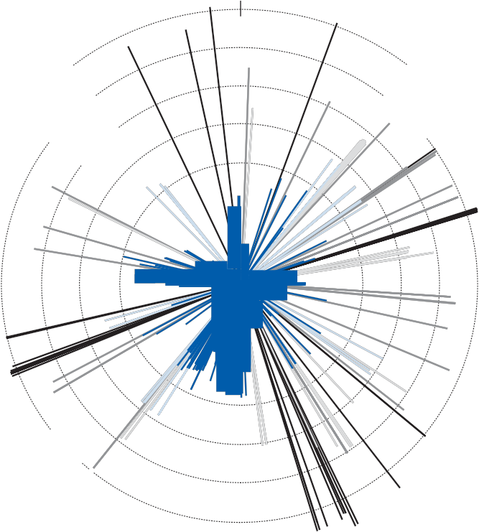 ssue and nternat onal.5,6,7 The panel —
nclud ng th s author — looked at the homes of the terror sts, the locat ons of

Distance From Terrorist Residence to Target
(All Groups)*

plann ng and preparat on, and the s tes of the terror st nc dents to d scover whether any patterns emerged.

What we learned was ntr gu ng: The cases of McVe gh, the Sept. 11 h jackers and Rudolph are actually unusual. In fact, we found that most terror sts l ve close to the r selected targets, and they engage n a great deal of preparat on — some over the course of months or even years — that has the potent al of com ng to the attent on of local law enforcement.

Terrorists Think Globally but Act Locally

44% (0-30 miles)

W

7% (31-90 miles) 8% (91-270 miles)

N

12% (271-810 miles) 29% (811-2,570 miles)

E

We stud ed:

■ Ten attacks by nternat onal groups that
nvolved 93 preparatory acts.

■ Fourteen attacks by r ght-w ng groups that
nvolved 55 preparatory acts.

■ Twenty-n ne attacks by env ronmental groups that nvolved 80 preparatory acts.

■ S x attacks by left-w ng groups that
nvolved e ght preparatory acts.

Accord ng to our analys s, almost half
(44 percent) of all terror sts exam ned l ved w th n 30 m les of the r targets. (See spa-
t al analys s on th s page, “D stance From Terror st Res dence to Target (All Groups).") When the types of terror st groups are exam ned separately, however, the f nd-
ngs are much d fferent.

Internat onal terror sts l ved relat vely near the r targets, whereas r ght-w ng terror sts l ved n rural areas but selected targets reflect ng the “pollutants of urban l fe”
n nearby c t es.

Terror sts most commonly prepared for the r attacks w th surve llance and ntell gence gather ng, robber es and thefts to ra se fund-
ng for the group, weapons v olat ons, and bomb manufactur ng. Aga n, most of these behav ors took place relat vely near the r homes, wh ch, n turn, were close to the

S
* Th s s a l near analys s of the d stance from the res dences of 423 terror sts to the r targets.

targets. Terror sts may stay close to home because of new mm grat on status, lack
of transportat on, lack of knowledge of the urban landscape or a des re to avo d attent on. Among s ngle- ssue terror sts
n part cular, 71 percent of the preparatory acts occurred w th n 12 m les and 92 percent w th n 28 m les of the target. Th s f nd ng may also be attr buted to the use of “uncoord - nated v olence” tact cs by these env ronmen- tal and ant -abort on extrem sts, wh ch often results n local target ng by “lone wolves” sympathet c to the cause.

A separate follow-up NIJ project8 that analyzed the d stance between more than 250 env ronmental and nternat onal
terror sts’ homes and the r targets conf rmed the earl er prel m nary f nd ngs that the r
spat al patterns are fa rly s m lar. The analys s

Distance From Environmental Terrorist
Residence to Target*
of the attack. Major crimes to procure fund- ing for the group — like thefts, robberies and burglaries — however, are intentionally

51% (0-30 miles)

W

9% (31-90 miles) 8% (91-270 miles)

N

8% (271-810 miles) 24% (811-2,430 miles)

E
committed many miles away to avoid drawing attention to the group’s location and target choice.

The Terrorist’s Timepiece

We found that preparations generally began less than six months before the attack and ended with a flurry of actions a day or so before. This pattern varied by group type. Single-issue and right-wing terrorists engaged in substantially less preparatory crime over a shorter period — once again, most likely reflecting the use of “leader-
less resistance” and lone-wolf strategies. The planning cycle of international terrorists tended to be longer. (See the table on page
5, “Cumulative Percentage of Preparatory
Acts Over Time.”)

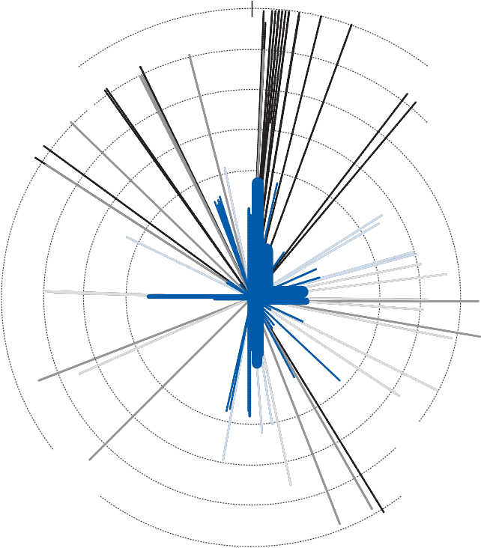

S
* This is a linear analysis of the distance from the residences of 208 environmental terrorists to their targets.

found that about half of the environmental terrorists and nearly three-fifths of the inter- national terrorists lived within 30 miles of their targets. (See the figure on this page, “Distance From Environmental Terrorist Residence to Target” and the one on page
5, “Distance From International Terrorist
Residence to Target.”) Sixty-five percent of
the environmental terrorists and 59 percent of the international terrorists prepared for their attacks within 30 miles of their target sites.

Although the terrorists studied committed most of their preparatory offenses near their homes, they conducted robberies, burglaries and thefts much farther away — an average of 429 miles from home. This suggests that most environmental and international terror- ists live near the selected target and conduct surveillance and other general preparation near their homes and the eventual location
In our follow-up study, we took a closer look at the specific patterns of international and environmental terrorists by placing
the preparations for all incidents on a time line. For instance, we examined the
21 incidents attributed to the environmen- tal terrorist group known as “The Family,” which was responsible for the Vail, Colo., ski resort arson in 1998 and many attacks against Forest Service and Bureau of Land Management buildings from 1996 to 2000. The Family consisted of at least 16 people.
Unlike most environmental terrorists who use uncoordinated violence and lone-wolf strate- gies, the group’s actions were more sponta- neous than other environmental cases, with
a short preparation period and little extended planning. Eighty-five percent of their known preparation activities — typically, inspection of the target, purchase of bomb-making items from local stores and identification
of a staging area a short distance from the target — occurred within six days of the planned attack. An explosive device was assembled at the staging area a day or so before the incident and then delivered to the target. Participants usually returned to the staging area to destroy any evidence.

International terrorists, on the other hand, engaged in nearly three times as many preparatory acts per incident as their

env ronmental counterparts. Th s may be due to the larger number of people usually
nvolved n nternat onal nc dents, the s ze

Distance From International Terrorist
Residence to Target*

and scope of the planned nc dent or s mply a longer plann ng cycle. Compar ng the 10
nternat onal terror st nc dents that occurred on Amer can so l,9 we found that the aver- age plann ng cycle for nternat onal terror sts was 92 days, as opposed to 14 days for
env ronmental terror sts. Averages can be
m slead ng, however, because of s gn f cant outl ers, such as the mult year plann ng cycle of the Islam c extrem sts seek ng to destroy New York C ty landmarks n the m d-1990s. Whereas env ronmental terror sts com-
m tted an overwhelm ng major ty of the r preparatory act v t es n the week before the
nc dent, nternat onal terror sts took up to s x months to prepare.

Arming Police With Knowledge
59% (0-30 miles)

W
17% (31-90 miles) 8% (91-270 miles)

N
12% (271-810 miles) 4% (811-2,430 miles)

E

For law enforcement agenc es, the mpl - cat ons of these patterns are s gn f cant. Comm tt ng an act of terror sm w ll usually
nvolve local preparat ons. Although much
of th s conduct w ll not necessar ly be cr m - nal, early ntell gence may g ve law enforce- ment the opportun ty to stop the terror sts before an nc dent occurs. Knowledge of the threat — for example, understand ng how long env ronmental or nternat onal terror-
sts prepare for the r attacks — w ll affect the manner n wh ch local off c als respond. Ident fy ng preparatory act ons by env ron- mental extrem sts may s gnal that an attack
s mm nent, whereas s m lar behav or by an
nternat onal group m ght suggest that an attack s st ll several months away.

S

* Th s s a l near analys s of the d stance from the res dences of 49 nternat onal terror sts to the r targets.

Understand ng that most terror sts “act locally” can be mportant to know as nves- t gat ve agenc es seek to prevent terror sm
and arrest perpetrators. These local patterns may be used by agenc es to more eff c ently

Cumulative Percentage of Preparatory Acts Over Time

Type of Terrorist  Group | Incident day | Day before | 2-3 days | 4-7 days | 8-14 days | 15-30 days | 1-3 mos | 4-6 mos | 7-12 mos | 1-3 yrs | 3+  yrs
International | 5% | 9% | 13% | 21% | 32% | 55% | 68% | 84% | 89% | 97% | 100%
Right wing | 15% | 26% | 31% | 44% | 49% | 67% | 94% | 96% | 96% | 100%
Environmental | 20% | 43% | 72% | 80% | 91% | 95% | 98% | 100%
Left wing | 50% | 75% | 88% | 88% | 88% | 88% | 100%
All categories | 13% | 27% | 40% | 48% | 57% | 72% | 85% | 93% | 95% | 99% | 100%

Percentage of acts completed w th n a spec f ed t me range:

0-25% 26%-50% 51%-76% 77%-100%

patrol known, h gh-r sk target areas and gather ntell gence on suspected act ons w th n a spec f c d stance from potent al targets. As we cont nue to deepen our understand ng of the relat onsh p among
the locat on of the terror st’s home, terror-
st preparat on act v t es and the target, th s grow ng knowledge should help off cers prevent and respond to attacks.

NCJ 222900

AcKNoWLEDGmENTs

We would l ke to express our apprec at on to the FBI, the U.S. House of Representat ves Jud c ary Subcomm ttee on Cr me, the U.S. Senate Jud c ary Comm ttee, Sen. Jeff
Sess ons, the Nat onal Memor al Inst tute for the Prevent on of Terror sm n Oklahoma C ty, the Department of Homeland Secur ty and NIJ for support ng our research and the Amer can terror sm study.

About the Author

For More Information
■ More nformat on on th s study s ava lable at http://trc.uark.edu.
■ For more nformat on on NIJ’s terror sm research, see http://www.ojp.usdoj.gov/ n j/top cs/cr me/terror sm.

Notes

1. Wr ght, R., and S. Decker, Burglars on the Job: Streetlife and Residential Break-ins, Boston: Northeastern Un vers ty Press, 1994; Wr ght, R., and S. Decker, Armed Robbers in Action: Stickups and Street Culture, Boston: Northeastern Un vers ty Press, 1997; and Reppetto, T. A., Residential Crime, Cambr dge: Ball nger Publ sh ng, 1974.

2. “Pre-Inc dent Ind cators of Terror st Group Act v t es,” NIJ Grant # 2003-DT-CX-0003; “Geospat al Analys s of Terror st Act v t es: The Ident f cat on of Spat al and Temporal Patterns of Preparatory Behav or of Inter- nat onal and Env ronmental Terror sts,” NIJ Grant # 2005-IJ-CX-0200; and “Terror sm
n T me and Space,” NIJ Grant # 2006-IJ- CX-0037.

3. The members of the panel and the r areas of expert se were: Ron Arnold, env ronmental

terror sm; Steve Chermak, r ght-w ng terror-
sm; Kelly Damphousse, terror sm database management; W ll am Dyson, domest c and
nternat onal terror sm; Mark Hamm, r ght- w ng terror sm; Robert He bel, left-w ng ter- ror sm; Aust n Turk, terror sm and pol t cal
v olence theory; and the author, Brent Sm th, domest c and nternat onal terror sm.

4. Cases were selected pr mar ly from the
Amer can Terror sm Study, a project that
nvolves data collect on on all persons nd cted as a result of an FBI “terror sm enterpr se”
nvest gat on as def ned by the attorney general gu del nes for domest c and nterna- t onal terror sm nvest gat ons.

5. Left-w ng terror st groups generally refer to those that adhere to a “forward-look ng”
deology, one that advocates a pol t cal or soc al system that has not ex sted before n the U.S. Typ cally assoc ated w th extreme
l beral sm, examples nclude the May 19th Commun st Party, the Weather Underground and the Black L berat on Army.

6. R ght-w ng terror st groups generally refer to those that adhere to a “backward-look ng”
deology, one that advocates a return to a
pol t cal or soc al system that s perce ved to have ex sted prev ously n the U.S. Typ cally assoc ated w th extreme conservat sm, examples nclude the KKK, wh te supremacy groups l ke the Aryan Nat ons or groups l ke the Sher ff’s Posse Com tatus that oppose central zed federal power.

Brent Smith is a professor of sociology and criminal justice at the University of Arkansas. A student of terrorism for nearly 30 years, he created the American Terrorism Study in 1988 with assistance from the FBI. Smith currently serves as director of the Terrorism Research Center (TRC) in Fulbright College at the University of Arkansas. He was assisted on the projects discussed in the article by Kelly Damphousse, professor of sociology and associate dean of the College of Arts and Sciences at the University of Oklahoma; Jackson Cothren, assistant professor of geosciences and affiliate of the Center for Advanced Spatial Technologies at the University of Arkansas; and Paxton Roberts, research associate at TRC.

7. L ke the name mpl es, s ngle- ssue terror-
st groups advocate on behalf of a part cular pol t cal or soc al ssue, such as ant -abort on or the env ronment.

8. “Geospat al Analys s of Terror st Act v t es,” NIJ Grant # 2005-IJ-CX-0200.

9. Temporal data on nternat onal terror sts
are l m ted due to the small number of nter- nat onal nc dents that have taken place n the U.S. Because of the FBI’s success n d srupt ng plots, the number of cases s small.

