RESEARCH BRIEF

Patterns of Lone Actor Terrorism in the United States

B A C K G R O U N D

In the early 1990s, law enforcement authorities became increasingly concerned about the advent of “lone wolf” terrorism. The extreme right began advocating this “uncoordinated violence” approach in 1992 under what was called a “leaderless resistance” model. It was around this time that the emergence of the Internet allowed cyberspace to become a major source of radical propagandizing for environmental terrorists and al-Qaida-inspired movements. The rise of the Internet also provided a way in which leaders of movements could identify targets, allowing subordinates or non-affiliated extremists the opportunity to commit acts of terrorism. All of these strategies developed as a means of minimizing the civil and criminal liability of group leaders. They also thwarted traditional law enforcement efforts that usually employed confidential informants or undercover operatives within identified cells or groups of terrorists.

O V E R V I E W

This research explores the differences in geospatial and temporal patterns between lone actor and group-based terrorists in the United States. These include differences in demographics, precursor activities, proximity to the terrorism incidents, and longevity of conducting terrorist activities.

Data for this analysis were derived from the American Terrorism Study (ATS). The ATS includes information on federal criminal cases resulting from FBI investigations for “terrorism or terrorism-related activities.” The analysis includes data from 264 prevented or completed terrorism incidents in the United States from 1980-present. These incidents involved 314 indictees charged with over
3,000 federal criminal counts. They were responsible for 1,788 recorded precursor activities that occurred at over 1,100 geocoded addresses.

KEY TERMS
• Lone actors: persons who had no help in planning, preparing, or committing the terrorism incident.
• Group participants: persons who had help in planning, preparing, or committing the terrorism incident.
• Precursor activities: any activities relevant to the terrorists’ planning or preparation.

F I N D I N G S

D E M O G R A P H I C S

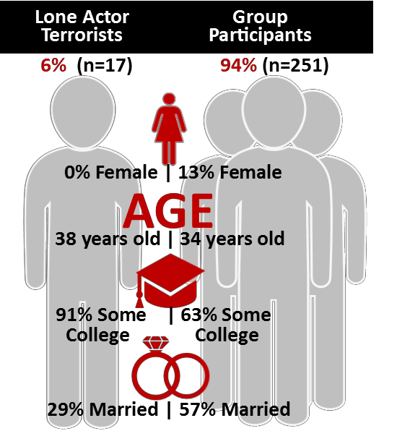Lone actor terrorists are relatively rare, representing less than 10% of all terrorists in the United States. Notably, however, lone actors are responsible for a disproportionate number (65 of 264, or 25%) of U.S. terrorism incidents.

Generally, persons committing terrorism incidents in the United States tend to be overwhelmingly male, having completed a high school degree or some college coursework. They are also more likely to be married and in their mid-thirties. Comparatively, lone actors are more likely to be
male and better educated than their group participant counterparts.
Additionally, lone actors are significantly less likely to be married than group participants. The two groups differ slightly in age when “age” is
measured as
“age at
indictment.”

Only 6% of terrorists in
United States are lone actors

But they are responsible for
25% of terrorism incidents in the United States
When comparing “age at first preparatory activity,” lone actors are
slightly younger
than group participants.

E X T E N T O F P R E C U R S O R A C T I V I T Y
Lone actor terrorists engage in significantly fewer precursor behaviors per incident than do group participants. Many of the activities of group participants involve meetings, which allow law enforcement greater opportunity to infiltrate group-level planning than the activities of lone actors. Despite this significant difference in the volume of precursor behavior among the two types, there is no difference in the length of the planning process among lone actors and group participants.

 | Precursor Acts | Incidents | Precursor Acts per Incident
Loners | 162 | 65 | 2.49
Cells/Groups | 1,675 | 199 | 8.42

G E O S P A T I A L P A T T E R N S
Lone actor terrorists live significantly greater distances from where they engage in precursor preparatory activities than group participants (median distances of 170 miles to 79 miles, respectively). They also live significantly greater distances from the terrorist incident location than group participants (328 miles to 118 miles, respectively). Both of these patterns indicate that lone actors go to significantly greater lengths to avoid detection than group participants.

L O N G E V I T Y

On average, lone actor terrorists have a significantly longer life span as terrorists than group participants. On average, group participants “survive” 370 days from the time they commit their first preparatory activity until the time they are arrested. In contrast, lone actors “survive” in excess of 1,900 days from date of first preparatory behavior to date of
arrest.
CONCLUSIONS

• Lone actor terrorists, while representing a very small proportion (6%) of terrorists, have been responsible for one-fourth of the terrorism incidents in the United States.

• Lone actor terrorists are significantly better educated, more likely to be male, and less likely to be married than group participant terrorists.

• Lone actor terrorists engage in significantly fewer precursor activities than group participants.

• There is no difference in the length of the planning cycle for lone actor terrorists and group participants.

• Lone actor terrorists lived significantly farther from where they prepared for an incident and where the incident occurred than did group participants.

• Lone actor terrorists have a significantly longer “life cycle” than group participants.

100%
80%
60%
40%
20%
0%
Length of Terrorist’s Life Cycle
First preparatory act to date of
arrest/indictment

Lone Actors Cells/Groups All Perpetrators

Less than 3 months 3-12 months 12+ months
All of these general patterns by lone
actors (more likely to be single, fewer planning activities, greater distances from residence to target, etc.) are all indicative of greater secrecy on the part of lone actors than group participants. It is not surprising, then, that lone actors are able to avoid arrest significantly longer than group
participants.

R E S E A R C H T E A M

Brent L. Smith
Distinguished Professor and Director, Terrorism Research Center in Fulbright College, University of Arkansas bls@uark.edu
Paxton Roberts Research Associate and Administrative Deputy Director, Terrorism Research Center in Fulbright College, University of Arkansas
Jeff Gruenewald
Assistant Professor of
Sociology and Criminal Justice,
University of Arkansas
Brent Klein
Graduate Research Assistant, Terrorism Research Center in Fulbright College, University of Arkansas

The National Consortium for the Study of Terrorism and Responses to Terrorism (START) is supported in part by the Science and Technology
Directorate of the U.S. Department of Homeland Security through a Center of Excellence program based at the University of Maryland. START
uses state‐of‐the‐art theories, methods and data from the social and behavioral sciences to improve understanding of the origins, dynamics
and social and psychological impacts of terrorism. For more information, contact START at infostart@start.umd.edu or visit
www.start.umd.edu.

