R e s e a r c h S p o t l i g h t : M e a s u r i n g
I n t e r v e n t i o n S u c c e s s
i n Te r r o r i s m A c t i v i t i e s
( M I S TA )

Following the attacks on September 11, 2001, the FBI quickly transitioned from a “responsive, investigative agency” to one focusing on “proactive early interdic- tion” of terrorist activities. The START project Measur- ing Intervention Success in Terrorism Activities (MISTA) examined this shift in policy to determine its impact on counterterrorism efforts. Brent L. Smith, from the University of Arkansas, led a team of researchers on the MISTA project in examining the impact of “proac- tive policing” on counterterrorism efforts, prosecuto- rial conduct, and conviction success. If the FBI suc- cessfully implemented such a change, a prominent effect of this policy shift should be reflected in the ratio of “prevented” to “completed” acts of terrorism
in the United States, a measure reported in the FBI’s annual reports on terrorism in the United States. If this change did occur, federal prosecutors would have been forced to adopt different methods and strategies to obtain convictions in these cases.

Methodology

To examine this issue, researchers examined over 325 officially designated “prevented” and “completed”
acts of terrorism reported in the FBI annual reports from 1983-2005. Data from these reports were linked to legal and sentencing data in the American
Terrorism Study, which chronicled federal ter- rorism indictments resulting from FBI domestic terrorism enterprise and foreign counterintel- ligence investigations during this period.

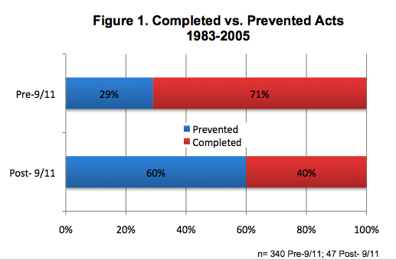Variables Measured Included:
• Ratio of prevented to completed acts of terrorism
• Number of defendants per case
• Average number of counts per indictment
• Percentage of cases resulting in plea agree- ments
• Count severity
• Percentage of non-convicted counts per case
• Conviction rate

Major Findings

The data suggest that the FBI successfully moved
to a more proactive, intelligence focused investiga- tive paradigm after 9/11. The ratio of prevented to completed acts of terrorism shifted dramatically, with the percentage of completed acts decreased
from 71% to 29%, while the percentage of prevented acts increased from 40% to 60% in the post-9/11 era (see Figure 1).

The investigators found that this shift had significant ramifications for federal prosecutors. Efforts to pre- vent terrorism require that investigators intervene earlier than normal. Investigators would have less opportunity to infiltrate groups causing prosecutors to have to indict with less evidence than they might normally like to have. The evidence supported this contention. The percentage of cases involving con- fidential informants (CIs) dropped from 73% to 20% after 9/11. Prosecutors were perhaps forced to indict before the full extent of conspiracies were known

as indicated by a drop in the average number of defendants per indictment after 9/11 (from 3.7 to 1.7 defendants per case) and a decrease in the average number of counts per case (from 13.8 counts to 7.3 counts per defendant after 9/11).

This created difficulties for prosecutors as reflected in the ratio of convicted to unconvicted counts in cases before and after 9/11. Analysis of 323 cases prior to
9/11 revealed that prosecutors obtained convictions on 63% of the counts for which terrorism defendants were indicted. In the four years after 9/11, an analy- sis of 47 terrorism cases from 2001-2005 revealed that terrorists were only convicted of 18% of the counts in these cases.

Despite these dramatic changes, federal prosecutors did not suffer a decline in the overall conviction rate in officially designated terrorism cases. It remained constant at 71% both before and after 9/11, probably due to a dramatic increase in the plea bargain rate among terrorists after 9/11.

6 START Bulletin Fall 2010

