From Extremist to Terrorist: Identifying the Characteristics
of Communities where Perpetrators Live and Pre- Incident Activity Occurs Prior to Attacks

Report to the Resilient Systems Division, Science and Technology Directorate,
U.S. Department of Homeland Security

April 2013

National Consortium for the Study of Terrorism and Responses to Terrorism A Department of Homeland Security Science and Technology Center of Excellence Based at the University of Maryland

8400 Baltimore Ave, Suite 250 •College Park, MD 20742•301.405.6600 www.start.umd.edu

About This Report

The authors of this report are Paxton Roberts, Terrorism Research Center in Fulbright College, University of Arkansas; Kevin M. Fitzpatrick, Department of Sociology and Criminal Justice, University of Arkansas; Brent L. Smith, Terrorism Research Center in Fulbright College, University of
Arkansas; and Kelly R. Damphousse, KayTen Research and Development, Inc.. Questions about this report should be directed to infostart@start.umd.edu.

This research was supported by the Resilient Systems Division of the Science and Technology Directorate of the U.S. Department of Homeland Security through Award Number 2009ST108LR0003 made to the National Consortium for the Study of Terrorism and Responses to Terrorism (START). The views and conclusions contained in this document are those of the authors and should not be interpreted as necessarily representing the official policies, either expressed or implied, of the U.S. Department of Homeland Security or START.

This report is part of a series in support of the Prevent/Deter program. The goal of this program is to sponsor research that will aid the intelligence and law enforcement communities in assessing potential terrorist threats and support policymakers in developing prevention efforts.

About START

The National Consortium for the Study of Terrorism and Responses to Terrorism (START) is supported in part by the Science and Technology Directorate of the U.S. Department of Homeland Security through a Center of Excellence program based at the University of Maryland. START uses state‐of‐the‐art theories, methods and data from the social and behavioral sciences to improve understanding of the origins, dynamics and social and psychological impacts of terrorism. For more information, contact START at
infostart@start.umd.edu or visit www.start.umd.edu.

Citations

To cite this report, please use this format:

Roberts, Paxton, and Kevin M. Fitzpatrick, Brent L. Smith, Kelly R. Damphousse, “From Extremist to Terrorist: Identifying the Characteristics of Communities where Perpetrators Live and Pre-Incident Activity Occurs Prior to Attacks.” Report to the Resilient Systems Division, Science and Technology Directorate, U.S. Department of Homeland Security. College Park, MD: START, 2013.

Contents

Executive Summary .......................................................................................................................................................................... 3

Major Findings ............................................................................................................................................................................... 4

Introduction and Background ...................................................................................................................................................... 6

Methodology and Data .................................................................................................................................................................... 8

Variable Selection ......................................................................................................................................................................... 8

Data ..................................................................................................................................................................................................10

Analytical Method.......................................................................................................................................................................11

Results .................................................................................................................................................................................................11

Analysis of Residential and Pre-Incident Activity and Incident Locations ..........................................................11

Community Characteristics of Locations with Residential or Pre-incident Activity

by Group Type .............................................................................................................................................................................18

Conclusions........................................................................................................................................................................................21

Next Steps...........................................................................................................................................................................................23

Appendices.........................................................................................................................................................................................24

Appendix 1. ...................................................................................................................................................................................24

Appendix 2. ...................................................................................................................................................................................25

Executive Summary

The goal of this project is to identify the characteristics of communities where persons indicted under terrorism related charges lived, planned, and prepared prior to carrying out terrorist attacks. Are there potential markers that can be identified to assist in intervention efforts before violence occurs? Although some research has been conducted on the community characteristics of the locations of terrorist incidents, 1 no empirical examinations have been conducted on the characteristics of the places where residential and pre-incident activities occur. The locations where perpetrators live and conduct pre- incident activity – both planning and preparation – are hypothesized to be different from the places where incidents occur.

The current research tackles this issue with three significant methodological nuances. First, residences and pre-incident activities are examined to verify whether they are located in the same county as the terrorist attacks with which they are associated. Second, this project uses the geocoded addresses of hundreds of known perpetrator residences and pre-incident activity locations to pinpoint the communities in which planning and preparation for terrorist incidents occurred. Third, because communities vary widely in their underlying social structure, census tract-level data are used to assess the characteristics of these locations rather than county-level census data.

Data for this project were extracted from the Terrorism and Extremist Violence in the United States (TEVUS) database. The TEVUS database compiles terrorist and extremist incidents, associated pre- incident activities, court case details, and background information on individual perpetrators and related groups. The information about perpetrators in this study was from the American Terrorism Study (ATS) portion of the TEVUS database, and thus all perpetrators were investigated by the Federal Bureau of Investigation for “terrorism and terrorism-related activities” and indicted in federal district courts. Although the TEVUS database includes indictees from 1980 to present, this project only includes data associated with FBI terrorism incidents from 1990 to 2010. At the time of this project the TEVUS database only included 2000 U.S. Census data. Because of this, our methodology limited the time range of incidents covered to those that occurred within 10 years of the year the Census was taken. To move beyond this time span we felt that the 1990 and 2010 data would be needed.

The locations of residences and pre-incident activities were linked to the 2000 U.S. Census dataset from which variables commonly used in community research were selected and analyzed. A one percent random sample of U.S. Census tracts where no residential or pre-incident activities occurred serves as a control group in order to determine whether there are empirical differences between places where
activity took place and places where it did not.

1 See LaFree, Gary and Bianca Bersani (2012) “Hot Spots of Terrorism and Other Crimes in the United States, 1970 to 20 08 ” Report
to the Human Factors/Behavioral Sciences Division, Science and Technology Directorate, U.S. Department of Homeland Security.

Major Findings

1. Over three-fifths of perpetrator residences and over one-half of pre-incident activities are located in counties different from the location of the subsequent terrorist incidents.

2. Perpetrator residential locations and pre-incident activities are distributed across the United
States, but concentrated on the East and West coasts.

3. Nearly half of all census tracts where perpetrators lived, planned, or prepared for a terrorist incident are located in the western United States, while nearly one-fourth are in the Northeast.

4. These patterns of residential and pre-incident activity vary significantly by group type: al- Qa’ida and Associated Movements (AQAM) terrorist groups’ activities account for over half (56%) of the census tracts with residential or pre-incident activity in the South and two-thirds (67%) in the Northeast. Far-right terrorist groups’ activities account for half (50%) of the census tracts with residential or pre-incident activity in the West and two-thirds (65%) in the Midwest.

5. Census tracts in which perpetrators live or conduct pre-incident activity are generally characterized by lower socioeconomic status, poorer housing conditions, and sociodemographic characteristics that are significantly different than tracts without residential or pre-incident activity. Equally important to note is that these overall patterns vary significantly by group type.

6. The Environmental groups’ activities for the most part occur in areas that are not significantly different from tracts without activity in terms of socioeconomic indicators. However, housing in these tracts tends to be newer, with higher values for owner-occupied homes, a lower percentage of non-white owner occupied housing, and higher percentages of one-person owner occupied housing compared with tracts with no activity. Sociodemographic characteristics are different from tracts without activity in that they have a lower percentage of non-whites, a lower percentage of foreign born, and a higher percentage of married (intact) families.

7. The Far-right groups’ activities occur in census tracts that are generally less affluent than tracts without activity, having a lower average income and more people living below the poverty level. The housing characteristics show that these tracts are lower than tracts without activity in both rental and owner-occupied values. Sociodemographically these tracts are less diverse, with a lower percentage of foreign born than tracts without activity.

8. The AQAM groups’ activities occur in census tracts that have lower incomes among families with children, higher unemployment, and more households living below the poverty level than tracts without activity. In terms of housing, AQAM operates in places where on average the housing is older but rent and home values are above those in tracts without activity. These tracts generally have a much higher percentage of non-white residents and one-person owner occupied houses. Compared with tracts without activity, these tracts are more urban, have a higher percentage of foreign-born residents, and a lower percentage of married families.

Introduction and Background

Building upon past exploratory research, the Terrorism Research Center (TRC) at the University of Arkansas conducted a preliminary examination at the census tract level of the characteristics of U.S. communities where perpetrators lived, planned, and prepared for their terrorist attacks. This effort was conducted primarily to: a) determine the appropriate type of location data to analyze for this project from the Terrorism and Extremist Crime in the United States (TEVUS) database, b) identify the community characteristics of areas where perpetrators lived, planned, and prepared for attacks, and c) reveal any variations in the community characteristics of the locations of activity both within and between different types of terrorist groups. These descriptive analyses seek to provide some insight into the characteristics of U.S. communities where perpetrators live and plan prior to conducting terrorist attacks.

In 2009, the Human Factors/Behavioral Sciences Division (HFD)2 of the Department of Homeland Security (DHS) Science and Technology Directorate funded a five-year project to integrate terrorism- related datasets developed by the University of Maryland (UMD), Michigan State University/John Jay College CUNY (MSU/CUNY), and the University of Arkansas (UA)3. The Terrorism and Extremist
Violence in the United States (TEVUS) database, funded through the National Consortium for the Study of
Terrorism and Responses to Terrorism (START), merges the UA American Terrorism Study (ATS), the MSU/CUNY Extremist Crime Database (ECDB), and the UMD Global Terrorism Database (GTD) with data from the U.S. Census. This relational database allows for analysis of records from one or more of the original datasets, and when sufficient location information is present, analysis can make use of census information for those locations. For this project, data were selected from TEVUS that originated from the ATS database.

The ATS database was created in 1988 with the cooperation of what was then called the Federal Bureau of Investigation’s (FBI) Terrorism Research and Analytical Center. The original database was designed to collect and code data from court case records on all persons indicted since 1980 on terrorism-related charges in federal criminal cases that resulted from an official FBI “terrorism” investigation.4 From 2003 to 2009, the TRC expanded the research through a series of studies for the National Institute of Justice (NIJ) in which the ATS dataset was modified to capture the activities of perpetrators while planning and carrying out their attacks.5 In order to analyze spatial and temporal patterns of incidents and associated
pre-incident activities (both ancillary and preparatory) the size of the dataset was increased from 80 to

2 This Division has since become part of the Resilient Systems Division (RSD).
3 DHS Grant Award Number 2009-ST-108-LR0003 “Creation and Analysis of an Integrated U.S. Security Database”
4 The study specifically includes only those cases resulting in indictment under a “terrorism enterprise” investigation under t he “Criminal Intelligence” section of the Attorney General Guidelines on General Crimes, Racketeering Enterprises, and Domestic Security/Terrorism Investigations and subsequent editions (1983, 1989, 2002) or in the case of international terrorists, those persons indicted in federal courts as a result of investigation under the Attorney General Guidelines for FBI Foreign Intelligence Collection
and Foreign Counterintelligence Investigations.
5 Pre-Incident Indicators of Terrorist Activities, NIJ grant #2003-DT-CX-0003; Geospatial Analysis of Terrorist Activities, NIJ grant
#2005-IJ-CX-0200; Terrorism in Time and Space, NIJ grant #2006-IJ-CX-0037.

more than 300 variables.6 During these projects, additional terrorism incidents that met the FBI definition of terrorism were added to the dataset from sources other than the court cases found in the original FBI lists.7 These sources include the Department of Justice, Executive Office of U.S. Attorneys, and open source media.

In addition to incident-, pre-incident activity-, and perpetrator-level analyses, the structure of the TEVUS database allows for analysis by the type of terrorist group or ideology with which the perpetrator was associated. The TEVUS database includes the following terrorist group types. Far-left groups include, for example, Marxist and anarchist groups such as the Weather Underground (WU) and the May 19th Communist Organization (M19CO), and Puerto Rican separatist groups such as the Macheteros and the Fuerzas Armadas de Liberación Nacional (FALN). Far-right groups include groups such as the Order, the Washington State Militia, and Mountaineer Militia. This category also includes assorted far-right single actors such as Timothy McVeigh and Terry Nichols, and abortion clinic bombers such as Eric Rudolph. International groups include such disparate groups as the Provisional IRA, the Japanese Red Army, and al-Qa’ida and Associated Movements (AQAM). Finally, environmental groups include groups such as the Animal Liberation Front and the Earth Liberation Front.

Past analysis has shown significant differences between perpetrators associated with different types of terrorist groups or ideologies in terms of their demographic characteristics and the spatial and temporal patterns of their activities. For example, the average age at indictment for environmental perpetrators is
27, compared to 35 for AQAM perpetrators and 40 for far-right perpetrators. Environmental groups also
have higher percentages of female members with 39 percent, compared to five percent and 11 percent female members respectively in AQAM and far-right groups. Additionally, analysis indicates significant differences in the educational background of perpetrators with almost 75 percent of environmental perpetrators having college degrees compared to 31 percent of the AQAM and 10 percent of the far-right perpetrators. Environmental perpetrators tend to be younger, more egalitarian, and better educated than members of other terrorist groups. Demographically, they resemble the far-left terrorist groups of the
1960’s and 1970’s.

Finally, spatial analysis of environmental perpetrators’ activities reveals that almost 45 percent of their targets are located within 30 miles of where they were living during the planning process and almost 60 percent are located within 90 miles. In contrast, less than 50 percent of the targets of AQAM and far-right perpetrators are located less than 90 miles from their residences. Additionally, significant differences in
distances between locations appear when examining the relationship between preparatory activity

6 “Incidents” also refer to terrorist incidents that were prevented by law enforcement. These planned, but not successful incidents were recorded when a target could be identified from court records or open source data collection. Pre-incident or “antecedent” activities are further divided into: ancillary and preparatory behaviors. Preparatory activities include those behaviors tha t can clearly be linked to preparation for a specific terrorist incident or planned incident. If this criterion cannot be confirmed, an activity is recorded as “ancillary.” A full listing of events that can be categorized as antecedent events is included in Appendix 1.
7 Terrorism is defined in the Code of Federal Regulations as “the unlawful use of force and violence against per sons or property to intimidate or coerce a government, the civilian population, or any segment thereof, in furtherance of political or social obj ectives” (28
C.F.R. Section 0.85).

locations and target locations. A total of 62 percent of the environmental perpetrators’ preparatory activity locations are within 30 miles of the target, while only 34 percent of AQAM and far-right perpetrators’ preparatory activity locations are within that distance. Clearly, environmental terrorist groups are not only different in composition, but also in the type of targeting and activity they engage in compared to other types of terrorist groups.

Methodology and Data

Variable Selection

For the purposes of this study, three types of locations were selected from the ATS portion of the TEVUS database to assist in examining the characteristics of communities where perpetrators planned and prepared prior to committing terrorist acts: (1) the actual or planned terrorist incident locations, (2) the locations where perpetrators prepared for their incidents, and (3) the residential locations of perpetrators. As discussed above, results from previous DHS and NIJ projects reveal that the characteristics of terrorist group members and their pre-incident patterns of behavior vary significantly based on group type. Therefore, in addition to an examination of the overall characteristics of communities where residential and pre-incident activity occurred, separate analyses were conducted for the following terrorist group types – environmental, far-right, and AQAM.8

A systematic analysis of the differences between these types of groups is an important component of any comprehensive examination of terrorism and perpetrator residential and pre-incident activity. This analysis underscores the importance of not merging all perpetrators together into one group, but carefully developing a typology and examining distinct differences among types of groups in relation to the communities where they lived, planned, prepared, and attacked. In addition, while cataloguing differences in the locations of residential and pre-incident activity, it was also essential that a control group of locations be constructed for comparison. Thus, we drew a one percent random sample from the remaining tracts in the United States that experienced no residential or pre-incident activity, creating a “tracts without activity” group of census tracts. This comparison group is crucial to one of our central research questions – What is the nature of communities where residential and pre-incident activity take place, and how are these communities different from places where no activity is recorded?

Because the first year of this study was largely exploratory, we selected forty variables (Table 1) from the
2000 U.S. Census data to capture community characteristics related to socioeconomic status (SES), housing, and sociodemographic factors. These are major constructs that urban researchers have identified as structural features of communities that are important to determining quality of life and also identifying areas of risk (health, crime, etc.). To detect potential correlates between community
characteristics and the locations of residential or pre-incident activity, census variables relating to SES,

8 We focused on these group types because they clearly emerged as the most significant terrorist groups during the 1990 to 2010 time period covered by this study in terms of number of indictments.

housing stock, urbanized development, race/ethnic composition, education and work composition, and region were analyzed.

Table 1. Selected U.S. Census 2000 Variables

CENSUS VARIABLE DESCRIPTION

SES
P053001 Median Income Household
PCT039001 Median Income Family Total
PCT039002 Median Income Family with Child Under 18yrs PCT03900 Median Income Family with No Child Under 18yrs Pcthsgrad Percent of High School Graduates
Pctunemmale Percent of Unemployed Males
Pctunemfemale Percent of Unemployed Females
Pctunemp Percent of Unemployed
Pcthssi Percent of Households on Supplemental Security Income (SSI) Pcthspubasst Percent of Households on Public Assistance
Pctblpoverty Percent of Households Living Below the Poverty Level
Pctforborpov Percent of Foreign-Born Persons Living Below the Poverty Level
Housing
H035001 Median Year Structure Built
H063001 Median Gross Rent
H085001 Median Home Value for All Owner Occupied Units
HCT020001 Median Real Estate Taxes at Tract Level Pctvacant Percent of Vacant Housing Units Pctownocc Percent of Owner Occupied Housing Units
Pctnwownocc Percent of Non-White Owner Occupied Housing Units
Pctoneperocc Percent of One-Person Owner Occupied Housing Units
Pctonedetach Percent of One-Person Owner Occupied Detached Housing Units
Sociodemographic
Pcturban Percent Living in Urbanized Areas
Pctnonwh Percent Non-White Pctmarfam Percent Married Families Pctothfam Percent Other Family Types Pctnative Percent Native Born Pctforborn Percent Foreign Born
Pctmarcoupwk Percent of Families Married Couple with Kids
Pctfathonly Percent of Families Father Only with Kids
Pctmotonly Percent of Families Mother Only with Kids
Race Race

In order to first determine if any regional variations existed in the locations of census tracts where perpetrators engaged in residential or pre-incident activity compared to those where they did not, the four major Census regions – Northeast, Midwest, South, and West (see Appendix 2 for a list of states in each region) – were utilized. This provided a snapshot of tracts with activity by region and allowed for assessment of possible relationships between geographical region and the community characteristics of

tracts with and without activity. Analyses also provided a more detailed examination of community characteristics at the census tract level by examining differences based on region and group type.

Data

The complete ATS portion of the TEVUS database includes perpetrators indicted in federal courts from
1980 to the present, although the range of cases analyzed for this report is more limited due to the
Census data currently available in TEVUS. The ATS dataset now contains over 437 terrorist incidents,
3,099 pre-incident activities, and 1,162 perpetrators including associated residential locations, as well as the dates activities occurred. Most importantly for this project, these data include the geocoded addresses of 376 locations where various perpetrators lived at some point prior to an incident, 457 pre- incident activity locations, and 247 incident locations. Researchers at the TRC with support from the Center for Advanced Spatial Technologies (CAST) at the University of Arkansas matched the geocoded locations of incidents, residences, and pre-incident activities with census tract-level data from the 2000
U.S. Census. Using the Oracle 11g spatial statistics package, the tract-level census data were extracted for all the geocoded locations of the pre-incident activities, the residences, and the incidents.

At the beginning of this project only the 2000 U.S. Census information was available in the TEVUS dataset, (1980, 1990, or 2010 had not yet been included) so this project only incorporated data associated with incidents from the time period 1990 through 2010. From this time frame a total of 247 incidents had sufficient spatial and temporal information to be selected for analysis. However, for inclusion in this
study there had to be related residential and pre-incident activity records with sufficient location data as well. After eliminating non-suitable incidents there were 144 incident locations available for analysis.

Residential locations suitable for analysis totaled 272 address records. 9 There were 442 pre-incident activities (both ancillary and preparatory in nature) suitable for inclusion in these analyses (examples of pre-incident activities included in the analyses are available in Appendix 1). In some cases, a location represented both a residential address and a pre-incident activity location when a house or apartment was used for meetings in the course of planning for an attack. For this project, we chose to analyze the census tracts based upon whether residential or pre-incident activity did or didn’t occur and thus eliminated any duplicate tracts before running the analysis. Residential and pre-incident activity locations were reduced down to unique census tracts of 176 and 209 respectively. These files were combined, and any duplicate tracts between the two files were eliminated. This left 343 census tract records with residential or pre-incident activity for analysis. The control group consisting of a one
percent random sample of census tracts without activity equaled 577 tracts.

9 It is important to note that if three perpetrators from a specific case were all staying at the same residence, then this add ress would be included three times in the database. Additionally, some perpetrators used more than one address prior to the incident or pl anned incident, and all of these addresses are included. For this analysis there were 222 unique address locations.

Analytical Method

For residential and pre-incident activity locations, the relationship between place characteristics and group type were examined using separate categorical, bivariate analyses. First, independent samples of means tests (t-tests) were used to establish differences between tracts that had residential or pre- incident activity compared to those that had no activity. Regional variations were noted, and their significance was established using Chi-square tests while the strength of the associations was examined using Cramer’s V. Second, one-way analysis of variance (ANOVA) was used to identify specific community characteristics and their differences across the activities of three terrorist group types
(environmental, far-right, and AQAM) and the control group of tracts without activity. Thus, the intention was to first establish simple distributional differences at the regional level, and then to examine more carefully the places associated with these terrorist groups’ activities, focusing on a set of community characteristics that typically have been used by community researchers to describe the multidimensional nature of place.

Results

This preliminary research provides analysis of the census tracts where residential or pre-incident activities were mapped using data available in the 2000 U.S. census. Our basic theoretical argument is that “place matters.” Context matters not only at the more aggregate, regional level, but analyses clearly reveal that there are important differences in the location characteristics at the tract level as well. The results first show the spatial relationship between residential and pre-incident activity and their associated incident locations to reveal whether they occur in the same county. Next, the spatial distribution of tracts with residential or pre-incident activity are examined, detailing regional variation in their locations including a breakdown by perpetrator group type. Finally, the characteristics of tracts
with activity are compared to tracts without activity both overall and by group type. The results are
divided into four sections relative to this overall theme: 1) Analysis of Residential and Pre-incident Activity and Incident Locations; 2) Spatial Distribution of Locations with Residential or Pre-incident Activity (Figures 1-4); 3) Community Characteristics of Locations with Residential or Pre-incident
Activity (Tables 2-4); 4) Community Characteristics of Locations with Residential or Pre-incident Activity by Group Type (Tables 5-7).

Analysis of Residential and Pre-Incident Activity and Incident Locations

The relationship between the location of terrorist incidents and the places perpetrators were living or preparing prior to the attack is necessary to establish in order to determine which location data to use to identify community characteristics where intervention efforts could be directed. The length of time individuals plan their attacks varies, resulting in the time spent in these communities ranging from many

years to several days. Discerning whether the planning and preparation process happens in the same community as the incident location is one important step forward in setting the stage for further analysis.

In order to determine whether incidents and associated residential and pre-incident activity were occurring in the same area, we first identified the state and county Federal Information Processing Standard (FIPS) codes for all residences, pre-incident activity, and incident locations with sufficient spatial data. Then those locations were analyzed to determine what percentage of residential and pre- incident activities occurred in the same county as an incident. The result of this analysis showed that almost two-thirds (61%) of perpetrator residences in the database were located in counties where no incident occurred. This is an important methodological finding. Although in our previous research, we found that approximately 40 percent of perpetrators lived, planned, and prepared for their activities within 30 miles of the incident location, that does not translate into assuming that incidents occurred in the same counties where the perpetrators lived, planned, and prepared for them. In a majority of cases, pre-incident activities and residences were in counties different than the incident locations. For pre- incident acts, this percentage was slightly over half (51%). In addition because over a third (40%) of residences were in the same county as associated pre-incident activity, we chose to use the census tract as the unit of analysis. This allows sub-county level differences in communities to be examined while maintaining the ability to aggregate to the county level if needed.

Spatial Distribution of Locations with Residential or Pre-incident Activity

Analysis revealed a clear patterned difference in the locations of perpetrator residential or pre-incident activity around the United States (Figure 1). 10 As the map clearly shows, activity is widely distributed across the United States, yet clearly there are concentrations close to the East and West coasts. 11 By mapping these locations we see that location does matter, as residential and pre-incident activity is not
randomly dispersed across the United States.

10 Due to the small size of census tracts these data were aggregated to the county level for graphic display in this report. However, all of the analyses were conducted at the census tract level.
11 These maps do not represent the amount of activity in census tracts, but whether activity simply occurred.

Figure 1. Census Tracts with Residential or Pre-incident Activity at the County Level

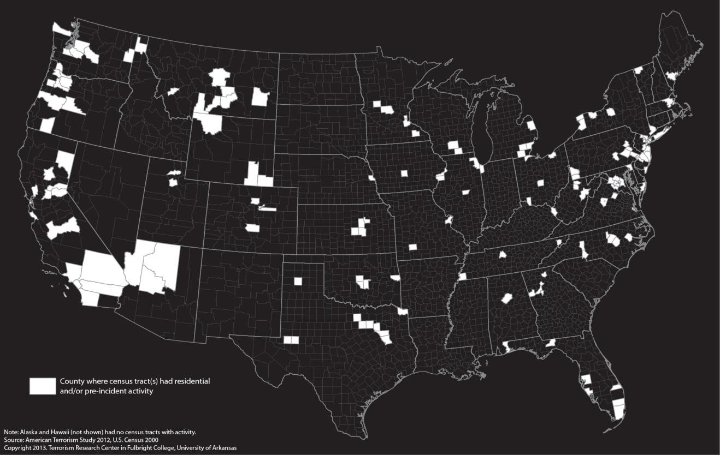

Further showing the geographic dispersion of residential and pre-incident activity, Figure 2 indicates that almost half (46%) of the census tracts with activity were found in the Western region of the United
States. The Northeast had the second largest number of census tracts with activity (23%) followed by the
South (16%) and the Midwest (15%). The concentration of residential and pre-incident activity in both coastal regions of the United States may not come as a surprise since this is where the largest centers of population concentration can be found. However, these patterns are important in that they show again that these locations do not occur equally across the United States.

Figure 2. Regional Variation in Locations with Residential or Pre-incident Activity

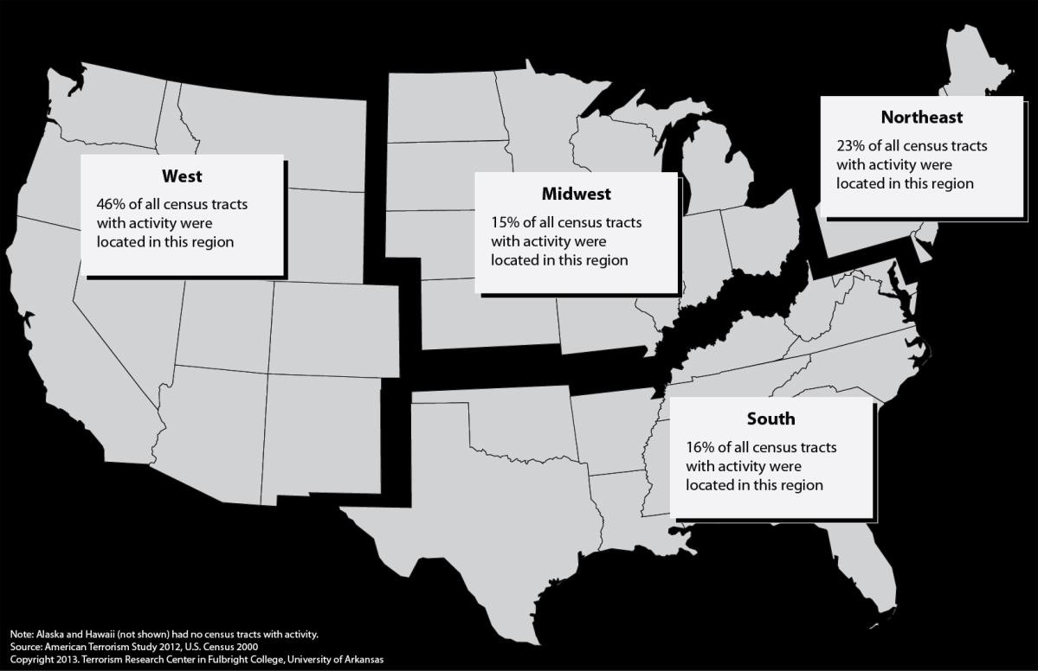

Figures 3 and 4 show how the residential and pre-incident activity locations of different categories of perpetrators are distributed differently within and between regions in the United States. For example, although 46 percent of census tracts with activity are located in the West, Figure 3 reveals that 50 percent of these tracts experienced far-right perpetrator activity, 30 percent environmental perpetrator activity, and 20 percent AQAM perpetrator activity. This suggests that far-right perpetrators operated over a wider geographic area in the Western region than either the environmental and AQAM groups.

Looking at the other regions, we see that far-right perpetrators also were active in a larger number of census tracts that experienced activity in the Midwest (65%), with AQAM perpetrators active in only 31 percent, and environmental perpetrators active in only four percent. This pattern reverses when looking at other regions; AQAM perpetrator activities accounted for 67 percent of the tracts with activity in the Northeast and 56 percent in the South. These patterns demonstrate that the residential and pre-incident activity of different types of terrorist groups is not evenly distributed across the regions of the U.S. Although not necessarily indicative of quantity, certain groups live, plan, and prepare more in some regions of the country than others. This analysis serves to make the case that knowing the “type of terrorist group” is a critical element when characterizing the communities where residential and pre- incident activity occurs.

Figure 3. Within Region Variation in Locations with Residential or
Pre-incident Activity

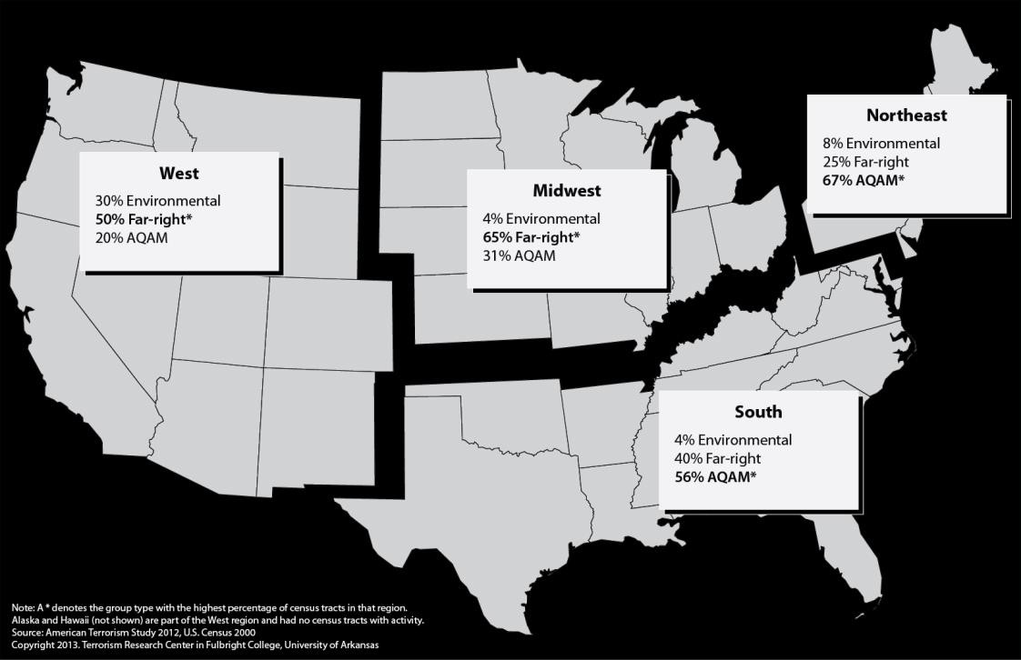

Figure 4. Regional Variation Locations with Residential or Pre-incident
Activity by Group

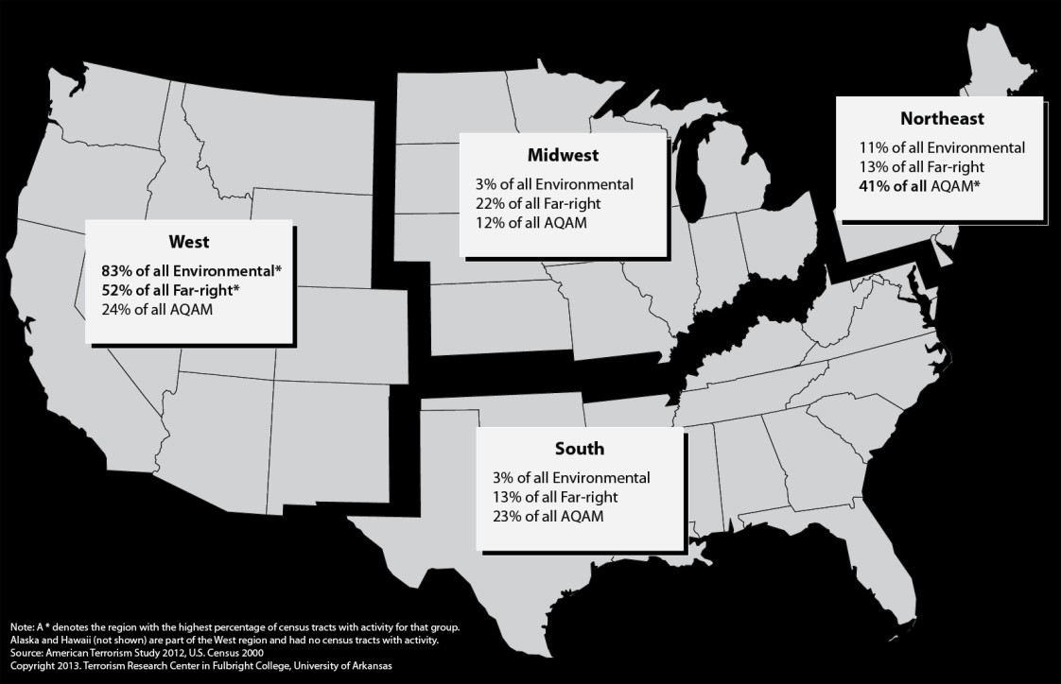

Analysis of the locations of census tracts with activity by type of group shows important differences not just within region, but also between regions. Figure 4 shows these differences across regions for each type of group studied. The vast majority of census tracts with environmental perpetrator residential and pre-incident activity (83%) were found in the West. This region also had the highest percentage of tracts with far-right perpetrator activity, with more than half these tracts (52%) found in the West. Tracts with AQAM perpetrator activity were more distributed across the regions but were most common in the Northeast, the location of 41 percent of all tracts that experienced the activities of this type of group. Substantively, this analysis suggests that different types of terrorist groups act in specific areas of the United States. These patterns could be crucial in designing intervention efforts by law enforcement that focus on where perpetrators live and operate rather than where the terrorist incidents take place.

Community Characteristics of Locations with Residential or Pre-incident Activity

Utilizing a set of community characteristics that have commonly been used to understand the
relationship between crime and place,12 a preliminary examination revealed significant differences in the characteristics of the census tracts with and without residential or pre-incident activity. Independent sample t-tests and one-way ANOVA were used to analyze the selected variables (Table 1) from the 2000
U.S. Census. Out of the forty variables selected, sixteen showed significant differences between tracts with and without activity.

Socioeconomic status indicators were analyzed for tracts with residential or pre-incident activity and then compared to the control group of tracts where no known activity took place (Table 2). The results show that median income indicators for households and families are significantly lower in tracts with activity compared to those without. The percentage of high school graduates is also lower in these tracts. Analysis of unemployment variables shows that unemployment rates in tracts with activity is
significantly higher than in tracts without activity. As a result, it is also not surprising that the percentage
of households living below the poverty level are significantly higher than in tracts without activity. Although the raw dollar figures and percentage differences between tracts with and without activity are not large (1 to 2%), the differences are statistically significant.

12 See Derek J. Paulsen and Matthew B. Robinson. 1994. Spatial Aspects of Crime: Theory and Practice. Boston MA: Allyn and
Bacon.

Table 2. SES Characteristics of Tracts with and without Residential or Pre-incident Activity

Census Variables- SES | Tracts with  Activity | Tracts w/out  Activity
Median Income Household | $41,032** | $44,667
Median Income Family Total | $48,613* | $51,914
Median Income Family W Child under 18yrs | $45,418*** | $51,105
Median Income Family No Child under 18yrs | $51,310 | $53,095
Percent of High School Graduates | 27%** | 29%
Percent of Unemployed Male | 5%** | 4%
Percent of Unemployed Female | 4%* | 3%
Percent of Unemployed | 9%** | 7%
Percent of Households on SSI Income | 5% | 5%
% Households on Public Assistance | 4% | 4%
% Households Living Below Poverty Level | 15%*** | 13%
Percent of Foreign Born Persons Living Below the Poverty  Level | 20% | 18%
* p < .05; ** p < .01; *** p < .001; independent samples t-test

Table 3 shows the results from analyzing the housing block of census variables for tracts with and without residential or pre-incident activity. The analysis of this group of variables does not reveal as many statistically significant differences as the analysis of SES group of variables. However, percentages of owner occupied housing units, one-person owner occupied housing units, and one-person owner occupied detached housing units are all significantly different for tracts with and without activity. For owner occupied housing units and one-person owner occupied detached housing units, results show significantly lower ownership rates (11% and 12% lower respectively) for tracts with activity compared to the tracts without activity. However, the percentage of one-person owner occupied housing units is significantly higher (6%) in tracts with activity; this substantively means that the one-person owner occupied non-detached housing units that are included in this category are responsible for the direction of this difference.

Table 3. Housing Characteristics of Tracts with and without Residential or Pre-incident Activity

Census Variables- Housing | Tracts with  Activity | Tracts w/out  Activity
Median Year Structure Built | 1959 | 1966
Median Gross Rent | $647 | $645
Median Home Value for All Owner Occupied Units | $143,507 | $135,653
Median Real Estate Taxes at Tract Level | $1,548 | $1,583
Percent of Vacant Housing Units | 8% | 9%
% Owner Occupied Housing Units | 55%*** | 66%
% Non-white Owner Occupied Housing Units | 24% | 23%
% One-Person Owner Occupied Housing Units | 31%*** | 25%
% of One-Person Owner Occupied Detached Housing Units | 49%*** | 61%
* p < .05; ** p < .01; *** p < .001; independent samples t-test

Table 4 reveals the differences between tracts with and without residential or pre-incident activity for
the sociodemographic group of census variables. The results show that overall, activity occurred in tracts that were significantly more urbanized (12% higher), had a higher percentage of non-traditional family types (2% higher), and a higher percentage of foreign born (3% higher) than tracts without activity. It is important to note that these and the previously discussed findings change somewhat when group type and region are included in the analysis. An example of this is that the higher percentage of foreign born
in tracts with activity are mainly the result of tracts with AQAM perpetrator activities.

Table 4. Sociodemographic Characteristics of Tracts with and without Residential or Pre-incident Activity

Census Variables- Sociodemographic | Tracts with Activity | Tracts w/o Activity
Percent living in urbanized areas | 85%*** | 77%
Percent Non-white | 28% | 26%
Percent Married Families | 73%* | 75%
Percent Other Family Types | 27%* | 25%
Percent Native Born | 86%* | 89%
Percent Foreign Born | 14%* | 11%
Percent of Families Married Couple with  Kids | 36% | 35%
Percent of Families Father Only with Kids | 16% | 18%
Percent Families Mother Only with Kids | 48% | 47%
* p < .05; ** p < .01; *** p < .001; independent samples t-test

In summary, the analysis of census tracts with and without residential or pre-incident activity revealed that overall, census tracts with activity are generally characterized by a lower socioeconomic status, poorer housing conditions, and sociodemographic characteristics that are significantly different from tracts without activity. This finding should not be overlooked – place matters, and without this comparison group it would be difficult to talk with any authority about the characteristics of the locations with activity. These findings only begin to reveal the complex picture of the characteristics of communities with residential and pre-incident activity, and when group type and regional variations are analyzed, the patterns become clearer.

Community Characteristics of Locations with Residential or Pre-incident Activity by Group Type

Patterns found between tracts with and without residential or pre-incident activity are somewhat different when group type is introduced as a variable. Out of the forty variables selected, sixteen showed significant differences between tracts with and without activity, but when group type was introduced – twenty-six of the variables were significant. The introduction of group type also reveals a clearer picture of just how much difference can exist between tracts with and without activity. Although the mean percentage of high school graduates in tracts with activity is on average two percent lower than that of

the tracts without activity, tracts where environmental and AQAM perpetrator activity occurs are on average four percent and five percent lower than tracts without activity. In contrast, tracts where far- right perpetrator activity occurs are not significantly different from tracts without activity. This finding demonstrates that we need to be extremely careful in drawing generalizations about characteristics of tracts where residential and pre-incident activity occurs when group type is not considered in the analysis.

Overall, for the socioeconomic status (SES) variables (see Table 5), tracts where far-right perpetrator activity took place have on average statistically lower incomes and a higher percentage of households living below the poverty level when compared to tracts that didn’t have activity. Tracts in which AQAM perpetrator activity occurs are on average significantly different than tracts without activity and are characterized by a lower percentage of high school graduates, lower income for families with children, and a higher percentage of persons who are unemployed or who are on supplemental security income.

One of the most significant findings in this analysis is that census tracts where AQAM and far-right perpetrator activity occur generally have a higher percentage of persons living below the poverty level (4% and 2% higher respectively) than tracts without activity. However, tracts with AQAM activity have a much higher percentage of foreign-born persons living below the poverty level – 31 percent or almost double that of census tracts without activity (18%) and tracts with far-right perpetrator activity (14%).

For the tracts with environmental perpetrator activity, the SES characteristics are more similar to the tracts without activity than are either the tracts where AQAM or far-right perpetrator activity occurs.
The only significant differences are that there is a lower percentage of high school graduates and a higher percentage of unemployed females in tracts with environmental perpetrator activity than in tracts without activity.

Table 5. SES Characteristics of Tracts with and without Residential or Pre-incident Activity by
Group Type

Census Variables- SES Environmental Far-right AQAM Tracts w/out
Activity

Median Income Household | $45,538 | $37,358*** | $43,446 | $44,667
Median Income Family Total | $55,591 | $44,586*** | $50,341 | $51,914
Median Income Family W Child under 18yrs | $53,536 | $45,429*** | $45,429* | $51,105
Median Income Family No Child under 18yrs | $55,492 | $47,129*** | $54,437 | $53,095
Percent of High School Graduates | 25%** | 30% | 24%*** | 29%
Percent of Unemployed Male | 5% | 5% | 6%*** | 4%
Percent of Unemployed Female | 4%* | 4% | 4%** | 3%
Percent of Unemployed | 9% | 8% | 9%** | 7%
Percent of Households on SSI Income | 4% | 5% | 6%** | 5%
% Households on Public Assistance | 3% | 4% | 4% | 4%
% Households Living Below Poverty Level | 12% | 15%* | 17%*** | 13%
* p < .05; ** p < .01; *** p < .001; ANOVA

Table 6 examines the housing block of census variables analyzed for tracts with residential or pre- incident activity and tracts without activity by group type. Looking at the percentage of owner-occupied housing units, we see that significant differences between tracts with and without activity are most evident for the AQAM perpetrators. Tracts with AQAM perpetrator activity have a statistically significant lower percentage of owner-occupied housing units (19% lower) than tracts without activity. In addition to a lower percentage of owner occupied housing units, tracts with AQAM activity have older structures, higher gross rents, and higher percentages of non-white owner occupied housing units than tracts without activity. Although the communities are older and home values significantly higher in tracts with AQAM activity, these areas have high percentages of multi-family or apartment residences that are one-
person owner occupied versus detached single homes occupied by families. Table 6 also shows that tracts
with environmental perpetrator residential or pre-incident activity have significantly newer structures, higher median home values and real estate taxes, and a higher percentage of one-person owner occupied housing units than tracts without activity. Also compared with tracts with both environmental and AQAM perpetrator activity and tracts without activity, the tracts where far-right perpetrator activity occurs have much lower home values (20% lower) and lower gross rents (15% lower).

Table 6. Housing Characteristics of Tracts with and without Residential or Pre-incident Activity by
Group Type

Census Variables- Housing | Environment  al | Far-right | AQAM | Tracts  w/out  Activity
Median Year Structure Built | 1971** | 1966 | 1947** | 1966
Median Gross Rent | $704 | $550*** | $738*** | $645
Median Home Value All Owner  Occupied Units | $177,744** | $108,482*  ** | $171,824**  * | $135,653
Median Real Estate Taxes at Tract  Level | $1,917* | $1,211*** | $1,786 | $1,583
Percent of Vacant Housing Units | 8% | 9% | 7%* | 9%
% Owner Occupied Housing Units | 63% | 59%*** | 47%*** | 66%
% Non-white Owner Occupied  Housing | 12%** | 18%* | 36%*** | 23%
% One-Person Owner Occupied  House | 28%* | 31%*** | 31%*** | 25%
% of One-Person Owner Occupied  Detached Housing Units | 60% | 55%** | 36%*** | 61%
* p < .05; ** p < .01; *** p < .001; ANOVA

Finally, Table 7 shows that the sociodemographic group of variables exhibit considerable variability among tracts with residential or pre-incident activity and tracts without activity by group type. The percentage of foreign born in tracts with activity is on average higher, but the pattern changes drastically

when group type is introduced. Census tracts where environmental and far-right perpetrator residential and pre-incident activities are located tend to be very homogeneous with only eight percent and nine percent foreign-born, respectively. Both of these figures are below the national average for tracts without activity (11%). Census tracts where AQAM activity occurred reveal a very different pattern. On average, foreign-born persons make up nearly one-fourth of the population (23%) in the census tracts with AQAM activity, more than double the tracts without activity (11%). In addition, tracts with AQAM activity have a higher percentage of the population living in urbanized areas – almost 20 percent higher on average – than the tracts without activity.

Table 7. Sociodemographic Characteristics of Tracts with and without Residential or Pre-incident
Activity by Group Type

Census Variables-  Sociodemographic | Environment  al | Far-right | AQAM | Tracts  w/out  Activity
Percent Living in Urbanized Areas | 74% | 81% | 96%*** | 77%
Percent Non-White | 15%* | 22% | 40%*** | 26%
Percent Married Families | 80%* | 73% | 69%*** | 75%
Percent Other Family Types | 20%* | 27% | 31%*** | 25%
Percent Native Born | 92%* | 91%* | 77%*** | 89%
Percent Foreign Born | 8%* | 9%* | 23%*** | 11%
Percent of Families Married Couple with Kids | 39% | 33% | 39% | 35%
Percent of Families Father Only with  Kids | 13% | 18% | 16% | 18%
Percent Families Mother Only with  Kids | 48% | 49% | 46% | 47%
* p < .05; ** p < .01; *** p < .001; ANOVA

Conclusions

In summary, our findings suggest several notable patterns regarding how “place matters” in understanding the locations of residential and pre-incident activities conducted by perpetrators. While these results are preliminary, the tract and regional data appear to be suggesting that communities where activity occurs vary not only by region but also by the group type engaging in the activity. It is not yet clear exactly how much, and to what extent, place influences decision-making and strategy. Nevertheless, we do know that certain types of groups appear to be planning and preparing for incidents in communities with certain regional and local characteristics and that these patterns are detectable. Below are several important findings from these analyses:

1) Preliminary analysis showed that almost two-thirds of residences and one-half of pre-incident activities are located in a different county than incidents. This has two important ramifications for this and future research:

a. First, this finding necessitates separating out incident locations as they represent the end point, goal, or outcome of the pre-incident activity and may be totally unrelated to the communities in which these activities take place.

b. Second, it makes the case for using census tract-level data when analyzing how community characteristics might be related to the locations of residential and pre- incident activity. When a third to half of the activities occur in the same county, then analyzing sub-county variation would appear to be crucial to understanding where activity occurs. Depending on the location within the United States, a county could be a comprised of many heterogeneous pockets of wealth and diversity, but when using county-level variables, it is treated as if it is homogeneous.

2) This research has also shown the necessity of analyzing the characteristics of tracts where activity occurs by group type. From these analyses we see that activity is not evenly
distributed across the United States, and when this activity is broken out by group type, we see that very different patterns emerge by region.

3) Overall, this research has shown a need for carefully examining community differences in the locations where residential and pre-incident activities occur while taking into account both regional variation and differences based on group type. Analyzing community characteristics that reflect neighborhood composition is critical to understanding these differences; SES, housing, and sociodemographic composition are all important in distinguishing communities where activity does and does not occur, as well as identifying differences across communities were the activities of different types of groups occur. Finally, we can summarize the complexity of these differences in the following way:

a. The Environmental groups’ residential and pre-incident activities for the most part occur in areas that are not significantly different from tracts without activity in terms of socioeconomic indicators. Housing in these tracts tends to be newer, with higher values for owner-occupied homes, a lower percentage of non-white owner occupied housing, and higher percentages of one-person owner occupied housing compared with tracts with no activity. Finally, the sociodemographic characteristics of these tracts resemble closely tracts without activity in terms of the percentage living in urbanized areas and the percentage of families with kids. However, they are different from tracts without activity in that they have a lower percentage of non-whites, a lower percentage of foreign born, and a higher percentage of married (intact) families.

b. The Far-right groups’ activities occur in census tracts that are generally less affluent than tracts without activity, having a lower average income and more people living below the poverty level. The housing characteristics show that these tracts are lower than tracts without activity in both rental and owner-occupied values. Sociodemographically these tracts are less diverse, with a lower percentage of foreign born than tracts without activity.

c. The AQAM groups’ activities occur in census tracts that have lower incomes among families with children, higher unemployment, and more households living below the poverty level than tracts without activity. In terms of housing, AQAM operates in places where on average the housing is older but rent and home values are above those in tracts without activity. These tracts generally have a much higher percentage of non- white residents and one-person owner occupied houses. Compared with tracts without activity, these tracts are more urban, have a higher percentage of foreign-born
residents, and a lower percentage of married families.

While “place matters” as a general rule regarding the location of residential and pre-incident activity across group type, understanding the nuances at the regional and community (tract) levels is complex. Nevertheless, this report advances our understanding of important contextual variation in the locations of residential and pre-incident activity at both the regional and local levels.

Next Steps

To fully understand the divergence in the characteristics of those tracts where activity occurs from those where it doesn’t, a regional approach is needed in examining the census variables selected for this project. Preliminary analyses show that in some cases what appears to be a strong divergence from the average tract without activity at the national level exists only in a specific region of the country and then only for one or, in some cases, more than one type of group. These differences will be explored in multi- ANOVA analyses that examine the interaction of group and region of the country. Additionally, future research will include separating out residences and pre-incident activities and running these types of locations separately in multi-ANOVA analyses that control for region and group type. Additionally, the types of residential locations will be examined to see if temporal information is sufficient to allow for the categorization of whether a residence was a long-term, permanent residence or one utilized solely in preparation for an attack. This could be crucial in truly identifying the community characteristics where extremists live prior to committing violent actions and terrorist attacks. Plans also include using the
1990 and 2010 Census data in order to extract values closer to the dates the activities occurred.

Appendices

Appendix 1.

Residential Types

Type of Residence Incident Staging/Planning
Other

Pre-Incident Activity Types

Type of Activity
Accident | Installation | Reconnaissance | Test run
Application | Institutionalized | Release from custody | Testing
Communication | Issue | Rental | Theft
Delivery | Manufacturing | Research | Threat
Escape | Material support of terrorism | Robbery | Training
Establish | Meeting | Sale | Transfer
Final preparation | Participation | Smuggling | Transport
Firing | Possession | Storage | Travel
Fortification | Procurement | Surveillance | U.S. entry
Fraud | Publish | Tampering | Visit
Hiring Purchase Target selection

Pre-Incident Activity Sub-Types

Sub-Type of Activity
Airplane | Family/Friend(s) | License | Stolen property
Automotive | Fatwah | License plate | Storage unit
Bank | Funds | Manuscript | Threat
Bank account | Headquarters | Material(s) | Transfer
Bank fraud | Hotel/Motel | Money | Transportation
Car | IRS | Phone call | Truck
Convention | Identification | Press/News release | U.S.  citizenship
Drugs | Illegal | Protest | Visa
Email | Jail/Prison | Psychiatric hospital | Weapon(s)
Equipment | Job | Residence | Wire
Evidence | Leadership | Safe house
Explosives/Bombs/Dynamite | Letter | Staging area

Appendix 2.

States by Census Region and in the U.S.

Northeast | Midwest | South | West
Connecticut | Illinois | Arkansas | Alaska
Maine | Indiana | Alabama | Arizona
Massachusetts | Iowa | Delaware | California
New Hampshire | Kansas | District of Columbia | Colorado
New Jersey | Michigan | Florida | Hawaii
New York | Minnesota | Georgia | Idaho
Pennsylvania | Missouri | Kentucky | Montana
Rhode Island | Nebraska | Louisiana | Nevada
Vermont | North Dakota | Maryland | New Mexico
 | Ohio | Mississippi | Oregon
 | South Dakota | North Carolina | Utah
 | Wisconsin | Oklahoma | Washington
 |  | South Carolina | Wyoming
 |  | Tennessee
 |  | Texas
 |  | Virginia
 |  | West Virginia

