NIJ Grant 2006-IJ-CX-0037

Terrorism in Time and Space:
The Inclusion of Spatio-Temporal Data from
Federal Terrorism Cases into the ATS Database

Brent L. Smith
Terrorism Research Center in Fulbright College
University of Arkansas

Jackson Cothren
Center for Advanced Spatial Technologies
University of Arkansas

Paxton Roberts
Terrorism Research Center in Fulbright College
University of Arkansas

Kelly R. Damphousse
KayTen Research and Development, Inc.

December 2008

http://trc.uark.edu Terrorism Research Center in Fulbright College

TABLE OF CONTENTS

Page
Number

Table of Contents .............................................................................................................................2
Figures..............................................................................................................................................3
Tables ...............................................................................................................................................4
I. Introduction .................................................................................................................................5
Organization of the Report...........................................................................................................5
History of the Current Project......................................................................................................5
Research Goals and Objectives....................................................................................................7
II. Review of Relevant Research ...................................................................................................11
Relevant Literature.....................................................................................................................11
Preliminary Results ....................................................................................................................17
Previous Research Conclusions .................................................................................................32
Research Questions ....................................................................................................................34
III. Method .....................................................................................................................................38
Terrorism Data ...........................................................................................................................38
Case Studies ...............................................................................................................................41
Variable Selection ......................................................................................................................50
Data Collection ..........................................................................................................................55
Database and GIS Development ................................................................................................57
Data Analysis .............................................................................................................................59
Data Presentation .......................................................................................................................63
IV. RESULTS ...................................................................................................................................64
Temporal Analysis and Patterns ................................................................................................64
Temporal Patterns All Categories of Terrorists .........................................................................66
Temporal Patterns of Right-Wing Terrorists .............................................................................68
Temporal Patterns of Left-Wing Terrorists ...............................................................................72
Temporal Patterns of International Terrorists............................................................................75
Temporal Patterns of Environmental Terrorists ........................................................................77
Temporal Patterns Single Issue – Other Terrorists ....................................................................84
Prevalent Types of Antecedent Conduct....................................................................................85
Spatial Patterns of American Terrorism ....................................................................................92
All Categories Terrorist Residences to Events Analysis ...........................................................94
ATS Only Terrorist Residences to Events Analysis ................................................................100
Right-Wing Terrorist Residences to Events Analysis .............................................................101
Left-Wing Terrorist Residences to Events Analysis................................................................103
International Terrorist Residences to Events Analysis ............................................................106
Environmental Terrorist Residences to Events Analysis.........................................................109
Single Issue – Other Terrorist Residences to Events Analysis ................................................111
All Categories Antecedent Activities to Incidents Analysis....................................................112
ATS Only Antecedent Activities to Incidents Analysis ..........................................................114
Right-Wing Antecedent Activities to Incidents Analysis ........................................................115
Left-Wing Antecedent Activities to Incidents Analysis ..........................................................117
International Antecedent Activities Incidents Analysis...........................................................119

Environmental Antecedent Activities to Incidents Analysis ...................................................121
Single Issue – Other Antecedent Activities to Incidents Analysis ..........................................123
The Interaction of Time and Space ..........................................................................................124
Categorical Comparisons .........................................................................................................127
Analysis of Individual Incidents ..............................................................................................129
V. Summary and Discussion........................................................................................................131
VI. References..............................................................................................................................137
Appendix A. .....................................................................................................................................1

Figures

Figure 1. Flow Chart of Terrorist Group Activity .........................................................................16
Figure 2. PITA- Temporal Averages of Terrorist Group Activities ..............................................18
Figure 3. PITA- LDA of Preparatory Antecedent Activity to Incident Locations ........................21
Figure 4. Temporal Averages of Environmental Terrorist Group Activities.................................23
Figure 5. Environmental Antecedent Activity (excluding ELF “Family” Activities) ...................24
Figure 6. ELF/ALF The Family Antecedent Activity ...................................................................26
Figure 7. Temporal averages of international terrorist group activities.........................................27
Figure 8. International Antecedent Activity ..................................................................................28
Figure 9. LDA of Environmental Terrorists’ Residences to Terrorist Incidents ...........................29
Figure 10. LDA of Environmental Antecedent Activity to Terrorist Incident Locations .............30
Figure 11. LDA of International Residences to Terrorist Incident Locations ..............................31
Figure 12. LDA of International Antecedent Activity to Terrorist Incident Locations .................32
Figure 13. Categorical Comparison of Timelines of Terrorist Preparatory Activities ..................67
Figure 14. Right-Wing Group 1 Antecedent Activity ...................................................................69
Figure 15. Right-wing Group 2 Antecedent Activity ....................................................................70
Figure 16. Right-wing Group Case Study- Up the IRS Timeline..................................................71
Figure 17. Left-wing Group 1 Antecedent Activity.......................................................................73
Figure 18. Left-wing Group 2 Antecedent Activity.......................................................................74
Figure 19. International Antecedent Activity ................................................................................76
Figure 20. Environmental Antecedent Activity Group 1 ...............................................................79
Figure 21. Environmental Antecedent Activity Group 2 ...............................................................80
Figure 22. Environmental Antecedent Activity Group 3 (ELF The Family) ................................81
Figure 23. Cavel West Arson Temporal Diagram .........................................................................83
Figure 24. Antecedent Activity of Single Issue – Other Terrorists ...............................................84
Figure 25. Terrorists’ Residences to Antecedent Activities Rose Diagram ..................................96
Figure 26. Average Travel Time to Work (In Minutes) Workers 16 Years and Over ..................98
Figure 27. All Categories Terrorists’ Residences to Incidents Diagram .......................................99
Figure 28. Right-Wing Terrorists’ Residences to Incidents Diagram .........................................102
Figure 29. Right-Wing Terrorists’ Residences to Antecedent Activities Diagram .....................103
Figure 30. Left-Wing Terrorists’ Residences to Incidents Diagram............................................105
Figure 31. Left-Wing Terrorists’ Residences to Antecedent Activities Diagram .......................106
Figure 32. International Terrorists’ Residences to Antecedent Activities Diagram ....................107
Figure 33. International Terrorists’ Residences to Incidents Rose Diagram ...............................108
Figure 34. Environmental Terrorists’ Residences to Incidents Rose Diagram............................110
Figure 35. Environmental Terrorists’ Residences to Antecedent Activities Diagram.................111

Figure 36. All Categories Antecedent Activities to Incidents Rose Diagram .............................113
Figure 37. Right-Wing Antecedent Activities to Incidents Rose Diagram .................................117
Figure 38. Left-Wing Antecedent Activities to Incidents Rose Diagram....................................119
Figure 39. International Terrorists’ Antecedent Activities to Incidents Rose Diagram ..............121
Figure 40. Environmental Terrorists’ Antecedent Activities to Incidents Diagram ....................122
Figure 41. Time and Space Interaction ........................................................................................126
Figure 42. Scatter plot of of preparatory acts to incidents by category .......................................128
Figure 43. Scatter plots of elapsed time vs. log10 distances of selected incidents .......................130

Tables

Table 1. PITA- Spatial Analysis from Terrorist Residences to Incident Locations ......................20
Table 2. Right-wing Breakdown of Case Studies Collected and Analyzed ..................................44
Table 3.Left-wing Breakdown of Case Studies Collected and Analyzed......................................45
Table 4.International Breakdown of Case Studies Collected and Analyzed .................................46
Table 5. Environmental Breakdown of Case Studies Collected and Analyzed .............................47
Table 6. Single Issue – Other Breakdown of Case Studies Collected and Analyzed ....................48
Table 7: Database Table Breakdown .............................................................................................51
Table 8. Summary of Antecedent Activities..................................................................................85
Table 9. Breakdown of major antecedent behavior by type ..........................................................88
Table 10. Breakdown of activities into crimes/ non crimes...........................................................90
Table 11. Breakdown of activities by crime type ..........................................................................91
Table 12. Geocoding success rate for each type of terrorist activity* ...........................................92
Table 13. All Categories Terrorists’ Residences to Events Linear Distance Analysis ..................95
Table 14. All Categories Terrorists’ Residences to Thefts and Robberies Analysis ....................97
Table 15. ATS Only Terrorists’ Residences to Events Linear Distance Analysis.......................100
Table 16. Right-Wing Terrorists’ Residences to Events Linear Distance Analysis ....................101
Table 17. Left-Wing Terrorists’ Residences to Events Linear Distance Analysis ......................104
Table 18. International Terrorists’ Residences to Events Linear Distance Analysis...................107
Table 19. Environmental Terrorists’ Residences to Events Linear Distance Analysis ...............109
Table 20. Single Issue – Other Terrorists’ Residences to Events LDA .......................................112
Table 21. All Categories Antecedent Activities to Incidents Linear Distance Analysis .............114
Table 22. ATS Only Antecedent Activities to Incidents Linear Distance Analysis ....................115
Table 23. Right-wing Antecedent Activities to Incidents Linear Distance Analysis ..................116
Table 24. Left-Wing Antecedent Activities to Incidents Linear Distance Analysis....................118
Table 25. International Antecedent Activities to Incidents Linear Distance Analysis ................120
Table 26. Environmental Antecedent Activities to Incidents Linear Distance Analysis.............123
Table 27. Single Issue – Other Antecedent Activities to Incidents LDA ....................................124
Table 28. Breakdown of antecedent acts to incident with spatio-temporal values. .....................127
Table 29. Breakdown by Category Terrorism for Residences to Incidents .................................132
Table 30. Breakdown by Category Terrorism for Residences to Antecedent Activities .............134
Table 31. Breakdown by Category Terrorism for Antecedent Activities to Incidents ...............136

I. INTRODUCTION

Organization of the Report

This report is divided into five major sections. Section I includes the history of the current project and our goals and objectives. Section II includes a brief literature review of issues related to the temporal and spatial study of terrorist incidents, rationale, preliminary findings
from our previous work in this area, and our research questions. Section III describes the method and methodological issues that emerged during the course of the project. The results from the project are provided in Section IV. To make the report as “readable” as possible, major findings are provided in charts and maps embedded in the text. Section V provides a discussion of these findings and draws some conclusions regarding the utility of the data and the implications of
these findings for counterterrorism efforts.

The appendices include information to assist other investigators in further analysis of the data or in the training of local law enforcement. A copy of the codebook and variables used in the study are available as part of the dataset upon release.

History of the Current Project

The “Terrorism in Time and Space” (TITAS) project culminates from a body of research started in 1988, hereafter referred to as the American Terrorism Study (ATS). The goal of the ATS has been to chronicle the behavior of persons indicted under FBI “terrorism enterprise” investigations.1 This research has revealed fundamentally important issues in the study of

1 As designated by the Attorney General Guidelines on General Crimes, Racketeering Enterprises, and Domestic Security/Terrorism Investigations and subsequent editions (1983, 1989, 2002) or in the case of international terrorists, those persons indicted in federal courts as a result of investigation under the Attorney General Guidelines for FBI Foreign Intelligence Collection and Foreign Counterintelligence Investigations.

terrorism that framed the current research. One issue frequently overlooked is that the etiology of terrorism is very different from that of traditional criminality and, as such, terrorists behave in fundamentally different ways than conventional criminals (Smith and Orvis, 1993; Smith, 1994; Smith and Damphousse, 1996; 1998a; Smith et al., 2002). In particular, while traditional violent crime tends to be very spontaneous, terrorist violence tends to involve considerable preparation and the commission of substantial preliminary or ancillary criminal conduct. The identification of “routinized” preparatory behaviors by terrorist groups could provide considerable opportunity for early law enforcement interdiction.

Geospatial methodologies hold substantial promise in this regard. However, the application of geospatial methodologies to pre-incident indicators of terrorist activities is so new that two fundamental issues arise when considering this approach. First, can enough information be derived from open source materials to address the research questions to be examined? Second, if sufficient data can be extracted from these sources, will the information reveal patterns of
conduct that might be useful for law enforcement or prosecutorial agencies? In 2003, the National Institute of Justice (NIJ) provided funding to begin a preliminary examination of these issues through the “Pre-incident Indicators of Terrorist Group Activities” (PITA) project.2 The patterns that emerged in this preliminary research were most prominent for two types of terrorist groups: (1) international terrorists, and (2) single issue terrorists, most notably environmental extremists.3 International and environmental terrorism were also identified as the two types of terrorism posing the greatest threat to the United States during the current decade (e.g., see Jarboe, 2002). In 2005, NIJ provided funding to expand on this initial study through the

2 “Pre-Incident Indicators of Terrorist Group Activities,” NIJ Award Number 2003-DT-CX-0003.
3 For the purposes of this report, we use the term “single issue – environmental extremists” to refer to both animal rights extremists and environmental extremists.

“Geospatial Analysis of Terrorist Activities” (GATA) project by focusing on these two

categories of terrorism.4 Building on the previous findings, the goal of the GATA project was to confirm whether these patterns were merely an artifact of small sample sizes and whether additional data would clarify patterns of behavior associated with these two types of terrorist groups. The spatial analysis confirmed that many terrorists lived relatively close to the incident target. Furthermore, terrorists engaged in their planning and preparatory activities within a similarly close proximity of the target. Remarkably, these patterns were identical for both environmental and international terrorists.

Although the spatial patterns of international and environmental terrorists were similar, their temporal patterns were dramatically different. Environmental terrorists were much more spontaneous than international terrorists, committing fewer preparatory behaviors over a much shorter planning cycle. The research from both projects showed that while terrorists may think globally, they act locally. The success of further delineating patterns of pre-incident terrorist activity led to the current research presented here that expands the previous research efforts to encompass the remaining American Terrorism Study court cases. The results of this new research yields a more comprehensive picture of terrorist activity in America by increasing sample size and quality of data and further identifying patterns.

Research Goals and Objectives

The purpose of the proposed project was to: (1) expand geospatial and temporal data collection and analysis to include the remaining FBI terrorism cases from 1980-2004, and (2)

4 “Geospatial Analysis of Terrorist Activities- The Identification of Spatial and Temporal Patterns of Preparatory
Behavior of International and Environmental Terrorists,” NIJ Award Number 2005-IJ-CX-0200.

create a more comprehensive “American Terrorism Study” database that merges all prior data from previous research efforts by the Terrorism Research Center so that scholars can conduct more robust analyses of terrorism behaviors.

Terrorists engage in a variety of non-terrorist criminal conduct prior to the commission of any terrorist act. These non-terrorist acts include crimes related to the creation of false identities for group members, thefts to procure funding for the group, thefts of weapons or explosive materials and, frequently, crimes related to the maintenance of internal security. These behaviors ultimately culminate in acts of terrorism. By examining these preparatory behaviors, routinized patterns of activity can be identified. The goal of the proposed project was to provide as complete a record as possible of the preparatory (pre-incident) behaviors of federally indicted terrorists to enhance the capability of scholars and analysts seeking to delineate patterns of preparatory behavior among terrorists on American soil.

According to records provided by the FBI, slightly over 1,000 persons were indicted in 371 federal criminal cases as a result of official FBI terrorism investigations during the period 1980 – August 31, 2004. As of January 1, 2007, the American Terrorism Study included statistical data and court case records on 95% of the pre-9/11 cases (150 of 158). Of the 213 cases from September 11, 2001 to September 1, 2004, data had been collected on 106 (50%) of the cases.

This research involved data collection, primarily temporal and spatial data, on the majority of the remaining official terrorism cases in the United States during the past 25 years not collected
as part of previous work under NIJ award # 2003-DT-CX-0003, Pre-Incident Indicators of Terrorist Activities; and NIJ award # 2005-IJ-CX-0200, Geospatial Analysis of Terrorist Activities and that met sufficient spatial and temporal analysis criteria. Court cases that did not

involve incidents or were not linked to a known terrorist incident or planned terrorist incident such as those comprised solely of immigration charges or material support charges were excluded from the study. The data collected on cases that did meet the criteria included information relating to the temporal sequencing of the terrorist planning process, the activities involved in each of these measured events, and the movements and distances among terrorists from planning to terrorist incident. The study included both criminal and non-criminal conduct.

To accomplish this goal, several objectives had to be completed:

a. Extract temporal and spatial data from federal court case records on remaining terrorism defendants indicted during the period 1980-2004. This objective was accomplished by selecting all remaining ATS court cases that met project criteria and then mining their previously collected court records as part of the ATS project to extract temporal and spatial data (geocodable locations, times and dates of meetings, preparatory crimes, and terrorist incidents, etc.)

b. Extract additional open source data on each case through the use of automated open source technology developed by the Institute for the Study of Violent Groups at Sam

Houston State University. The Institute for the Study of Violent Groups (ISVG) used a comprehensive web extraction tool specially adapted for terrorism-related information in conjunction with manual open source internet searches of the events surrounding each ATS court case.

c. Create a comprehensive “American Terrorism Study” database that is a compilation of

the new temporal and spatial data, in addition to previously collected demographic,

group, court case, and sentencing data accessible through a server-based Oracle relational database and traditional GIS architecture. This resulted in a relational database
consisting of over 250 variables and quantifiable data from all previous research efforts by the Terrorism Research Center. The project involved coding additional known, relevant preparatory behaviors (both criminal and non-criminal), any ancillary offenses, and actual and intended terrorist targets5 on the remaining cases from the ATS database into the relational database. This task was accomplished in coordination with the ISVG at Sam Houston State University and the Center for Advanced Spatial Analysis (CAST) at the University of Arkansas.

d. Conduct spatial and temporal analysis of the temporal and spatial patterns to confirm findings from the earlier studies. The increased sample size allowed for both clarification and confirmation of geospatial and temporal findings from the previous NIJ projects. Although, some minor patterns have changed from the previous studies results the overall patterns of terrorist activities across categories remains consistent with earlier research efforts. Our analysis was limited because the primary purpose was to make the data available to other scholars and analysts as quickly as possible so that a wide array of analytic techniques can be employed on the data.

5 For the purposes of this research, “preparatory behaviors” are defined as the criminal and non-criminal conduct by members of a terrorist group in preparation for a terrorist incident. “Antecedent offenses” are defined as the totality of non-terrorist crimes committed by a terrorist group. Antecedent offenses may be of two types: preparatory crimes – crimes committed to assist in the preparation of a terrorist incident; and ancillary crimes – crimes committed for order maintenance, internal security or personal reasons.

II. REVIEW OF RELEVANT RESEARCH

This section includes a brief summary of previous research from criminology and terrorism scholars relative to the spatial distribution of terrorism events and their preparation. Although little empirical work on the spatial and temporal aspects of terrorism has been conducted, criminology has a rich tradition in ecological research. More recently, some scholars have begun to identify theoretical models that might be used to explain terrorists’ behaviors. Secondly, preliminary results from the previous NIJ research projects are provided to frame the objectives
of the current project. Finally, this section includes a discussion of the research questions examined as part of this process.

Relevant Literature

Terrorists engage in a variety of non-terrorist criminal conduct prior to the commission of any terrorist act. These non-terrorist acts include crimes related to the creation of false identities for group members, thefts to procure funding for the group, thefts of weapons or explosive materials and, frequently, crimes related to the maintenance of internal security (Hamm, 2007; Smith and Orvis, 1993; Smith, 1994; Smith and Damphousse, 2002; Smith, Damphousse, and Roberts, 2006). These behaviors ultimately culminate in acts of terrorism. By examining these preparatory behaviors, patterns of activity may be identified.

The literature on this subject is characterized by two major problems. First, literature on terrorist targeting based on empirical findings is extremely scarce (e.g., see Turk, 1979; Crenshaw, 1992; Hoffman, 1992; Wardlaw, 1989; Blumstein, 1996). Recent advances, particularly in the development of relational database methodologies, have resulted in new

efforts to engage in the predictive modeling of terrorist group activities (Ward, 2005; LaFree,

2004). However, these efforts focus on issues other than the temporal and spatial relationships between pre-cursor crime and terrorism incidents. Second, reliance on the general criminological literature to identify testable hypotheses relative to terrorist behaviors is extremely difficult. The demographic characteristics of traditional offenders are substantially different from those persons indicted for terrorism related crimes here in the United States. Some terrorist groups include disproportionately higher percentages of females and white persons than non-terrorist criminals (Smith, 1994; Smith and Damphousse, 1996; 1998; 2003b). Some of these same groups also tend to be slightly better educated and they include more persons from middle and upper class backgrounds than the conventional criminal population (Smith and Morgan, 1994; Corley, Smith, and Damphousse, 2005). Most importantly, they are significantly older than traditional offenders, indicating the possibilities of a pattern of career
criminality uncharacteristic of common criminals (Smith and Damphousse, 1996; 1998; Bradley, Smith, and Damphousse, 2007). These demographic variations reflect the motivational differences between terrorists and traditional criminals (Schafer, 1974). In other words, the causes of traditional criminality appear to be fundamentally different from the causes of terrorism, thereby making generalizations from one to the other tenuous at best.

Target-specific literature: Despite this, some theoretical efforts have been made to predict the targets of terrorism. Most of these efforts focus upon ideology as a predictor of terrorist group activity (Drake, 1998). Crenshaw (1988), however, notes that other factors may be equally as important. Specifically, she contends that terrorist groups are, in practice, organizations advocating political change and that the “fundamental purpose of any political organization is to maintain itself” (Crenshaw, 1988:19). From this perspective, terrorism targets

are analyzed not as ends in themselves (i.e., to attain specific political goals), but as the outcome of efforts to maintain the integrity of the terrorist organization. Rapoport (1992) suggested that well over 90 percent of terrorist organizations have a life expectancy of less than one year. Crenshaw contends that the longer a terrorist group survives, the more likely its targets will reflect a concern for maintaining the group and its organizational structure. These assertions have important implications not only for the spatial distribution of ancillary and preparatory terrorist crimes, but also for the temporal characteristics of terrorist planning.

A dominant theme that has emerged in the evolution of the terrorism literature is the acknowledgment that the criminality of terrorists is more widespread and complex than previously discussed (Smith, 1994). Crenshaw’s (1988) expansion of terrorist targeting to include “organizational maintenance” crimes and Hoffman’s (1998) argument that the overriding tactical imperative of many terrorist groups “has been the deliberate tailoring of their violent acts
to appeal to their perceived constituencies” (Hoffman, 1998:158) are particularly intriguing when applied to the study of environmental and international terrorist groups, both of which have experienced substantial structural change over the past decade.6

General Criminological Literature Relative to Spatial and Temporal Patterns: In recent years geospatial and temporal research has emerged as a viable technique to identify patterns of behavior due to the development of geospatial technologies. However, criminology already has
a rich tradition in this arena stretching back to the early 20th century. Included among these early
works are the contributions of Park and Burgess (1925), and Shaw and McKay (1942) as part of the Chicago Area Project. While their findings may not be specifically relevant to the study of

6 Brent L. Smith, “Homegrown Terror,” presentation to Confronting Terrorism Conference, Los Alamos National
Laboratory, March 28, 2002.

terrorism, these early studies revealed the importance of an “ecological” or “environmental” approach to examining the changing patterns of criminal conduct within, in their case, a city and its environs. This methodology has become increasing important as new technologies have emerged that allow easier access to, and analysis of, geospatial data.

Since these early efforts, ecological approaches have manifested themselves in several important theoretical works. Although Wolfgang’s (1958) work on patterns of criminal homicide is not generally identified within the spectrum of ecological theories, his analysis of
homicides in Philadelphia produced some of the earliest spatial and temporal patterns involved in criminal conduct. His analysis and findings stimulated a number of subsequent theorists interested in temporal and spatial relationships. More recent efforts to examine the spatial distribution of crime have included Newman’s (1972) work on “defensible space” and C. Ray Jeffrey’s (1971) concept of “environmental design.” Both of these noted works focus upon the reduction and prevention of crime through manipulation of the social and physical environment.

More recent examinations of the geospatial relationship to victimization and crime include Cohen and Felson’s (1979) “routine activities theory” and Clarke’s (1992) “situational crime prevention.” Both of these perspectives have direct relevance regarding terrorist behavior and targeting. Research on routine activities theory has focused primarily upon “suitable targets” and the “absence of capable guardians,” two of the three major elements that must converge to produce criminal conduct. Less research has been done on the third component – the presence of capable or motivated offenders (Paulsen and Robinson, 2004). Despite its relevance, however, little empirical work has appeared in which this model has been used to predict terrorist activity. In contrast, Clarke and Newman (2006) have applied the situational crime prevention model to

preventing terrorism in their new work entitled Outsmarting Terrorists. Clarke and Newman, however, also acknowledge the lack of empirical data available to adequately test their perspective, calling for a DHS commitment to examine the issue.

Roach, Ekblom, and Flynn (2005) also apply the situational crime prevention model to the “conjunction of terrorist opportunity” to identify the conditions under which specific acts of terrorism might occur. In addition to motivational issues such as “readiness to act” and “ideological predisposition, Roach, Ekblom, and Flynn include training, resources, and targets, among others, as variables in their model. Efforts to obtain resources (through theft or legitimate activities) and training entail preparatory activities that can be measured to identify pre-incident indicators and patterns of precursor behavior. The identification of these antecedent behaviors may have important implications for preventing terrorism.

Studies of traditional criminality link a variety of antecedent crimes to the ultimate objectives of many types of offenders. The literature on drug use is replete with links to the use of antecedent preparatory crimes to fund an offender’s addiction (e.g., Inciardi, Horowitz, and Pottieger, 1993; Kaplan, 1995). Wright and Decker’s (1997) analysis of armed robbers characterizes armed robbery as an antecedent to the procurement of illicit drugs and alcohol. Similarly, the organized crime literature is saturated with descriptions of both legitimate and illegitimate ancillary activities related to the maintenance of crime cartels (Abadinsky, 2000; Albanese 1996). Importantly, numerous studies indicate that traditional offenders commit the overwhelming majority of their offenses within a short distance from their place of residence. Reppetto (1974) noted, for example, that eighty percent of burglaries occurred within five miles of the offenders’ homes. Wright and Decker (1997) implied similar patterns regarding armed

robbers. These issues led us to consider terrorist group conduct as occurring along a continuum involving four major activities: (1) recruitment; (2) preliminary organization and planning; (3) preparatory conduct; and (4) terrorist acts. These general principles and examples of each type of behavior are presented in Figure 1.

Figure 1. Flow Chart of Terrorist Group Activity

Recruitment

Membership in extremist group

Attendance at rallies or demonstrations

Exposure to
Internet sites

Personal recruitment

Accessing extremist literature
Preliminary Organization and Planning

Identification and clarification of roles in group

Exposure to terrorism training manuals

Discussion of potential targets

Training

Assignment of tasks
Preparatory Conduct

Theft of explosives, detonation cord, or weapons

Counterfeiting/laundering money to support group activities

Procurement of false IDs

Manufacture of silencers

Modifications to semi-automatic weapons to fire automatic

Buying of ANFO or other bomb materials such as timers and electrical components

Establishment of bomb making labs
Terrorist
Act

Bombings Assassination “Ecotage” Hostage taking Hoaxes
Threats

Hijackings

T1 Time T2 T3 Time T4
T5 Time T6

D1 Distance/Location D4, D5
D2

D1 D2 Distance/Location D4, D5 D6

Throughout the planning process of a terrorism incident or act, meetings take place, phone calls are made, and crimes are committed. These acts take place in locations such as the terrorists’ residence, or that of a relative or friend, a home base or safe house, or even surveillance of the intended target. These behaviors occur in measurable dimensions of time and space. Consequently, patterns of preparatory conduct may exist that could assist law
enforcement in early intervention. Rather than test specific hypotheses from the theoretical models discussed above, our goal was similar to that of Wolfgang (1958) in the Philadelphia Study – to merely identify general patterns of spatial and temporal conduct so that additional

research could build upon this empirical foundation. We had already identified potentially useful patterns of behavior in earlier projects, henceforth referred to as the PITA and GATA projects. Findings from these previous studies are discussed in the following section.

Preliminary Results

PITA Project Results: The “Pre-incident Indicators of Terrorist Activities” (PITA) project involved an examination of 60 “case” studies involving right-wing, left-wing, single issue (anti- abortion and environmental extremists) and international terrorists. Although the sample sizes from this project were relatively small, temporal and spatial patterns did emerge, particularly among international and single-issue7 terrorist activities. The following subsections provide a sample of the general temporal and spatial findings from this project.

Temporal Patterns: Temporal measurements were made at four points during the planning process: (1) when the terrorist(s) were recruited as members into the terrorist group; (2) when the terrorist “cell” originated, usually measured as a function of the first planning meeting; (3) when preparatory acts occurred; and (4) when the actual terrorist incident occurred or, if it was preempted or prevented, the date that it was planned to occur. Temporal measurements proved to be the most difficult to identify. Although 191 temporal measurements were obtained in the original project, some events were substantially more difficult to measure than others. For example, temporal information regarding when various members joined specific terrorist groups was, in large part, non-existent. If this information was located, it was frequently provided in
units of measurement that were so large (e.g., years) that calculations were unreliable. The basic findings from this pilot study are presented in Figure 2. On average, the terrorist cells held their
7 Interestingly, it appears that single issue extremists such as anti-abortion and environmental extremists exhibit similar spatial patterns regardless of ideology/political motivation. This will require further examination to confirm.

first planning meetings slightly over 3 months from the time they committed the terrorist

incidents studied. This is generally consistent with Rapoport’s (1992) notion that terrorist groups have a life expectancy of less than one year. The lifespan of these “cells” ranged from a few weeks to more than three years.

Figure 2. PITA- Temporal Averages of Terrorist Group Activities

When
Recruited
Cell
Origination
1st Known
Activity
Planning and Preparatory
Behaviors

Terrorist
Incident

avg. 58 / *12 days avg. 41 / *25 days

avg. 99 / *54 days

avg. 1205 days (3.3 years)

Unknown due to small sample size

Unknown due to small sample size

n=34 /*n=30 excludes outliers

Of significant interest in these temporal averages is the finding that there tends to be a substantial lull between the conclusion of the preparatory conduct and the actual incident. The initial “planning phase” appeared to last, on average, between twelve days and approximately two months. It is during this period that law enforcement agencies would have the greatest
probability of successful intervention. Initial analyses suggested that once preparatory behaviors begin, the process toward terroristic violence is relatively swift. Subsequent analysis suggested, however, that planning and preparatory activities are intermingled and not temporally separated (i.e. that not all planning meetings occur first, followed by preparatory acts). Substantial

variation existed among types of terrorist groups (e.g. single-issue, international, etc.) regarding this issue. However, the limited amount of temporal data available from these case studies precluded further specification other than the overall pattern of conduct. In fact, the chart above should be viewed as mere “averages” rather than as patterns of behavior.

Spatial Patterns: Preliminary findings indicated that there is a strong relationship among the locations of the terrorist incident, terrorists’ preparatory behaviors, and where these terrorists reside. For example, preliminary spatial analysis on 426 measurements of distance from terrorist residence to incident location have identified that 46% were within 30 miles, while 37% were
271 miles or greater (see Table 1). This bimodal distribution was most apparent among international, left-wing, and single-issue terrorists. Only right-wing terrorists did not fit this pattern of behavior.

Of particular importance were the patterns that seemed to be emerging with regard to international and environmental terrorists. The differences shown in the chart below suggested that significant spatial differences exist among types of terrorist groups. In particular, 50% of
the international terrorists selected targets within 30 miles of their residences. The reasons these offenders do not venture far from their residences may be related to new immigration status, lack of transportation, lack of knowledge of the urban landscape, an attempt to minimize attention or
a variety of other reasons. The important point, however, is that the pattern exists, regardless of the reason. In contrast, an additional 39% lived over 800 miles from the target. This bimodal pattern existed among single-issue terrorists as well, although not quite as pronounced.

Furthermore, a significant proportion of single-issue extremists also committed their offenses close to home. Fifty-nine percent of these terrorists resided within 90 miles of the target (see

Table 1). Once again, however, the chart suggests a bimodal spatial distribution of the residences of these offenders and their targeting. Specifically, these offenders were apt to either select localized targets of opportunity or they traveled great distances to meet with local extremists at a staging area near the target.

Table 1. PITA- Spatial Analysis of Distances from Terrorist Residences to Incident Locations

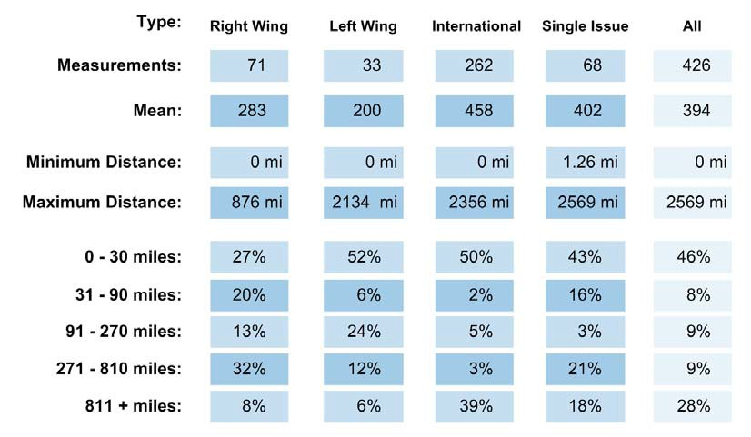

Finally, similar patterns emerged when examining the relationship between the residences of these terrorists and their preparatory activities. These patterns also held when examining the relationship between the locations of terrorist targets and their preparatory activities (Figure 3). At least one-half of all terrorists in the sample lived and committed their preparatory activities within a 50-mile radius of the eventual terrorist target.

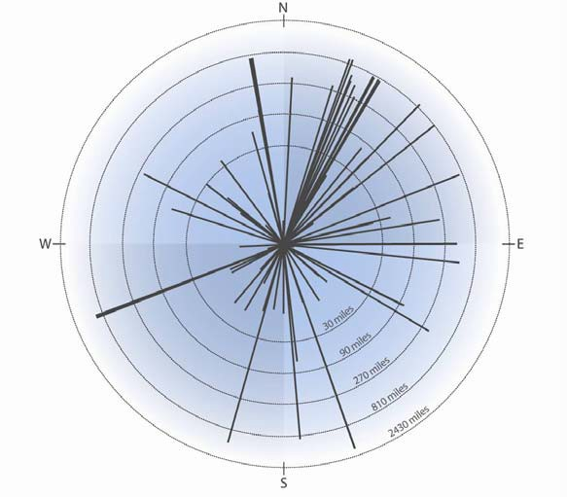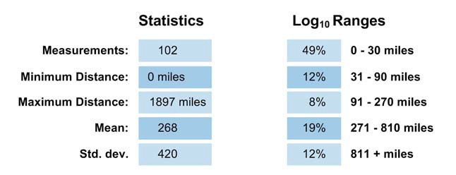Figure 3. PITA- Linear Distance Analysis of Preparatory Antecedent Activity to Incident Locations

GATA Project Results: The “Geospatial Analysis of Terrorist Activities” (GATA) project included an initial sample of approximately 54 court cases that were selected from the American Terrorism Study, a database composed of information from federal indictments resulting from FBI terrorism investigations from 1980-2004. These cases were augmented by twenty-nine additional case studies identified by subject matter experts as important terrorism cases that might render the type of information sought for the study. Of the eighty-three court cases and case studies, fifty-eight case studies were eventually collected and analyzed.

Data collection methods and sources used were the same as in the previous PITA project. Data extracted from the original 58 cases/case studies were added to a relational database composed of 164 variables that eventually included geospatial data on some 1,430 international and environmental terrorists’ residences, planning locations, preparatory activities, and target locations. These “case studies” rendered information on 173 terrorist “incidents” (55 international; and 118 environmental). Data on 136 of these incidents were included in the spatial analysis. For the temporal analysis, identification of both an incident date and dates of preparatory behaviors were required for analysis. Consequently, only 39 incidents were sufficiently fertile to provide some data for analysis. These included 10 international, and 29 environmental case studies. Temporal analysis is limited to these 39 incidents.

Temporal Patterns of Environmental Terrorists: The basic averages for environmental terrorists are presented in Figure 4 below. Despite a lack of information regarding recruitment, sufficient temporal data existed to identify basic patterns of preparatory conduct. On average, the environmental terrorists studied engaged in their first planning and/or preparatory activities only 15 days prior to the date of the incident. Rather than there being a lull in activity immediately prior to the incident as was noted among some other types of groups; once begun, the activities quickly culminated in an incident. In fact, there tended to be a flurry of activity in the day or two immediately preceding the incident. It should be noted that Figure 4 merely represents “averages” – and averages are subject to extreme variation due to outliers. These averages should not be mistaken for “patterns” of behavior.

Figure 4. Temporal Averages of Environmental Terrorist Group Activities
Planning and Preparatory Behaviors

When
Recruited
Cell
Origination
1st Known
Activity
1st
Preparatory/Planning Last
Preparatory/Planning

Terrorist
Incident

avg. 14 days avg. 1 day

avg. 15 days

avg. 124 days

Unknown due to small sample size

Unknown due to small sample size
Number of Incidents =29

Furthermore, our examination of environmental cases included the recently prosecuted case involving “the family” – the largest federal criminal case involving members of the Earth Liberation Front/Animal Liberation Front in American history.8 While traditional environmental terrorists have adhered to an “uncoordinated violence” model involving “lone wolf” or “elf” activity, the Family case is unique in that it constituted a vast conspiracy involving at least 16 persons. Consequently, incidents involving the Family were analyzed separately from the other environmental cases for comparison. We then conducted a collective visual analysis of the cases to identify patterns by placing all of the preparatory activities of each incident in a single graph (see Figure 5).

8 U.S. v Dibbee et al., including CR-06-60069, CR-06-60070, CR-06-60071, CR-06-60078, CR-06-60079, CR-06-
60080, CR-06-60120, CR-06-60122, CR-06-60123, CR-06-60124, CR-06-60125, CR-06-60126, U. S. District
Court, District of Oregon.

Figure 5. Environmental Antecedent Activity (excluding ELF “Family” Activities)

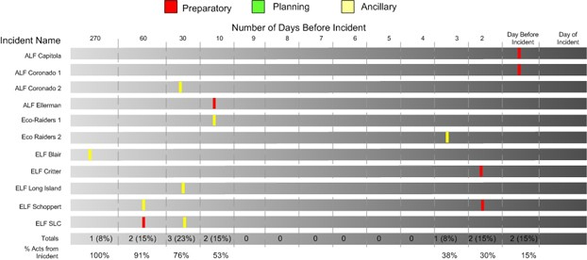

Two features are noteworthy of “typical” environmental terrorist preparation. First, because they are usually conducted by single individuals rather than groups, there are fewer meetings or other forms of known communication between participants. Consequently, these individuals, with perhaps the exception of the Unabomber, have restricted their preparatory activities to rather simple incendiary devices. Second, the planning and preparatory process is rather short.
Over three-fourths of the antecedent activities occurred within 30 days of the incident and almost all (91%) took place within 60 days of the incident.

In contrast, the Family case represented a significant departure from traditional environmental terrorists’ organization and structure. Since the early 1990s, environmental extremists advocating the use of terrorism have adhered to an uncoordinated violence model, very similar to the “leaderless resistance” approach adopted by the extreme right about this same time. Consequently, we expected to find substantial differences in the temporal patterns of the
“Family” and “typical” environmental cases. Specifically, we expected to observe a much larger

number of planning activities associated with the Family as well as a longer planning process. Such was not the case.

As Figure 6 shows, the Family was actually more spontaneous than other environmental groups. Approximately 85% of their known antecedent activities relating to specific incidents occurred within six days of the incident. 95% occurred with ten days of the incident. Most striking is that three-fourths of these activities occurred within the three day period immediately prior to, and including, the day of the incident. These activities typically included purchasing the materials for the incendiary device to be used in the arson. Rather than transport these materials over great distances, usually these were purchased from a local store, such as a Wal-Mart, in the immediate vicinity of the target. A staging area was selected and the firebomb was usually constructed on site at the staging area the day of, or one day prior to, the bombing. Because the planning sequence was so short and many of the preparatory activities did not involve illegal
acts, these tactics gave law enforcement little opportunity to intervene early. However, had early intelligence been available regarding, for example, the purchase of the particular combination of ingredients used in most of their incendiary devices, local law enforcement would have known that: (1) an attack was imminent, and (2) that it would take place in the general vicinity of the purchases.

A comparison of the Family activities and other environmental cases is compelling in that it revealed that despite differing organizational structures (one being cellular, the other emphasizing “lone wolf” direct actions); the length of the planning process did not vary
substantially between these groups. If anything, the Family was more spontaneous than the other environmental cases studied.

Figure 6. ELF/ALF The Family Antecedent Activity

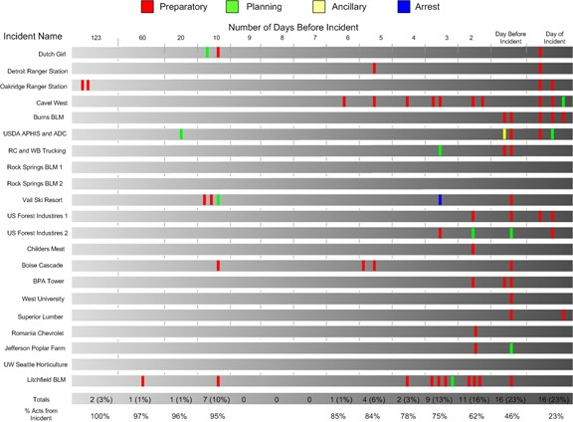

Temporal Patterns of International Terrorists: The amount of temporal data available on international cases in the United States is limited for two reasons. First, international terrorism has been relatively rare in the United States compared to other types of extremist violence. Second, the FBI has been remarkably successful in preventing terrorist plots involving international terrorists operating here in the United States. Consequently, only cases where an actual incident date or a projected date for the attack was known are included in the analysis.
The basic temporal pattern is shown in Figure 7 below. The small sample size precludes us from making conclusive statements regarding these patterns. However, the differences between the international terrorists in Figure 7 and the environmental terrorists in Figure 4 are enlightening. On average, the first known preparatory activities for the international terrorists was 92 days

prior to the incident date compared to only 15 days for the environmental terrorists. Likewise, the last known preparatory behavior among international terrorists was seven days prior to the incident compared to only one day for the environmental terrorists. The data strongly suggest a more extensive planning cycle among international terrorists than among domestic environmental groups. Once again, however, these averages can be misleading. Therefore,
temporal diagrams were also created for each of the international incidents and then compiled on a single timeline.

Figure 7. Temporal averages of international terrorist group activities

When
Recruited
Cell
Origination
1st Known
Activity
1st Preparatory/Planning Last Preparatory/Planning

Terrorist
Incident

avg. 85 days avg. 7 days

avg. 92 days

avg. 1155 days

Unknown due to small sample size

Unknown due to small sample size

Number of Incidents = 10

Figure 8 confirms the “patterns” suggested in Figure 7 above. While 75% of the antecedent behaviors by environmental groups occurred in the three days immediately prior to an incident, only 13% of these behaviors occurred in this same time period among international terrorists. This trend continues the further back one goes in the planning cycle. At incident minus six days (I-6), 85% of the antecedent conduct of environmental terrorists had not yet been committed

compared to only 18% of the antecedent behaviors of the international terrorists. To reach the

85th percentile among international terrorists, one has to retreat to approximately six months prior to the incident. In fact, in most of the international cases studied where preparatory data could be matched with an incident date; the first known preparatory behaviors began about four to six months prior to the incident.

Figure 8. International Antecedent Activity

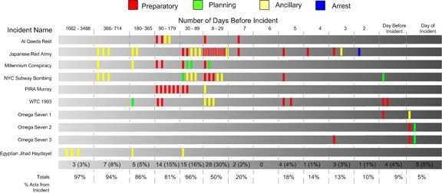

Spatial Patterns of Environmental Terrorists: The spatial patterns of the Family and all other environmental terrorists were substantially different. Members of the Family tended to live
much further from the incident than the environmental terrorists in other incidents. However, all of the environmental spatial data have been combined for this summary. Over one-half (51 percent) of the environmental terrorists lived within 30 miles of the selected target at the time the incident occurred (see Figure 9). In contrast, nearly a fourth of the incidents were committed by environmental terrorists who lived over 810 miles from the target location. These included members of the Family who flew in from other states to participate in locally selected targets by

other members of the group. With the exception of the Family conspiracy, environmental terrorism has been, by and large, committed by local extremists.

Figure 9. Linear Distance Analysis of Environmental Terrorists’ Residences to Terrorist
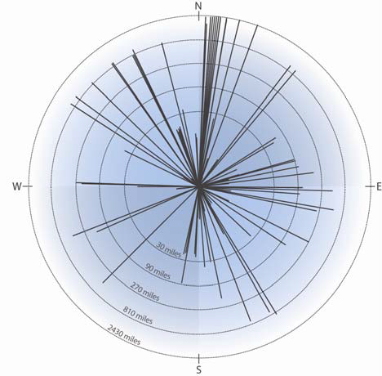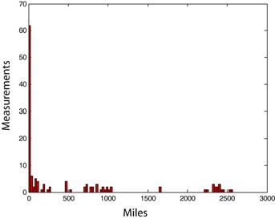Incidents

Graphed Ranges
51% are 0-30 miles
9% are 31-90 miles
8% are 91-270 miles
8% are 271-810 miles
24% are 811-2637 miles
n = 208
Min: 0.3 miles Max: 2637 miles Mean: 480
Median: 24
Mode: 0.3
Std.dev: 772

If preparatory behaviors can serve as pre-incident indicators to local law enforcement agencies, it is important to know the relationship between where these acts occur and the location of the residence of the terrorist and the target location. Once again, nearly two-thirds (65 per cent) of the antecedent or preparatory behavior of the environmental terrorists occurred within 30 miles of the target (see Figure 10). Rather than commit these acts near their places of residence, environmental terrorists, particularly members of the Family had a tendency to travel closer to
the target before engaging in preparatory behaviors (figures not shown, see Final Report).9

9 This pattern may be skewed due to the inability to identify residential locations for all members of the Family and due to their tendency to congregate at a protest site where environmental activists were residing. Use of that address would have reduced these distances considerably.

Figure 10. Linear Distance Analysis of Environmental Antecedent Activity to Terrorist
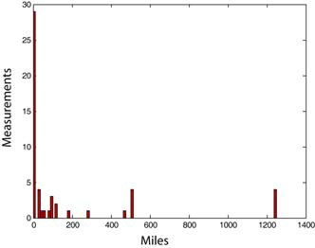Incident Locations

Graphed Ranges n = 75  65% are 0-30 miles Min: 0 miles  8% are 31-90 miles Max: 1251 miles  7% are 91-270 miles Mean: 205  7% are 271-810 miles Median: 5.3  13% are 811-2570 miles Mode: 0  Std.dev: 410 | 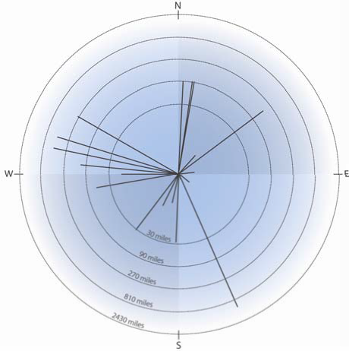

Spatial Patterns of International Terrorists: Although the temporal patterns of environmental and international terrorists differed substantially, their spatial patterns were fairly similar. Of 49 measures from the international terrorists’ residences to the target location, three-fifths (59 per cent) were within thirty miles of the target (Figure 11). However, unlike their environmental counterparts, international terrorists did not reflect a bimodal distribution regarding the relation between residences to target. Instead, a general linear relationship between residence and target location emerged – the farther the distance from the incident, the lower the percentage of international terrorists’ residences.

Figure 11. Linear Distance Analysis of International Residences to Terrorist
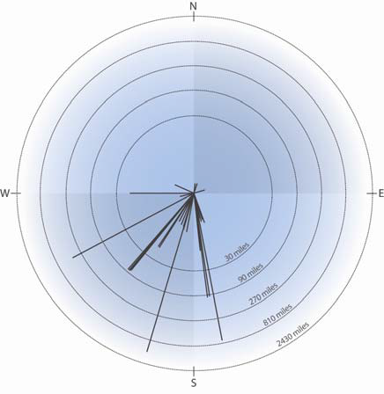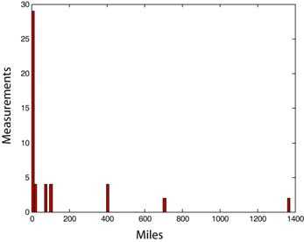Incident Locations

Graphed Ranges
59% are 0-30 miles
17% are 31-90 miles
8% are 91-270 miles
12% are 271-810 miles
4% are 811-2570 miles
n = 49
Min: 0.5 miles Max: 1372 miles Mean: 139
Median: 12.5
Mode: 4.6
Std.dev: 308

International terrorists also committed a majority of their antecedent and preparatory behaviors close to the incident location (Figure 12). Like the environmentalists, about three- fifths (59%) of the known, measurable antecedent activities occurred within a 30 mile radius of the selected target. Although these spatial patterns are similar for both groups, the implications for local law enforcement are different. Observation of environmental extremists’ antecedent behaviors by local law enforcement probably signals that a terrorist attack is eminent. In contrast, the antecedent activities of international terrorists in a local community may occur over several months in advance of the incident.

Figure 12. Linear Distance Analysis of International Antecedent Activity to Terrorist
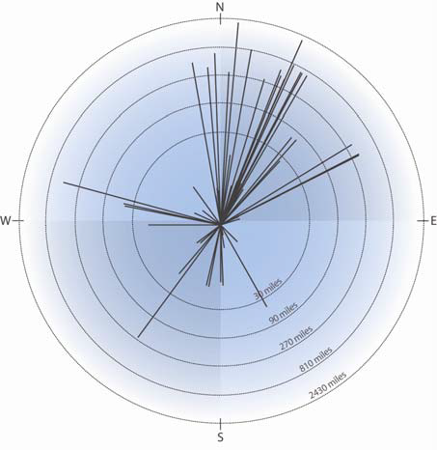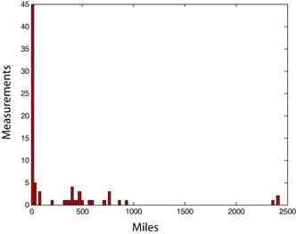Incident Locations

Graphed Ranges n = 78
59% are 0-30 miles Min: 0 miles
9% are 31-90 miles Max: 2419 miles
1% are 91-270 miles Mean: 249
24% are 271-810 miles Median: 9.8
7% are 811-2570 miles Mode: 0
Std.dev: 501

Previous Research Conclusions

The PITA exploratory study broke new ground by examining the temporal and spatial distribution of terrorist group activities. The findings demonstrated the potential uses of geospatial methodologies using open source data on terrorism. The study revealed a bi-modal spatial distribution of terrorist planning and targeting. About one-half of the terrorists in the study resided, planned, and prepared for terrorism relatively close to the eventual target. Another one-fourth lived and planned their acts a distance of several hundred miles from the terrorist target. These two patterns reflect operational variations among terrorist groups. In particular, the latter strategy reflected the use of air transportation for planning and operational
activities or the use of postal services as a means of weapons delivery. This bimodal pattern was most prominent among environmental and international terrorists. In contrast, right-wing terrorists’ behaviors were more evenly distributed spatially. The temporal data identified

through this project was less revealing. Although average lengths of time in the planning process could be calculated, they are less reflective of consistent patterns of conduct than they appear. Temporal data was difficult to obtain and the groups studied varied widely in their utilization of time. Even more ominous is the finding that the type of terrorism (environmental) projected to
be the most prevalent form of American terrorism over the next decade (Jarboe, 2002) was also the type of group that committed the fewest number of preparatory acts per incident. By definition, the implementation of uncoordinated violence tactics implies an increase in “lone wolf” and individual “direct actions.”

The GATA project further investigated the patterns of environmental and international terrorists targeting the United States exhibited showing that they had similar spatial patterns of behavior, but highly divergent patterns of temporal conduct. The study confirmed a “localized” spatial distribution of terrorist planning and targeting by both environmental and international terrorists. Slightly over one-half of both groups of terrorists in the study resided, planned, and prepared for terrorism relatively close to the eventual target. However, about one-fourth of the environmental terrorists lived and planned their acts a distance of several hundred miles from the terrorist target. These two patterns reflected operational variations among terrorist groups. Among both international and environmental terrorists, the use of “long distance terrorism” reflected one of two tactics: (1) the use of air transportation for planning and operational
activities or (2) the use of postal services as a means of weapons delivery.

In contrast, the temporal patterns of environmental and international terrorists were quite different. Environmental terrorists were much more spontaneous, engaging in an extremely short planning and preparation cycle. Usually targets were selected and attacked within one week.

The planning process of international terrorists was significantly longer, usually lasting several months. These differences also manifested themselves in the number and type of preparatory activities. International terrorists engaged in significantly more group interaction, planning meetings, and preparation than did the environmental terrorists. International terrorists also committed a much broader range of criminal conduct than environmental terrorists.

Research Questions

Although the primary purpose of the proposed research was to create a comprehensive record of American terrorism for scholars and analysts to utilize, the above discussion of preliminary findings from our prior NIJ projects on the temporal and geospatial distribution of terrorist activities raised a number of research questions. These questions are outlined in the sections below. Additionally, the interaction between time and space has never been addressed. Initial impressions of our temporal and spatial data suggested a scenario much like a predator closing in on a prey—as the planned incident draws nearer temporally, the spatial events also draw nearer
to the target location. What our initial data did not reveal was whether these events are temporally and spatially sequenced in such a way that they can be of predictive value. The current project collected data in an effort to confirm these findings and further clarify these relationships.

Therefore, the fundamental research question of the project was: What spatial and temporal patterns exist among terrorists in relationship to their preparatory behaviors and the location and time of the terrorist act? The preliminary analyses from the previous studies raised a number of supplementary questions to be addressed. The exploratory nature of this research dictates that we address general research questions rather than specific hypotheses. The schematic diagram

on page 17 was used to guide our assessment of these questions. The schematic groups the behaviors of terrorist organizations into four categories: (1) recruitment; (2) preliminary organization and planning; (3) preparatory conduct; and (4) terrorist acts. Examples of some of the types of behaviors are provided for each category. While we recognize that these categories are not exclusive and that they may overlap on occasion, they provide a systematic method to examine the temporal and spatial dimensions of terrorism.

Temporal Issues: Our preliminary data on the temporal dimensions of terrorist activity revealed that terrorist planning and preparation is more complex than originally anticipated. International groups tended to plan for attacks longer than either right-wing or single-issue domestic groups. Furthermore, right-wing terrorists and single-issue terrorists, particularly environmental extremists, tended to commit fewer preparatory acts than international terrorists prior to the commission of a terrorist incident. This research attempted to further clarify whether these differences were merely artifacts of the small sample size in the earlier studies or do they reflect variations in organizational structure or tactical methods, such as the use of “uncoordinated violence” as opposed to a more organized cellular approach? Additional
research questions include:

(1) How long do terrorist groups typically plan their activities? How much time typically elapses between various phases of terrorist group planning and the eventual commission of terrorist acts?
(2) Are there substantial variations between these types of groups relative to the length and sophistication of the planning process?

(3) Does planning initially begin slowly and then culminate in a frenzy of hurried activity immediately prior to commission of the terrorist act? Preliminary findings suggest a lull in activity prior to the commission of the incident, but these findings were based on sample sizes too small to identify group-specific patterns.
(4) Does the number and type of preparatory crimes and activities substantially differ between terrorists groups?

Geographic Issues: First, we have learned that, if our preliminary patterns hold, about one-half of terrorists both reside and prepare for their terrorist incidents within a thirty mile radius of their residences. Furthermore, among environmental and international terrorists, a bimodal pattern emerges where the terrorists reside either very close to the target or very far from it. Why does this variation exist? Under what conditions do terrorists remain local, while others adopt more long range targeting? Can these tactical differences be predicted from the demographic, ideological, or group characteristics of the
terrorist organization? Additional research questions included:

(1) Once terrorist groups emerge in a given locale, do they commit their preparatory acts near their “home base” or select other jurisdictions to avoid drawing attention to their group? Additionally, are these residences, home bases, or safe houses within a similar proximity to the terrorist incident targets or are they intentionally staying away to avoid detection? The preliminary patterns suggested this to be the case, but more data was needed to confirm this finding.
(2) How far from the epicenter of the terrorist groups’ organizational and planning activities are most of the terrorists’ targets? As a corollary, do terrorist groups commit their preparatory acts in remote locations far from the actual terrorist target? Once again, preliminary data

suggested that planning activities and targeting occur in the same general area, but additional

cases were needed for adequate sampling.

.

III. METHOD

Terrorism Data

Although the previous NIJ research projects mentioned earlier in the report have contributed greatly to the body of empirical data on terrorists, the resulting amount of data was still too small to yield enough data for substantial analysis. The current research attempts to add to a growing body of empirical data on terrorism. It expands on previous efforts by the Terrorism Research Center in Fulbright College at the University of Arkansas by focusing on adding more case studies and data to the previous research efforts to ensure that the data are representative of American terrorism. The basic underlying data source and foundation was the American Terrorism Study (ATS) that began in 1988, and the previous NIJ projects “Pre-Incident
Indicators of Terrorist Activities” (PITA) under grant #2003-DT-CX-0003 completed in October

2005 and “Geospatial Analysis of Terrorist Activities” (GATA) under grant #2005-IJ-CX-0200 completed in October of 2007. These projects formed the base data, structure for research, and findings to further investigate spatial and temporal patterns.

The ATS began in 1988, was later funded by the National Institute of Justice (NIJ) under grant #1999-IJCX-0005 and was funded by the Oklahoma City National Memorial Institute for the Prevention of Terrorism (MIPT) under grant #106-113-2000-064 from 2000 to 2008. The information in this database results from the examination of indictments, sentencing memoranda, and other federal court records from FBI investigations into terrorism (Smith 2003a). The
project is managed by the staff at the Terrorism Research Center in Fulbright College at the

University of Arkansas, in collaboration with Dr. Kelly Damphousse at the University of

Oklahoma; with analytical support from the Center for Advanced Spatial Technologies (CAST)

at the University of Arkansas.

The ATS database contains demographic variables for almost all federally indicted terrorists from 1980 to 2004. In addition to basic demographic and legal information, spatial variables, including known operational bases and primary and secondary targets are found in the database. These data provide a starting place for the selection of case studies for inclusion in this research. The database contains information on over 700 individuals from about 68 terrorist groups.

Utilization of this database as the primary data source mandates that the definition of terrorism used in the project be synonymous with that of the Federal Bureau of Investigation. The FBI, in turn, adheres to the definition of terrorism provided in the Code of Federal Regulations (28 C.F.R. Section 0.85). This document defines terrorism as “the unlawful use of force and violence against persons or property to intimidate or coerce a government, the civilian population, or any segment thereof, in furtherance of political or social objectives” (Federal Bureau of Investigation, 1999:1).

The PITA project started out only using cases or incidents that originated in the ATS dataset and thus were investigated under official FBI terrorism investigations. However, in order to obtain a sample of cases with data sufficiently fertile data for analysis in this preliminary project, additional cases were selected based on criteria that were included as salient characteristics of the FBI definition: (1) that the behaviors (incidents) were unlawful; (2) that the incident involved
the use of force or violence against persons or property; and (3) that the act committed by the individual or group was politically motivated. In addition, politically motivated protests that turned violent, such as riots or other actions that resulted in damage or injury to persons, were

excluded. The GATA project followed this same model by including other incidents that fit this expanded definition in addition to adding court cases that were highly likely to appear on the next release of the FBI terrorism court case list. 10

This research divides terrorism into two main categories used by the FBI: domestic and international. Domestic terrorism is further divided into right-wing, left-wing, and single-issue terrorism. For consistency, our project retained these distinctions. For most of the cases studied, the FBI had already categorized incidents into these groupings in listings provided to the American Terrorism Study. New cases selected for analysis were placed into these categories, utilizing the FBI’s practical application of “right-wing,” “left-wing,” “single issue” as closely as possible. The single issue category has been further broken down into “– environmental and single issue – other.” Environmental has been broken out from the other single issue category due to a large amount of incidents that greatly overwhelm the single issue category and its every increasing presence in terrorism incidents in the United States. While these categories are not mutually exclusive (e.g., single issue terrorists such as abortion clinic bombers may also be characterized as “right-wing”), the distinctions provide a commonly understood conceptual framework from which to initiate analysis. For this research “single issue – environmental” will be referred to as simply “environmental”, while the “other” category will retain the “single
issue” classification.

10 It is important to note that a variable has been added to designate case studies that involved court cases from the ATS dataset and thus meet the official FBI and Attorney General Guidelines definitions of terrorism. For analytical purposes these cases can be examined separately or in combination with other acts of terrorism included in the dataset.

Case Studies

Case Studies from Previous Projects: The previous NIJ projects revealed that: (1) sufficient open source data on preparatory conduct were available, and (2) that geospatial and temporal patterns were emerging. The current project was tasked to collect data on the remaining ATS court cases that were not included in the two prior projects. Selection of cases from past projects that are included in the data requires some explanation to avoid confusion regarding the unit of data collection and analysis. We use the term “case study” somewhat loosely. In this project, a “case study” merely represents the starting point from which data collection and analysis began. We have chosen to use the term case study because in most instances we began with a federal criminal court case that had been identified by the FBI as resulting from indictment under the FBI Counterterrorism Program.11 These “starting points” or “case studies” were selected by previous panels of subject matter experts (SME’s) and Terrorism Research Center personnel. Subject matter experts on the two projects included Ron Arnold, Jonathan White, Bill Dyson, Brent Smith, and Kelly Damphousse. These SME’s provided knowledge on specific incidents

for data collection and synthesis of analysis on the groups.

In some instances, the panel recommended data collection on a “case study” that represented a single known terrorist incident that was deemed worthy of investigation. In other instances, federal criminal cases were selected that involved several members of a group indicted for multiple acts or prevented acts of terrorism. Although these case studies represent the initial starting point for data collection, the “case study” is not typically used as a unit of analysis. The “terrorist incident” or “prevented incident” was the primary unit of analysis. However, some
case studies rendered multiple incidents or prevented incidents for analysis.

11 See Footnote 1.

Case Study Selection for Current Project: The unit of data collection for the current project was a court case from the ATS dataset. However, after data collection was performed on these court cases they were distributed into case studies that could be a combination of one or more court cases. This approach was necessary due to multiple court cases involving the same persons and/or terrorism incidents. Occasionally, defendants are split out from a court case and tried separately for the same terrorism incident or planned incident. In these cases it was necessary
due to the structure of the court documents to collect the data separately, but then to combine them into a single case study for an accurate picture of the events leading up to the terrorism incident and to remove duplicate events. Additionally, there are case studies included in the database from past NIJ grants that are not tied to an ATS court case. These case studies were retained in the final database due to them meeting selection criteria as described previously. However, they are coded in such a way that they can be included or excluded from the analysis.

Court Case Selection: The court cases for the current project were selected from the ATS dataset that covers 1980-August 31, 2004. There were 363 federal criminal court cases resulting from official FBI terrorism investigations during this time period. Of these cases, 143 did not meet selection criteria for inclusion in this project (73 cases were closed but had not been collected, 43 were known immigration cases, and 27 cases were still open). However, out of the
220 court cases viable for the project, 87 had been collected previously as part of the PITA and

GATA projects leaving 133 total court cases for inclusion in the current project.

Upon receipt of the court case list, SHSU further examined the list of 133 court cases and excluded 10 additional court cases that did not meet selection criteria. This left a total of 123
ATS court cases on which to collect geospatial and temporal data. We had anticipated that

approximately 100-125 cases would be viable for data collection of geospatial and temporal data and we were at the upper limit of our estimate.

At the conclusion of the current project, a total of 214 ATS court cases are now in the database that have had geospatial and/or temporal data collected (current project data collection combined with previous NIJ grants). Of these, 163 court cases involved one or more terrorism incidents or preventions and were potentially viable for spatial and temporal analysis. The remaining 85 court cases were not selected for analysis for failing to meet specific criteria (23 had no terrorism incidents or links to terrorism incidents, 22 were material support cases and 6 involved overseas incidents).

It should be noted that many cases result in more than one incident for analysis. For example, the Unabomber case resulted in the coding of over a dozen separate bombings. This was true in over 80 of the cases. In the following section of the report, a breakdown provides details regarding how many of these cases yielded sufficient data for each type of analysis.

Case Studies: One hundred and twenty-eight case studies are included in the database, 50 right-wing, 10 left-wing, 31 international, 30 environmental, and 7 single issue – other. Tables 2 through 6 lists the case studies and the type of data collected on each category of terrorism. The second column lists whether the case study involved one or more court cases from the ATS dataset. The additional columns list whether analysis was performed for the specific measurement. The majority of the cases studies involve at least one ATS court cases. All cases studies have been coded for whether they appear in the ATS dataset so that they can be removed for additional analysis if preferred

Table 2. Right-wing Breakdown of Case Studies Collected and Analyzed

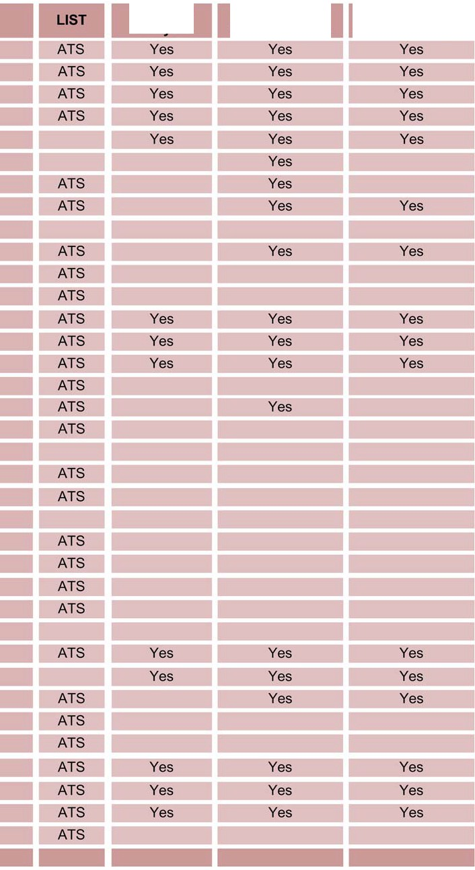
Case Study Name

American Front
AN Furrow AN Winslow AOG Jordi AOG Kopp AOG Waagner ARA
Arizona Patriots

Bixby SC
Brailey Assassination
C1LF Chewning CSA
Felton Chase
FRSH
Fuselier Dartez
HDFB Hemphill
KKK Barefoot KKK DelVecchio KKK Droege KKK Seace
KKK Texas
Krar IDC KSM Logan
MM Woodring
Montana Freeman

Moody MP Ricin NA Doles New Order
OKC Bombing OKC Militia Order
Order II

Continued on Next Table
Temporal
Analysis
Residence to
Event Analysis
Antecedent to
Incident Analysis

Table 2. Con’t Right-wing Breakdown of Case Studies Collected and Analyzed

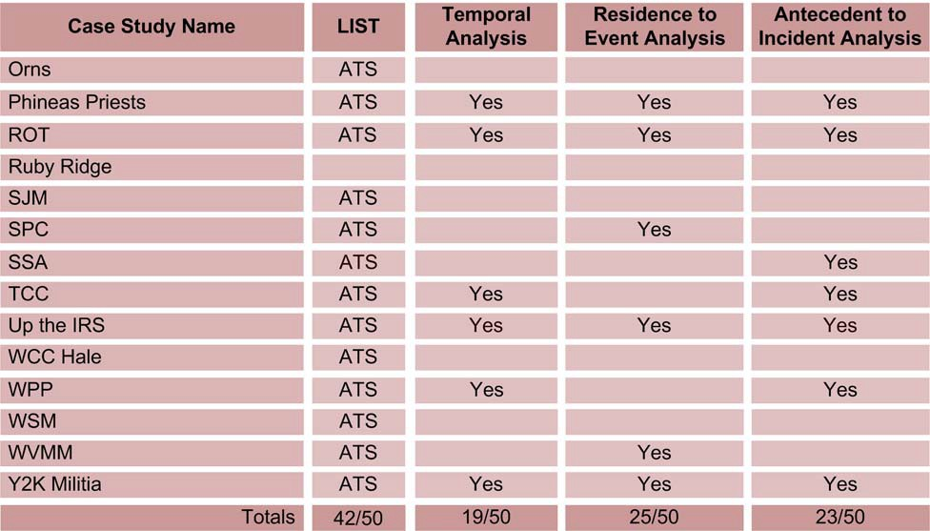

Table 3.Left-wing Breakdown of Case Studies Collected and Analyzed

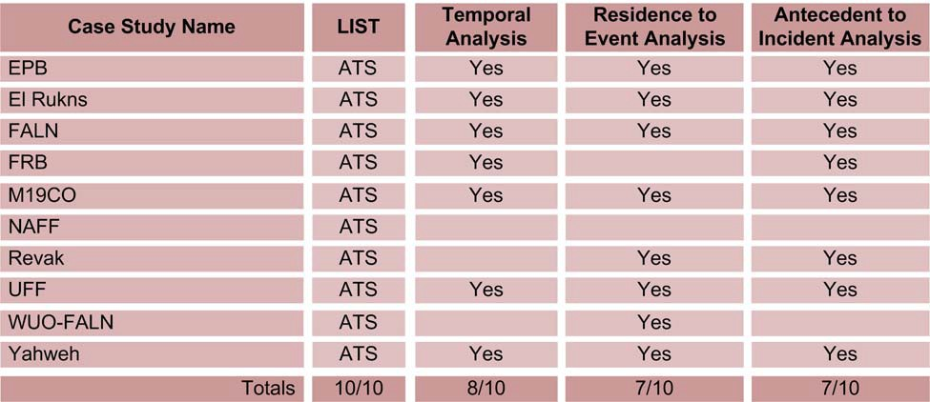

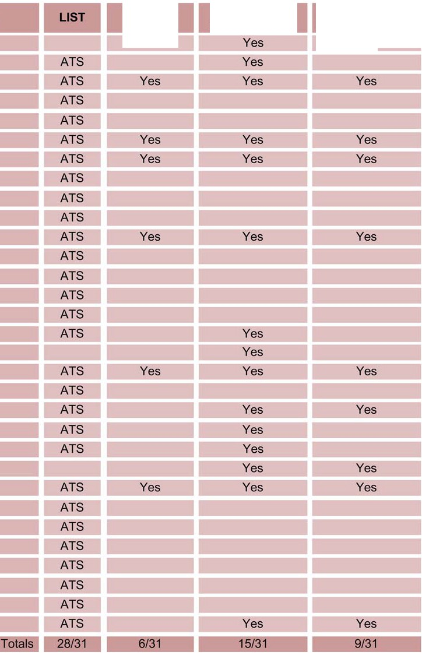Table 4.International Breakdown of Case Studies Collected and Analyzed

Case Study Name

AlAI Walker
Abu Nidal
AI Qaeda 9-11
AI Qaeda Embassy

AI Qaeda Lindh
AI Qaeda Millenium AI Qaeda New York AI Qaeda President AI Qaeda Reid
Amal Militia
CNM CNPZ EZLN FARC FMLN
Hamas Steitiye
Haydayet

JRA JSO Jokhan
Lackawanna Six
Lemmons Malike Omega 7
PIRA Brennan PIRA Johnson PIRA McKinley PIRA Muqhy PIRA Murray SSNP
Warrayat
Temporal
AnaiY,sis
Residence to
Event AnaiY,sis
Antecedent to
Incident AnaiY,sis

Table 5. Environmental Breakdown of Case Studies Collected and Analyzed

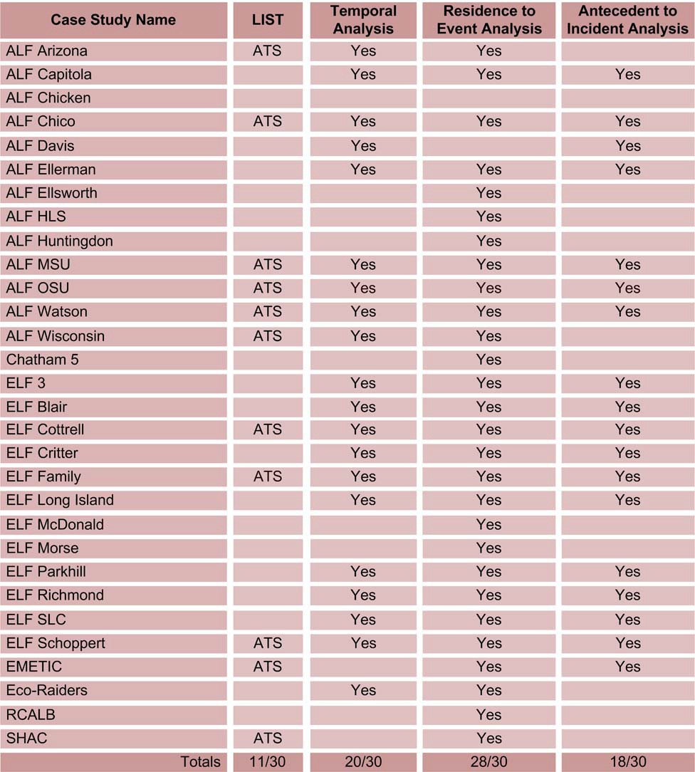

Table 6. Single Issue – Other Breakdown of Case Studies Collected and Analyzed

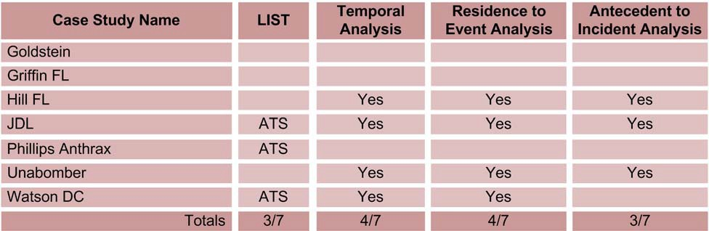

The data collection on these 128 case studies revealed 75 right-wing, 78 left-wing, 54 international, 111 environmental, and 7 single issue – other terrorism incidents. A total of 325 total incidents had spatial data collected, and we were able to make over 3,000 spatial measurements (1,122 right-wing, 798 left-wing, 656 international, 579 environmental, and 65 single issue – other). These measurements included residence to target, residence to antecedent acts (both preparatory and ancillary), and antecedent acts to target distances. In our rose diagrams shown in the results section, measurements involving incidents were limited to those that a location could be determined for geocoding and placement on a map. The results section breaks down the number of measurements for each case study and the number of incidents analyzed. For single issue – other cases, the lack of incident measurements is due primarily to the low number of case studies in this category.

The third column of Tables 2 through 6 identifies the number of cases that generated sufficient data for temporal analysis. While geospatial measurements could be made from residence to antecedent activity without having an actual target location, temporal measurements were somewhat more difficult. We wanted to measure the entire length of the planning process.

Consequently, we decided not to include cases in the temporal analysis unless we knew the date of the incident or when a prevented incident was planned or we could estimate it closely.

Date estimation was performed on a case by case basis using the following criteria. Estimation of the month or day of an event was only done in cases where the time being measured would not introduce significant error into the analysis of the incident or planned incident. The data collection sources often reveal temporal information not in specific days and months, but refer to the beginning, middle, or end of the year or a specific season such as spring or winter. Additionally, the first, middle, or end of a month may be discussed in court documents regarding a specific event. When the time measured is in years then a few months or days will not make a statistically significant difference in the results as would measurements between several days in a month. In the database, dates that have been estimated are marked with a "*" at the end of the “description” field of the event. This is to allow researches to exclude or modify these dates from future analysis.

When date estimation is used the surrounding events are included in the decision making of what date estimate is used. If the times being measured are in the same month and one of the exact dates is unknown, the median point between the 1st of the month and the date being measured to were used to minimize error. For example, if an event is know to occur in January and prior to an event that occurs on January 20th then the 10th of the month is used. This minimizes the amount of error that could be introduced into the analysis. In cases where the next event is months away the 15th day of the month is used. In cases where a month is unknown for an event, the same method as described above for handling these approximate dates is used. This is not always done and is up to the discretion of the analyst to make this decision based upon the

events surrounding the approximate date and the amount of error it could introduce into the measurements.

Therefore, temporal measurements were limited to 324 for 40 right-wing incidents, 285 for

46 left-wing incidents, 452 for 9 international incidents, 182 for 64 environmental incidents, and

26 for 11 single issue – other incidents. The environmental category incidents proved to be the most successful for gathering temporal data. This was primarily due to the group known as the “family” which an FBI informant was able to document a large amount of activities. However, as will be discussed later, their temporal patterns were very similar to the other environmental incidents measured. A complete breakdown and discussion of the temporal analysis can be
found in the results section.

Variable Selection

Collecting data on terrorism incidents requires a set of variables for the coding of information pertaining to the specific incidents. A large set of variables was needed to encompass the many aspects of terrorism incidents and precursor activity leading up to the incidents being studied.
For this research the same variables were used as in the previous PITA and GATA projects. Some reorganization of variables was necessary, but the overall number of variables did not decrease. Over 170 variables were selected for coding of information into the Oracle relational database tables. In addition 80 variables from the original ATS dataset are included due to the inclusion of the ATS data into the Oracle database, resulting in a total of 254 variables. Each table provided a storage place for inputting information that would enable spatial analysis of the incident. The database tables and number of variables are listed in Table 7.

Table 7: Database Table Breakdown

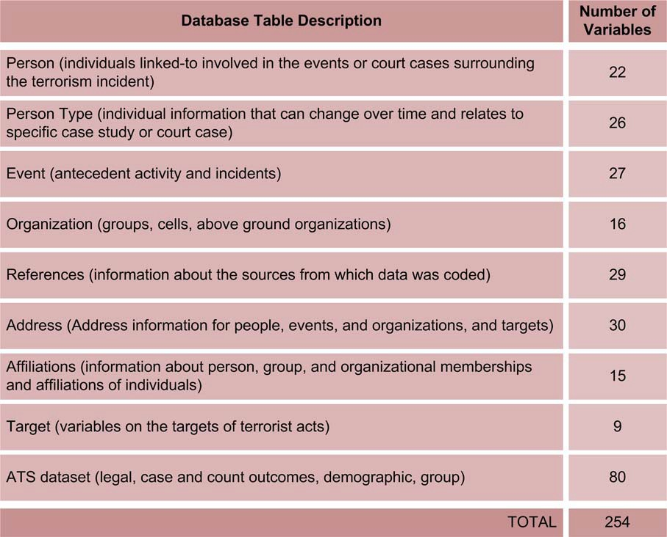

The bulk of the data are coded into four main tables: Person, Person Type, Event, and Organization. The remaining tables function as storage for additional data directly relating to records in the main tables. These include the References table for inclusion of all references used to code the data; the Address table for storage of all spatial data relating to a person,
organization, or event; the Affiliations table to store links between persons and organizations; and the Target table for data collected on the targets of terrorist acts. The four main tables are described below with additional tables that are linked to these main tables described as a part of the main table due to their relational nature and to simplify discussion.

The Person table contains one record for each individual appearing in the database. Basic demographic information that does not change over time such as race, gender, ethnicity, birth location, and birth date are included in this table. Additionally, if the person has been indicted and appears in the ATS dataset then a variable is coded to show this relationship. It is important to note that by an individual’s name being included in the Person table they are not being labeled a terrorist. Individuals that appear do have some sort of link to a person, incident, court case, or case study that appears in the database.

The Person Type table contains specific information about an individual related to a case study found in the database. This information reflects a snapshot in time for that person specifically relating to the case study. Individuals appear in multiple records in this table as they can be associated with multiple case studies and/or incidents at different times. These variables include one or multiple addresses, age, marital status, education, income, profession, and military history that when combined with the information in the Person table provides an in-depth look at the individuals linked-to and/or responsible for terrorist acts.

The Event table stores information on the antecedent activities and incidents related to each case study. For the purposes of this research the Event table was coded to define what type of an event took place. This division of the data into different types of events resulted from the need to measure the temporal and spatial differences in the terrorist planning process. Coding all of the events into one table allows a timeline to be created of the events that took place prior to the terrorism incident. The specific variables associated with each of these “event types” are described below:

(a) The Incident variables consist of basic information about the terrorism incident such as name of the incident target, address of the target of the incident, and whether the incident was prevented or occurred. A large number of terrorists are captured prior to the execution of a terrorism incident and thus some incidents in this study did not occur, but information is known on the location and time of the events that were planned. These incidents are coded
as such in order to allow selection for analysis. In addition, the names of the individuals involved in the terrorism incident are included as well as information on destruction of property, and persons killed or wounded.

(b) The Antecedent Activity variables consist of information on antecedent activity conducted by terrorists prior to the terrorism incident. This activity includes both criminal and non- criminal conduct. Research conducted as part of the American Terrorism Study shows that terrorists commit scores of crimes such as identity theft and theft of property and money in order to carry out a terrorism incident. The antecedent activity is broken down into two types– preparatory and ancillary. It should be noted that in the prior PITA and GATA projects we distinguished between “preparatory’ and “planning” activities. This distinction
was removed in the final dataset. We decided it was too arbitrary of a designation to be used. This type consisted of meetings and phone calls and are now included as preparatory or ancillary depending on how they fit into the following definitions. Preparatory activity is defined as “actual acts carried out by a terrorist as part of the planning and preparation
process of a terrorism incident.” This activity may include both criminal and non-criminal conducts. It may include robberies, identity thefts, surveillance etc. Ancillary activity includes “activity carried out by a terrorist, but not in direct planning or preparation for an

incident.” This activity may include the murder of an informant in order to protect the secrecy of the plot, robbery to sustain an underground lifestyle, or other order/maintenance crimes.

The Organization table contains information on organizations that were linked to the case study or whose terrorists were related to the case in some manner. Terrorists that commit a terrorism incident may be a part of a larger terrorist group, but act as a smaller unit for the execution of plans for a terrorism incident. The information in this table describes the structure and dynamic of these groups. The Group variables specify what known terrorist group(s) with which the individual(s) that carried out the terrorism incident may have been affiliated. The majority of the terrorists in this study were members of a larger terrorist group through which they carried out the agenda of the organization. Cell variables consist of data that relate to the group of individuals who carried out the terrorist incident. There is not always a terrorist cell involved in an incident so this designation is only for use if a cell is present. A few of the terrorists are considered “lone wolves.” No group information is included in this table for these individuals. The Above Ground Organization variables exist to link the terrorists to possible legal organizations that could be providing ideological, psychological, or even financial support in some way. The information collected could be important in understanding basic ideological issues of terrorism behavior. These Above Ground Organizations could be crucial in performing future social network analysis relationships to discern otherwise unknown links between individuals in a terrorist group or between groups.

Data Collection

Data collection focused on a court case in this project and on case studies of a terrorist group or incident in previous projects. If the court case or case study involved a terrorist group, then one or more incidents may have been selected for collection of data. If the court case or case study was a single incident, then only information on that incident was collected. This was due
to the fact that some terrorism incidents were carried out by individuals that had no formal ties to a terrorist group. In some cases, however, the terrorist groups studied conspired to commit a series of terrorist incidents. Occasionally, groups or individuals from different groups work together toward a common goal and in some cases, planned incidents jointly. Thus individuals are found in multiple court cases and case studies.

For this research project, staff at the Terrorism Research Center and the Center for Advanced Spatial Technologies at the University of Arkansas modified the structure of the Oracle 10g relational databases and created new web-based data entry forms. A list of the 133 cases
available for collection was provided to the Institute for the Study of Violent Groups (ISVG) at Sam Houston State University.12 The list was further reduced to 123 cases due to their failure to meet data collection criteria. Staff from the Terrorism Research Center instructed the SHSU staff on coding of variables and the method associated with the research. Using the court case
records as a basic foundation, the ISVG staff used a highly acclaimed technology-enhanced open source data collection methodology capable of processing thousands of current and archived

12 ATS project personnel visited with, and/or interviewed several possible subcontractors with experience in extracting open source terrorism data. ISVG was selected following a site visit, comparison of method and scope of data collection, quality of potential data, and cost efficiency.

news articles each day.13 First, the research analysts were provided with electronic copies of all court records previously compiled by the ATS on each of the cases. These included copies of the indictment, sentencing memoranda, selected trial transcripts, and other affidavits providing
details of the alleged conspiracies or terrorist incidents. The indictments are particularly useful

in large conspiracies since they routinely provide a timeline as well as the geographic location of alleged activities. Second, this information was supplemented with data extracted through the ISVG automated open source search capabilities and placed in “folders” associated with each case, with addresses and other geospatial and temporal data highlighted for further extraction. Finally, the ISVG data collectors and analysts coded the highlighted data into the server-based Oracle relational database provided through the University of Arkansas’ Center for Advanced Spatial Technologies.

The data collection concentrated on three main areas of investigation: residences, antecedent activities, and incidents. The data resulting from these investigations were input to the relational database. Two of the tables in the relational database were primarily utilized for containing data for spatial and temporal analysis. First, data on the terrorism incident were compiled in the D_EVENT table. This included information such as the incident’s geographic location, time of occurrence, incident type, and the person(s) involved. Second, data on the person(s) involved in the incident were acquired in the D_PERSON and D_PERSON_TYPE tables. These included basic demographics, places of residence, prior criminal history, etc. Finally, acts that the individuals performed or were associated with were also recorded in the D_EVENT table. These included meetings and trips for information gathering, as well as preparatory and ancillary acts.

13 The ISVG data collection methodology was recognized by Harvard University and Mitretek Systems as one of five finalists for the 2006 Innovations in Homeland Security Award.

The acts of individuals not indicted, but associated with the incident, were also studied.14 The temporal aspect of the case study included all activity from the known time of occurrence for the terrorism incident and working backward to the earliest activity that could be identified relating to the incident. This time period was assumed to encompass the extent of planning by the terrorist or terrorists.

Database and GIS Development

The spatial and temporal data from the activities of the terrorists in the case studies were entered into an Oracle 10g relational database and then analyzed using statistics functions provided by Oracle’s spatial package and MATLAB and visualized using Google Earth. The data from the case studies were managed using Oracle 10g and Safe Software’s FME which allows for seamless integration into MATLAB and Google Earth. The Oracle 10g platform also allows for efficient data management and analysis through its unique architecture system. This allows integration of the spatial data into a GIS type environment contained completely within
the database software. The software stores the spatial data in tabular form and can output queries based on a determined attribute or location to other software for graphic display. This allows analysis of distances between points and an output for presenting the data in an efficient and easily understood manner.

Distances and directions referenced in this report were computed using Oracle Spatial

10gR2. Each residence and event with a valid known address was assigned a latitude/longitude coordinate on the WGS84 datum coded using the NavTech street database through www.batchgeocoding.com. The geocoding process assigns an “x and y” value for each spatial
14 The public release version of the dataset has names of individuals replaced with unique id’s to protect their identities.

point representing an event leading up to the terrorism incident. This “x and y” value is placed on a map using a predetermined coordinate system that allows the measurements of distance in a specified unit. These features were then displayed graphically on a base map such as a map of a city or county. Distances between associated events and between associated events and residents were then computed along the ellipsoid in arcs known as geodesics. Likewise, directional measurements reflect the forward geodetic azimuth from the antecedent event to the incident or from the residence to the event. By working on the WGS84 ellipsoid, we avoid distortions introduced by various map projections. Reported distances are “as the crow flies” and do not reflect distances traveled along a road network. We compared several arcs to road network distances and found that the differences did not significantly affect the results presented later in this report. Furthermore, as the travel mode (foot, car, train, aircraft or a combination of these) is not always known, the geodesic distance between two points provides a measure that can be used to compare a variety of events. Future work could selectively refine this calculation.

Once geocoded, the data is migrated back to the Oracle 10g database and joined with associated address records. KML files may also be output from the geocoding service. Google Earth allows for visualizing selected incidents and their related preparatory acts and ancillary activities. The base map allowed for the overlay of layers that contained information such as roads, rivers, and buildings. This allowed for presentation of these data so that a person would be able to recognize the location where an incident takes place. The software allows for overlay of a large number of layers.

Data Analysis

The primary unit of data collection for this research was a “case study,” but the primary unit of analysis was a terrorism incident. Some case studies were split into multiple incidents that may involve similar events or persons, but these were split into separate incidents for analysis. An example would be a series of bombings that a group carried out over the course of several years. Each bombing was an incident with its own precursor activity. Some of the precursor
activity may have been related to more than one incident; thus allowing each antecedent behavior to be linked to each incident with which it was related. The incident provided the basis for the case study which encompassed information about the precursor activity leading up to the terrorism incident. Each terrorism incident consisted of a single act of terrorism such as a bombing or hijacking. Almost all of these incidents involved one or more individuals who had been indicted under federal law and deemed “terrorists” as prescribed by the Attorney General Guidelines for FBI Terrorism Investigations.

The precursor activity leading up to the terrorism incident is found in the Activity database. This database provided for spatial analysis of preparatory and ancillary activity as described above. The linear distance was calculated between the terrorism incident and all activities that were uncovered through investigation of the incident and inputted into the Activity database. This calculation allowed for determination of distances between the location of the terrorism incident and precursor activity. In addition, the residences of the terrorists involved in the terrorism incident were included in the spatial analysis in order to divulge potential relationships between the location of the terrorism incident, precursor activity, and terrorist residences or operational activity centers.

The method for choosing case studies for analysis was based on the amount of open source materials available for data collection. Case studies that could potentially yield large amounts of spatial data were chosen by looking at the amount of information available on each incident in order to provide enough data for comparison within and between the designated categories. For the purposes of this research, 203 incident locations from the selected case studies were eventually identified.

Incidents selected for final analysis included those where a specific geographic location

could be identified for the occurrence or planned occurrence of the terrorism incident. For a few of the incidents an address could not be found. In these cases, the centroid of the zip code of the city that the event was located was used in calculating distances. Since using these city centers potentially could skew the data, a method was established for determining when a city center could or could not be used. For example, if the diameter of the city for which the location of the incident was placed in its center was greater than 10% of the distance being measured, then the incident was not included for analysis. By using this 10% rule, the potential for skewed data is greatly lessened and still allows for meaningful results and comparison.

The spatial analysis consisted of Exploratory Spatial Data Analysis (ESDA) using standard spatial statistical methods. Anselin (2000:26) describes this methodology as “a collection of techniques to describe and visualize spatial distributions; identify atypical locations or spatial outliers; discover patterns of spatial associations, clusters, or hot spots; and suggest spatial regimes or other forms of spatial heterogeneity.” The methods include the analysis for patterns in spatial variance among related activities. The distribution of incidents across the United States yields vital information regarding where concentrations of terrorism incidents have

occurred in the past. Questions such as whether terrorism incidents are concentrated in rural or urban areas are easily answered. On a larger scale, patterns within cities are possible to determine by looking at the spatial distribution of all the points involved in a given terrorism
incident. By displaying all of the available points on the map derived from spatial data housed in the relational databases, it is possible to determine a terrorist “routine activity” space for the time period of the incident planning process. For the purposes of this research, basic patterns are divulged through the analysis of the linear distances between points within a specific incident, a specific category, or terrorism incidents as a whole.

The spatial analysis from which relationships and patterns can be derived consists of the measurement of the linear distance between points that represent terrorist activities, residences, and the location of the terrorism incident itself. Three different calculations of linear distance were taken for each incident. First, the linear distance from the terrorist incident to the terrorist residence was calculated. For incidents that involved more than one individual the distance was measured to each terrorist residence that was involved in the terrorism incident. The linear distance from incident to residence was then calculated and the mean distance from all residences to the incident was recorded. This value was used in representing the incident- residence measurement for analysis. The second measurement is the incident to activity linear distance. The same methodology as stated above applies to instances where more than one activity occurred relating to a terrorism incident. The mean was once again used as the value to represent the incident-activity value for analysis. The third major measurement is the linear distance calculation between terrorist residences and activities. In this case it often occurs that there are multiple residences and multiple activities that relate to a specific incident. In these cases, the measurement was calculated from each point of residence to each activity and vice

versa. This allows for averaging the values to derive a mean distance for the residence-activity analysis.

Problems encountered in both the coding and analysis of residence data affect the reliability of the information. In cases where multiple addresses were found for individuals (such as homes, apartments, staying with friends, hotels, campgrounds, etc.), these locations present a methodological problem for determining which is to be used for the “residence to incident” measurement. If it was known that an individual was staying at a particular location in accordance with a specific incident then that location was used. If multiple locations exist for a terrorist residence and information was not found pertaining to when the individual was staying at the residence then problems arise. Without specific court documentation or interviews with
the individuals, it cannot be known for certain at which location the individual was staying. This could induce error into the process of analysis. This issue was addressed by giving the residence locations a descriptive name and using the most likely location given the data available. By coding these residences as such, it allows further study of this matter in the future if/when more information becomes available. This also allows other researchers to recode and explore the possible differences.

Temporal analysis was conducted on an incident basis and was completed for case studies where dates were available for both incident and antecedent activities. Where available, specific hour, month, day, and year were coded for each activity. However, not all of the temporal data was available for each activity so the day of the activity was used in the calculations. Hour data would have been ideal, but this proved to be the most difficult temporal data to obtain. In some cases, we were not able to find the exact day for a specific activity and only a month was known.

In these cases, depending on the length of time between the activity and the incident, the middle day of the month (15th) was used in the calculations. This was only done in cases where the timeframe was longer than several months. This was done in order to avoid adding a large degree of error into the calculations.

Data Presentation

The results of this research are available in a variety of formats. Spatial data results are output as tables, rose diagrams, histograms, and Google Earth KML files. Due to the nature of Google Earth software, interactivity with the data is possible. The geocoded points converted to KML files allow a user to graphically portray the data in a variety of visual formats allowing for analysis and presentation. These data can be accessed and displayed on a map through spatial or attribute queries. For example, a user can choose to look at and analyze patterns for all of the terrorism incidents in a specific state or region of the country through a spatial query. The temporal data was output to Microsoft Visio for creation of antecedent activity charts, timelines, and tables.

IV. RESULTS

This project combines all data collection and analysis from all of the Terrorism Research Center’s NIJ funded geospatial and temporal projects. This extensive body of empirical research now allows a more complete picture of terrorism activity in the U.S. to be formed and presented to the broader research community. Although shifting slightly, the patterns revealed in previous research confirm that spatial and temporal relationships do exist in terrorist activity. Terrorists and terrorist groups operate within the constraints and boundaries of both time and space. One common myth about terrorism incidents is that they are random and “can occur anywhere.”
While it is true that they can occur anywhere, the probability of their occurrence in specific locations varies widely (Davis et al., 2004). In many ways both the indiscriminant and spontaneous nature of terrorism has been overemphasized. Terrorist incidents do not materialize out of “thin air” -- they require time to plan, meet, procure and prepare explosive devices, and travel time to and from the selected target. These events are further constrained by the distances among the residences of the terrorists, where they meet and plan, where they procure or manufacture their explosives, and the distance to the target. In this project, both spatial and temporal issues were examined regarding the planning and execution of terrorist incidents by environmental and international groups.

Temporal Analysis and Patterns

Temporal measurements have proven to be the most difficult to identify over the course of the past studies. In the current study, additional effort was made to locate and quantify the times and dates of antecedent conduct among these groups. The volume of temporal data collected, however, clarified and somewhat shifted preliminary findings from the previous studies. Despite

these efforts, some events were substantially more difficult to measure than others. For example, temporal information regarding when various members joined specific terrorist groups remained, in large part, non-existent. If this information was located, it was frequently provided in units of measurement that were so large (e.g., years) that calculations were unreliable. For groups with greater longevity and groups that committed multiple acts of terrorism, it is difficult to ascertain start and stop dates for specific events due to overlapping activities.

It also should be noted that the analysis presented below includes only cases where: (1) the date of a planned incident was known or the incident actually took place; and (2) adequate information was available to identify precursor activity. Consequently, a number of case studies with antecedent activities are not included in the analysis because a known end-date was not available for the incident or planned incident. This was true in certain case studies, particularly where the FBI was able to intervene before the incident occurred or an actual date for the incident was identified. The elimination of incomplete data for the temporal analysis attenuates our results. Consequently, the divergent temporal patterns that we identify for terrorists are probably even greater than we observed in our measurements.

Within each section, separate subsections address each of the relevant research questions. Temporal measurements were made at points during the planning process: (1) when the terrorist(s) were recruited as members into the terrorist group; (2) when the terrorist “cell” originated, usually measured as a function of the first planning meeting; (3) when preparatory and ancillary acts occurred; and (4) when the actual terrorist incident occurred or, if it was preempted or prevented, the date that it was planned to occur.

Temporal Patterns All Categories of Terrorists

Temporal analysis across all categories of terrorism incidents was problematic in the previous PITA and GATA projects due to problems in quantity of temporal data available in open source documentation. The data collection from the PITA project resulted in the analysis of only 34 incidents across all categories, and consequently “between category” comparisons were not possible due to small sample size. The GATA project increased the number to 29 environmental and 10 international, but did not add to the other categories. This allowed for a more thorough analysis of these two groups and some comparison, but did not help to shape the picture of the timeline of terrorist activities overall. The current research was able to bring the total incidents that could be analyzed spatially to a total of 184 (Figure 13). Although the international category of incidents analyzed spatially was not added to significantly, the other categories all saw large increases in data collection.

Due to the increased collection of temporal data it is now possible to examine the temporal relationships of terrorist planning for incidents and draw comparisons between certain categories. Overall it appears that over half, or 55% (702 of 1285) of the preparation and planning for terrorism incidents occur within three months of the incident or planned incident. If one looks at the number of acts in the one month window from the incident this percentage does not decrease drastically, only dropping to 39% (495 of 1285) acts. If you look specifically at the individual categories both the environmental and international groups perform almost half of their acts within one month of the incident. This pattern differs for right-wing (29%) and left-wing (11%) terrorist incidents. This temporal pattern may be related to spatial differences in these two
groups. Right-wing terrorists carry out more activity farther from the target location than left-

wing terrorists. Within three months of the incident left-wing groups have only committed 26% (74 of 285) acts, and right-wing 46% (145 of 324) activities. Figure 13 shows the overall results of the temporal analysis. Further discussion of the temporal results breaking down the analysis of each category can found later on in this section.

Figure 13. Categorical Comparison of Timelines of Terrorist Preparatory Activities

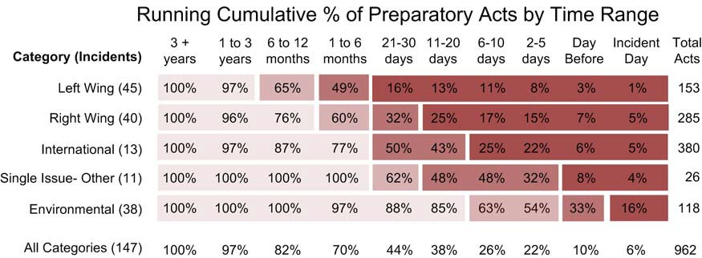

It should be noted that the temporal analysis is a very conservative representation of the amount of activity that takes place prior to the commission of a terrorism incident. Temporal
data was not collected for a significant number of the antecedent acts coded from the open source materials. Additionally, more acts were certainly to have been committed in preparation for the terrorism incidents than were found in the open source materials. This is a major limitation of
this type of research and specifically temporal analysis of terrorism incidents. Thus, the results here should be viewed as minimums in terms of the number of acts that took place and the time of planning. Specifically, the results show the minimum amount of time that the incidents were planned and the minimum number of acts that took place. However, we have no reason to believe that missing temporal data is non random. Therefore, comparison across groups is assumed to be valid. It is anticipated that with increased funding that these temporal dimensions

can be better addressed through increased data collection and mining of additional open source documents.

Temporal Patterns of Right-Wing Terrorists

The right-wing category of terrorist groups had the third highest ratio of incidents analyzed temporally to incidents collected (53%, 40 of 75). The amount of temporal data available for coding was similar to that of the left-wing category (59%). Dates were found to be most prevalent in court case documents (35 of the 40 incidents analyzed were found in ATS court cases). Temporal data bout right-wing group preparatory activities were far easier to collect than were ancillary activities. Of all the preparatory acts collected for right-wing groups, 74% (284 of
386) yielded dates for events. Only 36% (40 of 111) of ancillary acts collected yielded valid temporal dates. The acts relating directly to the incidents recorded were found largely in the court documents and had specific dates mentioned. The ancillary activities were found in media articles and other open source documents and did not always have specific dates mentioned. Figures 14 and 15 show the number of antecedent activities that were recorded, breaking them into time periods for visualization of the antecedent activities prior to the commission of an incident. They are divided into arbitrary groups for ease of graphic presentation.

Figure 14. Right-Wing Group 1 Antecedent Activity

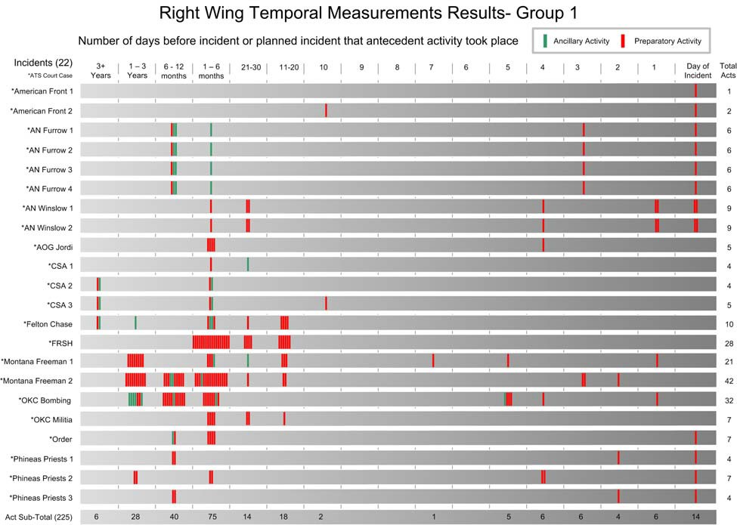

Figure 15. Right-wing Group 2 Antecedent Activity

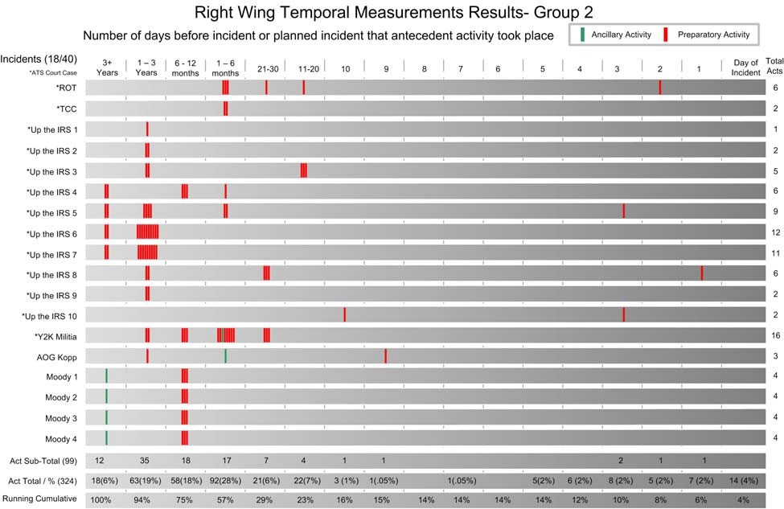

The figures above illustrate the temporal dimension of right-wing planning and preparation for incidents. The majority of the activity is preparatory and thus directly related to the incident that was being planned. The preparation process for the Right-wing incidents seems to differ greatly from that of environmental and international groups. Over 70% of the acts (231 of 324) were carried out more than one month prior to the commission of an incident. Additionally, almost half of the antecedent activity occurred greater than six months (43%, 139 of 324) prior to the incident. The majority of these acts were meetings, travel, phone calls, and bank fraud in preparation for the incidents.

In addition to the temporal measurements chart above, the incidents relating to a specific case study can be viewed through a temporal timeline for analysis. In Figure 16 below, the “Up the

IRS” case study is shown with all of the incidents and their preparatory activities shown on the timeline. In this particular case study one individual or “lone-wolf” carried out a series of bombings primarily targeting the IRS. Such “anti-tax” feelings are common to groups of the extremist right. Temporal timelines for each incident such as the one shown below can be created using the dataset.

Figure 16. Right-wing Group Case Study- Up the IRS Timeline

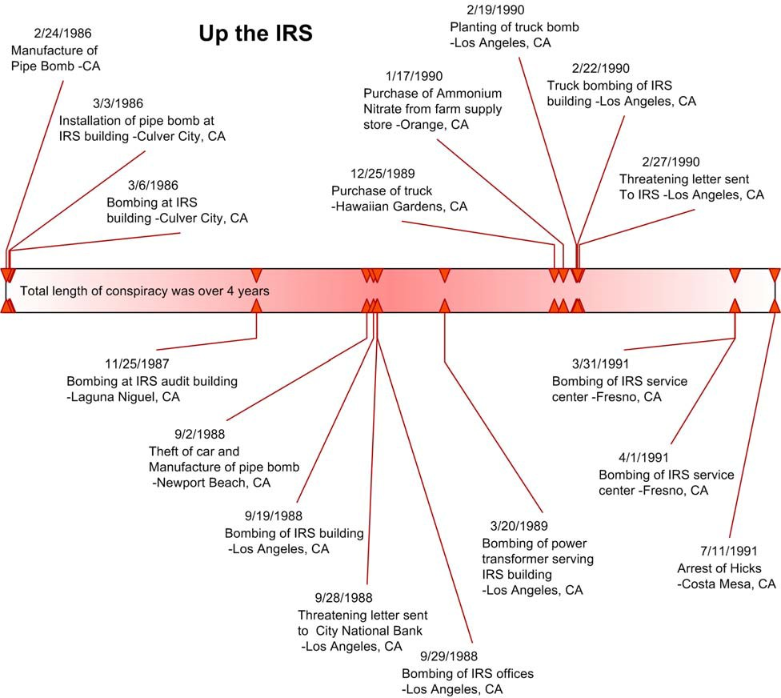

Temporal Patterns of Left-Wing Terrorists

Left-wing temporal analysis was similar to the right-wing groups in that the preparation and planning for terrorism incidents seem to have involved a significantly longer period than that of the other terrorism categories. The exception is the single issue – other category, but to the low number of incidents and acts recorded the validity of the analysis is low. Thus, compared to the other categories left-wing groups have the longest planning period leading up to the commission of incidents. Almost two-thirds of the activity (60%, 172 of 285) took place greater than 6 months from the incident or planned incident. This was a larger amount than the right-wing category and significantly greater than international and environmental categories. Almost half of the recorded incidents that were analyzed spatially cam from the United Freedom Front. This group was very active in bombing targets of the course of a decade. The amount of information found in the court records involving activities closer than one month to the incident was practically non-existent. There was certainly activity that took place in order to carry out the incident, but it was just not found in the open source data.

In terms of data collection results, temporal information was found in similar amounts to that of the right-wing and environmental groups and significantly more so than the international groups. Data collection yielded valid temporal data on 46 of 78 left-wing incidents collected. Once again the number of incidents extracted from ATS court cases was high; in fact all of the incidents gathered for left-wing groups were from ATS court cases. Figures 17 and 18 show a breakdown of left-wing groups antecedent activity by incident plotted on a timeline.

Figure 17. Left-wing Group 1 Antecedent Activity

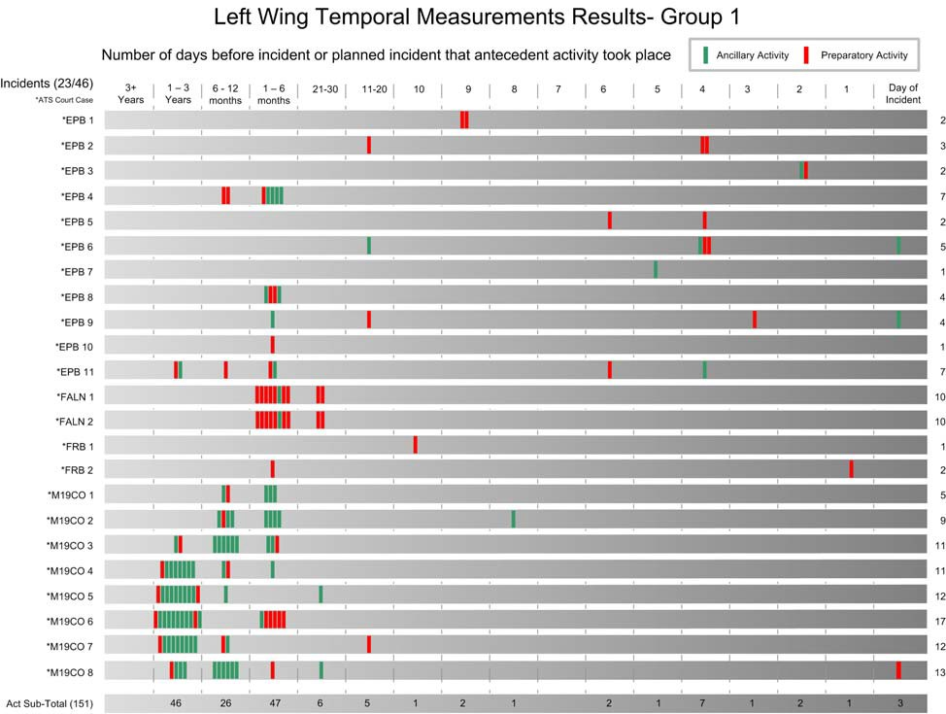

Figure 18. Left-wing Group 2 Antecedent Activity

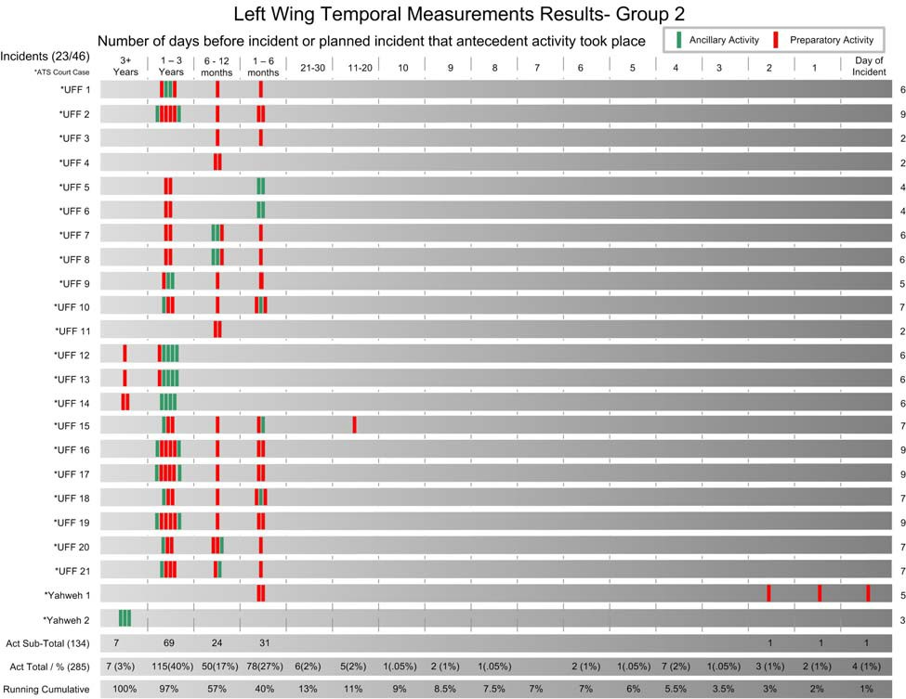

A difference in the amount of ancillary activity that data collection yielded is noticeable from that of the right-wing groups. A total of 382 antecedent acts, 110 ancillary and 172 preparatory were collected for all left-wing incidents. Over three-quarters of the acts, (77%, 285 of 382) had temporal data collected from the open source documents. Over a third of these acts, (39%, 110
of 285) were ancillary in nature and thus not directly related to any single terrorism incident. These activities involved meetings, phone calls, and smuggling activities that were not directly related to a specific incident.

Temporal Patterns of International Terrorists

The amount of temporal data available on the population of international incidents in the United States is limited for two reasons. First, international terrorism has been relatively rare in the United States compared to other types of extremist violence and thus the total number of incidents that have occurred is significantly less than the other categories (Figure 13). Second, the FBI has been remarkably successful in preventing terrorist plots involving international terrorists operating here in the United States. Consequently, while the ratio of measurements of preparatory activity data to incidents was the highest of all the categories (36:1), early intervention precluded the identification of a projected or actual incident date for the majority of the incidents yielded the lowest overall percentage of incidents analyzed (24%, 13 of 54). Rather than speculate regarding projected dates, the cases have been excluded from the analysis. Only cases where an actual incident date or a projected date for the attack was known are included in the analysis.

The basic temporal pattern is shown in Figure 19 below. It should be cautioned that the small sample size of incidents precludes us from making conclusive statements regarding these patterns. However, the differences between the international terrorists and the other categories are enlightening. The data suggest a more extensive planning cycle among international terrorists than among domestic terrorist groups. This is likely the result of the activities surrounding the commission of the 9-11 attacks overwhelm the analysis of the data. In fact incidents involving Al Qaeda make up the majority of the temporal measurements made. These attacks that occurred such as 9-11 and the planned attacks on New York City’s subways and bridges required a sophisticated amount of preparation to pull off such complex attacks. A lot of

people and equipment had to be involved in order to carry out these large scale terrorism incidents. Additionally, the scale of these attacks yielded a large amount of media articles and very detailed descriptions of the preparation that took place in the court documents. Once again, however, these averages can be misleading due to the small number of incidents overall. Therefore, temporal diagrams were also created for each of the international incidents and then compiled on a single timeline.

Figure 19. International Antecedent Activity

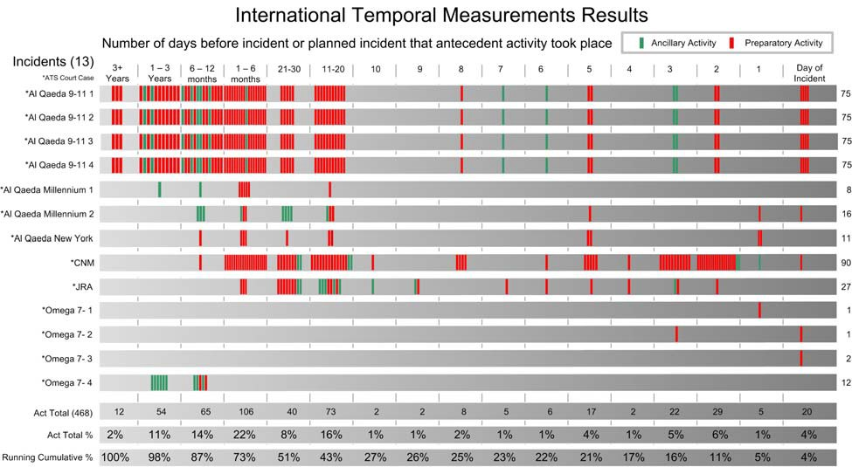

Figure 19 supports the “patterns” suggested above. While 21% of the antecedent behaviors by the international terrorist groups occurred in the less than 5 days immediately prior to an incident, only 14% and 6% of right-wing and left-wing groups occurred in this same time period. The international groups appear more similar to the environmental groups who committed 28% during this same time. This trend continues the farther back one goes in the planning cycle. By
6 months back from the incident date, 73% of the antecedent conduct had been committed

compared to only 57% and 40% or right-wing and left-wing groups. Once again the international groups were more similar to the environmental groups who had completed 81% of their acts. However, most of the international cases studied (excluding 9-11) where preparatory data could be matched with an incident date- the first known preparatory behaviors began about six to twelve months prior to the incident.

Temporal Patterns of Environmental Terrorists

The patterns that were revealed in previous temporal research from the PITA and GATA project were substantiated in this latest research. The single most prominent pattern that emerged regarding environmental terrorists is that they seem to be much more spontaneous than other types of terrorists. For groups adhering to an “uncoordinated violence” approach to terrorism, this was highly expected. Adopted by many terrorist groups in the early 1990s, uncoordinated violence emphasizes lone activities, greater commitment by “true believers,” and fewer contacts between the leaders of extremist movements and those who engage in terrorist actions. Uncoordinated violence is exemplified by the extreme rights’ use of “leaderless resistance,” Islamic extremists’ use of the “fatwah,” and violent anti-abortion activists’ use of internet “hit-lists.” Animal Liberation Front (ALF) and Earth Liberation Front (ELF) extremists adhered to a similar strategy, encouraging individual adherents to undertake “direct actions”
without supervisory guidance or direction. All of these efforts are intended to minimize civil and criminal liability for group leaders. Use of this tactic should result in fewer and smaller conspiracies, less contact among participants, and generally fewer preparatory activities.

As expected, the planning process was remarkably short for most of the environmental incidents and the number of antecedent (preparatory and planning) behaviors associated with the

terrorist incident was less than for other types of terrorist groups previously studied. The great majority of the first known preparatory activities of the group took place approximately four months prior to the incident Ancillary activities not directly related to a specific incident were found as far back as 3 years from the incident date, but this is not unusual once you take a look at the types of activities. It was not uncommon to find that the individuals attended conferences or protests for some time leading up to their extreme radicalization. They seemed to be very mobile
– traveling from coast to coast to attend rallies and protests. Overall, for the environmental groups the temporal data shows a more shortened time period of preparation for an incident. The lifespan of these “cells” ranged from a few days to more than six years. These basic findings are presented in Figures 20, 21, and 22.

All of the recorded events were placed on a single form that recorded the type of event and the number of days prior to the terrorist incident the event occurred. Figures 20 and 21 shows all of the recorded events for the environmental cases with the exception of incidents involving “the family” case.15 As these figures show, almost half of the known preparatory behaviors occurred within 30 days of the incident and almost 90% occurred within 1 year of the incident. Frequently these incidents involved local environmental activists who became “revolutionized” after hearing speeches by nationally known radical environmentalists. In the days and weeks following those speeches, local activists planned and committed attacks on local targets.

15 The ELF/ALF “Family” case is the largest environmental case in U.S. history. Consequently, incidents involving this group were analyzed separately. See Federal Criminal Cases CR 06-60069, 70, 71, 78, 79, 80, 120, 122, 123,
124, 125, and 126; United States District Court, District of Oregon for more information.

Figure 20. Environmental Antecedent Activity Group 1

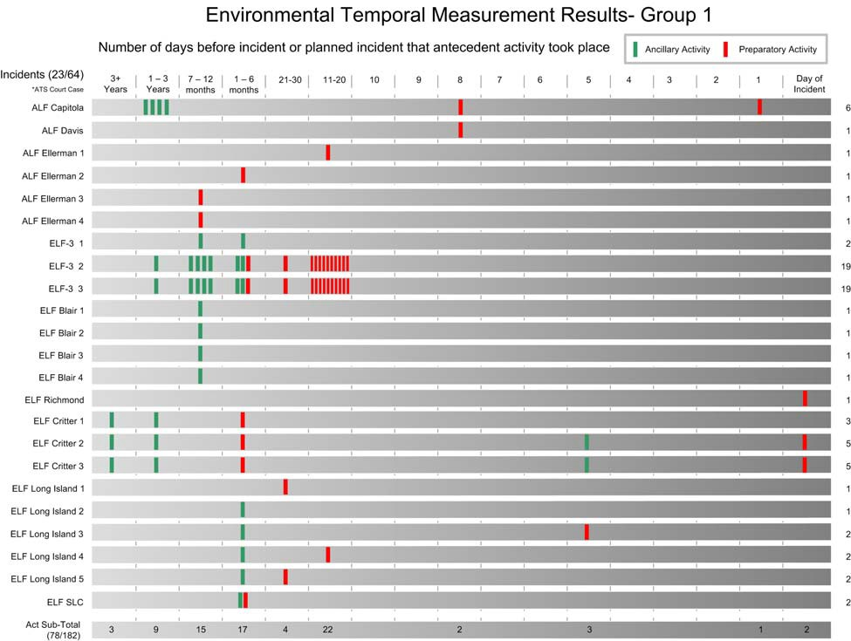

Figure 21. Environmental Antecedent Activity Group 2

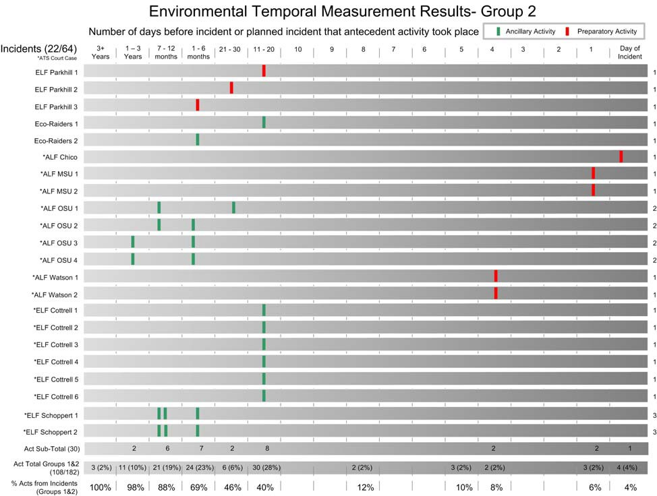

The destructive level of environmental terrorism soared from 1995-2001. Attacks on federal Bureau of Land Management facilities, university labs, and private enterprises such as lumber companies and ski resorts reached a peak in 1998 and 1999. Many of the attacks were the result of a single environmental group known as the “book club” or “the family.”16 This group of approximately sixteen to twenty individuals engaged in over twenty FBI officially designated acts of terrorism during this seven year period. See Figure 22 for a summary of Family activities during this period. Sometimes acting alone, but more frequently in small groups of three to five, the Family committed the most notorious acts of environmental terrorism in U.S. history.

16 Government’s Sentencing Memorandum, CR 06-60069, U.S. District Court, District of Oregon, Eugene, Oregon.

Adopting a “cellular” model in lieu of the more prominent “uncoordinated violence” model advocated by environmental extremist leaders, the Family engaged in training classes to learn sabotage techniques, encryption software, and security measures to minimize infiltration by law enforcement. Consequently, this provided an opportunity to examine if organizational
differences between the Family and other environmental extremists resulted in different temporal patterns of behavior. Due to its use of a cellular approach, we expected to find that the Family would engage in more planning and preparatory activities and that the planning process would be considerably longer than previously studied acts of environmental terrorism.

Figure 22. Environmental Antecedent Activity Group 3 (ELF The Family)

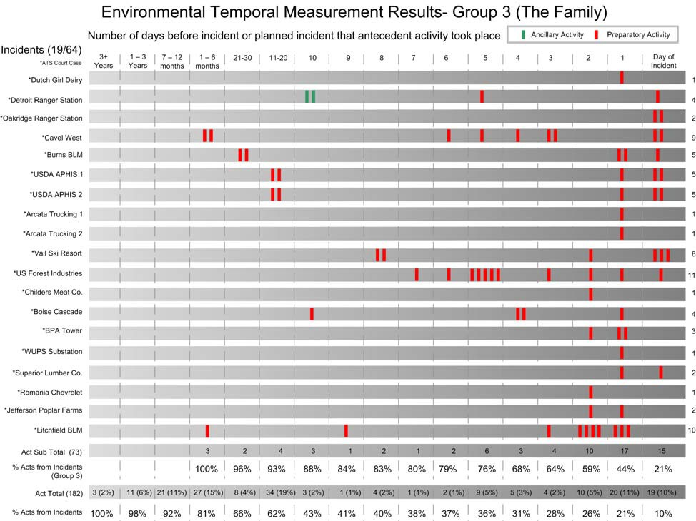

However, as Figure 23 shows, the Family was actually more spontaneous than other environmental groups. This cell committed over a third (19 of 64) of the incidents that were measured in the environmental temporal analysis. Approximately 85% (62 of 73) of their known antecedent activities relating to specific incidents occurred within six days of the incident. Over
95% occurred with ten days of the incident. This is an extreme departure from other terrorist groups. Most striking is that three-fourths of these activities occurred within the three day period immediately prior to, and including, the day of the incident. These activities typically included purchasing the materials for the incendiary device to be used in the arson. Rather than transport these materials over great distances, usually these were purchased from a local store, such as a Wal-Mart, in the immediate vicinity of the target. A staging area was selected and the firebomb was usually constructed on site at the staging area the day of, or one day prior to, the bombing. Because the planning sequence was so short and many of the preparatory activities did not involve illegal acts, these tactics gave law enforcement little opportunity to intervene early. However, had early intelligence been available regarding, for example, the purchase of the particular combination of ingredients used in most of their incendiary devices, local law enforcement would have known that: (1) an attack was imminent, and (2) that it would take place in the general vicinity of the purchases.

Figure 23. Cavel West Arson Temporal Diagram

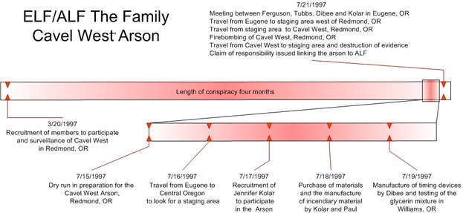

Figure 23 shows how this temporal information can be viewed by other methods such as a timeline of a specific incident. This particular incident involved the arson through the use of an “improvised incendiary device” (IID) on a horse slaughterhouse in Redmond, OR. This incident was carried out by five individuals who started planning the operation 4 months prior to the incident. Although, the group decides on the target 4 months, almost all the activity took place during the week leading up to the incident. During this time they traveled from their various residences in surrounding Oregon cities to the incident location to perform reconnaissance in addition to finding a staging area along the way, purchased materials from hardware stores to construct the IID devices, and constructed and tested the IID’s. This incident is a good example of how “the family” carried out there attacks. A comparison of “the family” activities and other environmental cases is compelling in that it revealed that despite differing organizational structures (one being cellular, the other emphasizing “lone wolf” direct actions), the length of the planning process did not vary substantially between these groups. If anything, the Family was more spontaneous than the other cases studied.

Temporal Patterns Single Issue – Other Terrorists

The single issue – other category had the smallest population of case studies and incidents on which to attempt temporal analysis. Out of 8 total case studies and 22 total incidents possible, data collection for temporal information yielded only 4 case studies and 11 incidents with any sort of valid temporal activity. In addition, the ideologies of the groups that fall into this
category are wide ranging from a violent extremist Jewish organization to a lone-wolf that targeted faculty at colleges all over the United States. Because of the wide range in ideology and actors the temporal results are simply not substantial enough to make anything but cursory comments. Figure 24 below shows the results.

Figure 24. Antecedent Activity of Single Issue – Other Terrorists

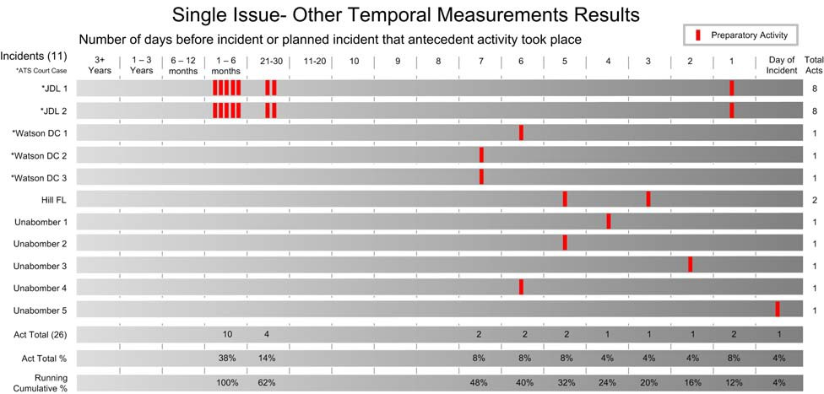

Only 50% of the other category incidents had enough temporal data for analysis. Only 2 of the case studies and 5 of the incidents involved ATS court cases and thus extraction of temporal data was difficult. Figure 24 shows the data that were collected and the limited amount of

preparatory activities that were found. All but 3 of the incidents had only 1 act that was recorded. The majority of these acts were within one week of the incident.

Prevalent Types of Antecedent Conduct

Antecedent conduct is divided into preparatory and ancillary activities. Preparatory and ancillary conduct may include criminal and non-criminal activity. The most common preparatory behaviors included meetings, travel by air or car, purchase of bomb materials and weapons, surveillance and reconnaissance, the purchase of supplies and materials, and banking activities, which included everything from bank robbery to fund the planned incident to legitimate withdrawals. Furthermore, some of the antecedent conduct of terrorists may be ancillary – behaviors related to funding the group or maintaining internal security that are unrelated to the planning and preparation of specific acts of terrorism. The most common ancillary behaviors are meetings, smuggling, travel, phone call, establishing residences, attending conventions, and rental of hotel/motel. A summary of the number of each type of activity by category is included in Table 8.

Table 8. Summary of Antecedent Activities

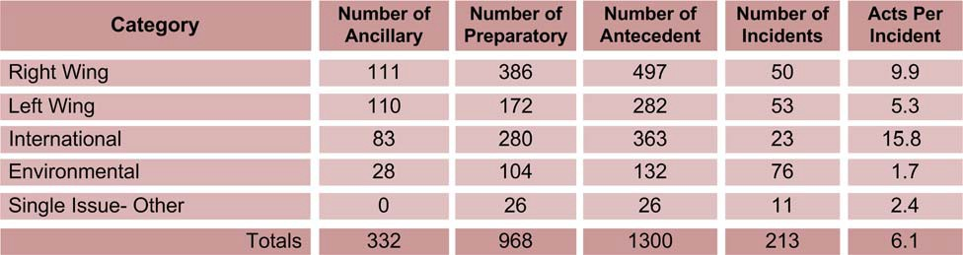

To determine how many antecedent activities terrorist groups engaged in per incident, analysis was conducted restricted to the 213 incidents revealed from data collection on the case studies. Right-wing and international terrorists engaged in a significantly larger number of antecedent behaviors than other terrorists. International terrorists had the highest ratio of acts per incident, 15.8 despite the fact that they committed fewer terrorist incidents. The substantially longer planning and preparation cycle of international terrorists resulted in nearly twice as much antecedent activity as the right-wing terrorists and over three times that of the other terrorist categories.

Right-wing terrorists also engaged in a significant number of antecedent activities in comparison to the left-wing and single issue categories. Each of these behaviors could serve as “pre-incident indicators” to analysts monitoring such activities. However, many of these behaviors, such as buying legally obtainable bomb making components or conducting surveillance on a target, are not illegal. The problems associated with utilizing “reasonable indication” or the existence of a “criminal predicate” (the standards used to determine whether to open an FBI terrorism investigation) may preclude the monitoring of such conduct in the absence of ongoing intelligence investigations. Furthermore, much of the ancillary behaviors may or
may not be criminal. These behaviors, however, may attract the attention of the police and could be utilized as pre-incident indicators of terrorist group activity. The breakdown in Table 8 shows types of behaviors committed by the various categories of terrorists that we were able to record and whether these behaviors were associated with “preparatory” behaviors or whether they were merely “ancillary” activities. Over one-quarter (332 of 1300; 26%) of the activities were ancillary. It is reasonable to assert that the fewer preparatory acts per incident, the less the likelihood that law enforcement would be able to intervene before and incident occurs.

Extensive planning, therefore, becomes a two-edged sword. Terrorist incidents requiring extensive preparation may result in greater damage, but they also are at greater risk of early interdiction.

Table 9 shows the types of behaviors measured by group type. Almost a fourth of these activities or 20 per cent (264 of 1300) involved some form of meeting that was either ancillary or preparatory in nature. It is possible that some of these meetings would be further categorized if more was known about the activities that took place. For example, if weapons or bomb materials were exchanged then they could be classified as “Purchase- Weapons” or “Acquire- Bomb Materials.” Travel by car or air was the second most common activity recorded at 10 per cent (128 of 1300). Activities associated with bomb procurement, manufacture and testing accounted for an additional 8 per cent (102 of 1300) of the measured conduct. The fourth most common activity included behaviors associated with research, training, reconnaissance, and surveillance – all activities reflecting intelligence gathering. The remaining activities included the purchase of supplies and materials, banking activities ― which included everything from bank robbery to fund the planned incident to legitimate withdrawals, weapons violations, and a variety of non- criminal ancillary conduct.

Table 9. Breakdown of major antecedent behavior by type

Antecedent Type

Meeting
Travel- Car 67
Phone Call |  | 62
Travel- Air |  | 61
Purchase- Bomb Materials |  | 43
Surveillance |  | 40
Fraud- Bank |  | 34
Manufacture- Bomb |  | 31
Establish- Residence |  | 28
Transfer- Money |  | 25
Smuggling |  | 25
Reconnaissance |  | 24
Robbery- Bank |  | 24
Purchase- Weapons |  | 22
Rental- Hotel / Motel |  | 21
Threat |  | 21
Possession- Weapons |  | 16
Fraud- Identification |  | 16
Training |  | 15
Procurement- Equipment |  | 14
Purchase- Transportation |  | 14
Rental- Storage Unit |  | 14
Transport- Bomb Materials |  | 13
Communication- Letter |  | 13
Rental- Transportation |  | 11
Attend- Convention |  | 10
Communication- Email |  | 9
Purchase- Airplane Tickets |  | 9
Murder |  | 9
Visit- Family/ Friends | 2 | 8
Issue Fatwah | 2 | 8
U.S. Entry- Legal | 8 | 8
Acquire- Bomb Materials |  | 8
Smuggling- Drugs |  | 8
Research |  | 8
Theft- Bomb Materials

• There were a totalof 1300 recorded acts tied to incidents.The other 290 not shown each occurred less than 8 times.

Labeling specific overt acts as criminal or non-criminal can be problematic. Many acts, when counted independently, might not be criminal, but when considered as overt acts of a broader conspiracy, they become part of larger criminal activities. An act was coded as criminal if given the observance of the act by law enforcement personnel outside of the bigger context of the conspiracy- “would it be considered criminal”? For example, if a police officer observes the legal purchase of materials in a hardware store that could be used to construct a bomb, but is not aware that the individual is part of a conspiracy, then this would not constitute a crime and he could not arrest the individual. We would code this act as non-criminal. If a police officer observes a person shoplifting supplies from a hardware store, as was the case in one ELF Family case study, then the police officer would arrest the person for this act and it would be coded as criminal in the database. This would be coded such even if the person was successful and not observed by a police officer.

Table 10 shows a breakdown regarding whether specific acts would have constituted criminal or non-criminal conduct. Our analysis reveals that the ratio of criminal to non-criminal activity is pretty evenly divided (47% to 54%). The single issue – other category seems to depart from this average, but due to the low number of activities this cannot be assumed to be an accurate measure. The other categories where a large number of activities took place and where the majority of conduct was non-criminal were the international and environmental groups. Non- criminal conduct accounted for 59% of the measured environmental terrorists behaviors compared to 66% of the international terrorists conduct. The right-wing and left-wing groups were similar to each other with more crimes than non-crimes with 53% and 57% respectively.

Table 10. Breakdown of activities into crimes/ non crimes

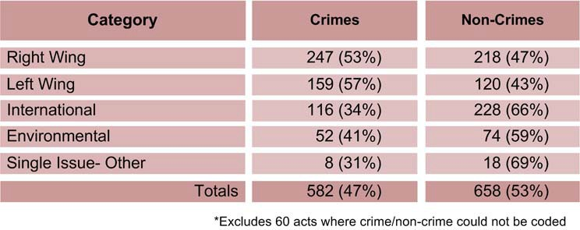

Despite the similar ratio of crimes to non-crimes over all categories, a total of 582 behaviors were recorded that reflected overt criminal conduct. A summary of these crimes is provided in Table 11. The most common of these crimes (27%, 155 of 582) involved overt acts such as meetings associated with broader conspiracies. Conspiracies do not frequently become known to law enforcement agencies until after the completion of the act or other arrests are made. Consequently, many of these behaviors, such as meetings and phone calls, may not come to the attention of local law enforcement agencies if an informant or undercover agent is not in place. However, almost three-quarters of these crimes involved “observable” offenses which might lead the police to suspect more sinister activities.

The most common “observable” criminal offenses were associated with weapons and/or bombs and bomb materials. Over 18 per cent (105 of 582) involved bomb acquisition or manufacture, training, illegal trade, fraud, illegal entry into the United States, weapons violations, and smuggling. The manufacture and testing of bomb making materials constituted the most common “overt” criminal conduct among both right-wing and international terrorists. However, the right-wing terrorists engaged in more preparatory criminal behaviors over all, in addition to violating a much broader range of criminal laws. The breadth and diversity of the

pre-cursor crimes committed by the right-wing is a distinguishing feature among this type of terrorist group. The next most common crimes committed by the terrorists involved procurement of funds for their larger conspiracy. Once again, right wing terrorists were more actively engaged in trying to fund their conspiracies than other group types. Over half of the funding activities recorded (60%, 47 of 81) involved acquiring money through types of bank fraud or robbery.

Table 11. Breakdown of activities by crime type

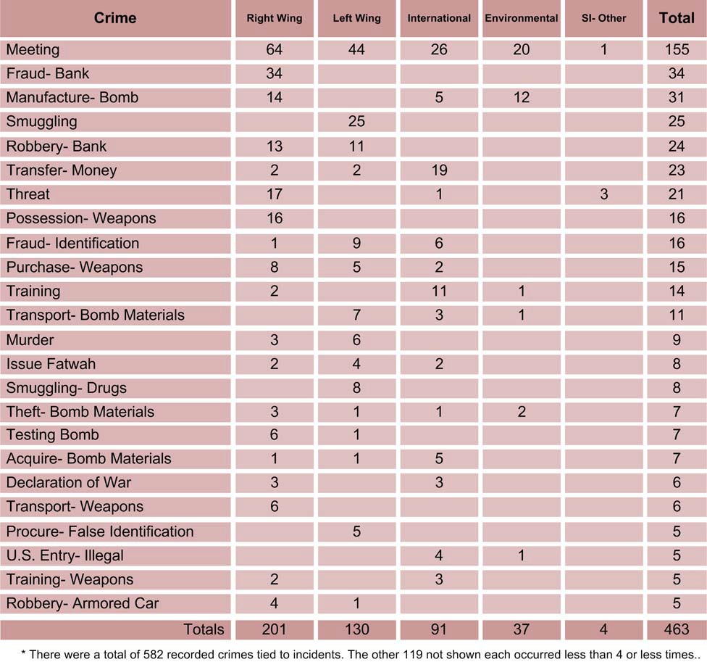

Spatial Patterns of American Terrorism

In this subsection, we review the spatial patterns of terrorists’ behavior resulting from the analysis of the data using the Oracle 10g Spatial package and The Mapworks Inc. MATLAB7 software. Previous research projects have shown a significant amount of geocodable data is available on residences, planning locations, preparatory activities, and terrorism incidents. The current research was able to expand on previous efforts to bring the total geocoded records to
2,364 (see Table 12). However, variability in the quality of the available data affected our ability to geocode to street level in each category of activities.

Table 12. Geocoding success rate for each type of terrorist activity*

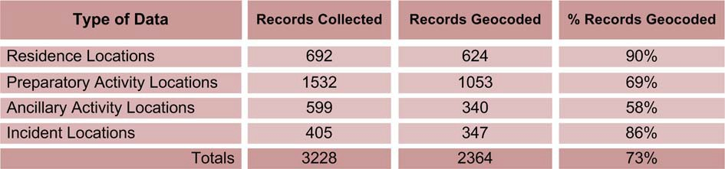

*Does not include 561 geocoded addresses that are Post-Incident related.

The locations of activities where geocoded either to a street address level (1,562 or 53%), street (113 or 4%), or a zip code level (1,250 or 43%). The results from this research are similar to both the GATA and PITA projects. The residences and incident locations had the best geocoding success rate with almost 350 incident locations identified. This was to be expected since targets are often described in explicit detail in open records like indictments. In addition, we were able to find addresses for 90% of the residences. Unfortunately, we were less successful with mapping antecedent activities. Again, this is not so surprising. Open source records commonly reported that “a meeting took place” but there was no record of where the

meeting occurred. Rather than trying to estimate these locations or to impute any of these missing values, we treated them all as missing data and assumed that the error was random.

Once we gathered all of the geocoded information possible, we created a series of “rose diagrams,” a technique that allows the user to plot distance and direction from multiple points of the same type. Rose diagrams allow us to visualize spatial patterns concerning distance and direction for all of the incidents in our case studies. Our first step was to create a circular figure with all of the “incidents” represented by the center of the circle. The circle then was oriented such that the top of the circle (“12 o-clock”) is north and the bottom of the circle is south. If one of the residences for terrorist Group A was located 20 miles to the west of the incident, then we drew a line 20 “units” away from the center (i.e. “incident”) to the left (i.e., “west”). If an residence by terrorist Group B was located 90 miles to the south of the terrorist’s incident, then we would draw a line 90 “units” away from the center in the “6 o-clock position (i.e., “south”). Because there are some extreme outliers in these distances, we categorized the distances using a Log10 transformation for both the rings in the rose diagram and the ranges in the tables. Each incident was subsequently superimposed on the rose diagram such that each incident was “located” in the center of the diagram and each residence was located at the end of each radiating line.

The resulting diagrams show the direction and relative distance between each residence and incident in the database (represented by each of the lines). By representing the measurements from terrorist residences to incidents in this way, we can visualize patterns involving directions or distances. Rose diagrams were created to describe distance and direction: (1) from terrorist
residences to incident locations; (2) from terrorist residences to antecedent location; and (3) from

antecedent activity to incident location. For each rose diagram, we drew one “distance and direction” line for each spatial relationship in our database. We also provide a histogram that shows the variation in distances and a table that provides aggregate information such as means, minimums, maximums, and grouped modal distances. In the following sections, we assess spatial relationships between each of these three key variables (residences, incidents, and antecedent activities).

All Categories Terrorist Residences to Events Analysis

We begin by looking at an aggregate of measurements across all categories from known residences to all known related preparatory, ancillary and incident acts. Measurements to preparatory events exceed the number of measurements to ancillary events and incidents by about four and two times respectively. This reflects the relatively large number of unique preparatory events recorded. In aggregate, we see roughly the same distribution of distances as in the PITA and GATA projects – once again a significant percentage of all recorded residences were located within 30 miles of event. (Table 13) The range bins we have chosen show a relatively even distribution beyond 30 miles.

Table 13. All Categories Terrorists’ Residences to Events Linear Distance Analysis Table

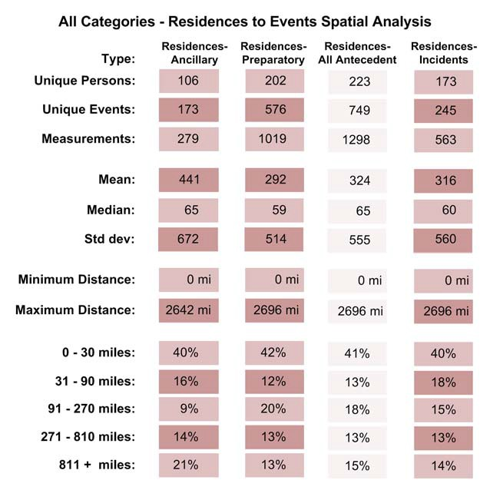

To show the distance measurement results in greater detail a rose diagram and histogram (Figure 25) are shown for the terrorists’ residences to incident analysis. The histogram is heavily skewed to the left and is dominated by short distances. This tends to obscure the smaller peaks
in the right tail of the histogram. These peaks appear at approximately 400 miles, 1,000 miles,

1,400 miles and 2,300 miles. While the number of measurements contributing to these events is relatively small – around 20-50 measurements – they are not typically composed of activities from one group or category. For example, groups whose activities contributed to the peak from
900 to 1,100 miles include AN Furrow, ARA, Al Qaeda 9-11, CNM, Chewning, ELF 3, ELF Family, El Rukns, JRA, M19CO, Montana Freeman, OKC Bombing and Omega 7. Here, as in all the spatial analysis in the report, the median value is a much better measure of central

tendency than the mean. No subset of our spatial measurements exhibits a strong Gaussian distribution but instead reveals one or more large peaks, several smaller peaks and large variation. The median is a much better measure in this case.

Figure 25. All Categories Terrorists’ Residences to Antecedent Activities Rose Diagram

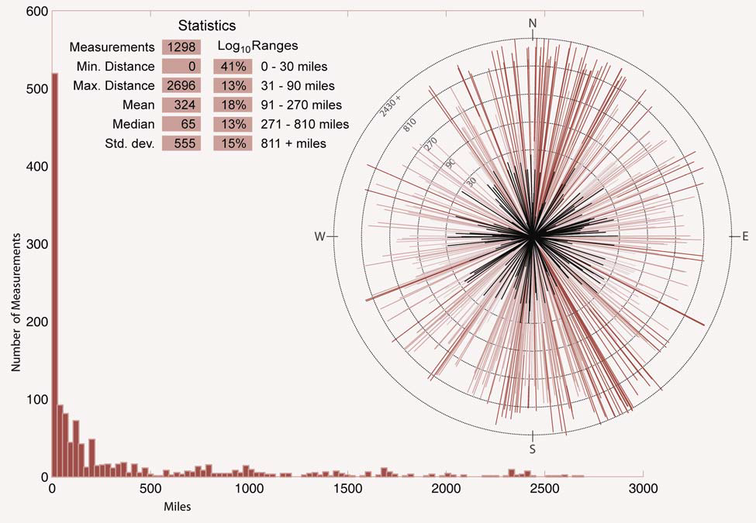

Further analyzing the make-up of these antecedent activities reveals some patterns specific to certain pre-cursor crimes used to fund and support the overall conspiracy. Reppetto (1974) and Wright and Decker (1994, 1997), found that traditional offenders commit their offenses close to their places of residence. Their findings served as a starting point to determine if the same were true of terrorist’s behaviors. In general, one of the major findings from these three projects has been that terrorists do tend to act locally. Ironically, this did not apply to the two specific types

of crimes studied by Reppetto, Wright and Decker. Instead, we found that residences and target selection were closely related, terrorist committed crimes of theft and robbery much farther away from the target.

Table 14. All Categories Terrorists’ Residences to Thefts and Robberies Distance Analysis

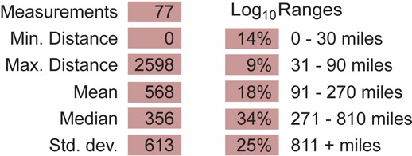

Table 14 shows that the average distance from terrorist residence to the theft or robbery is

568 miles (mean 568 miles; median 356 miles, n = 77) with almost 60 percent (59%) occurring farther than 271 miles away from the residence. This is considerably farther than other types of antecedent conduct (mean 324 miles; median 65 miles; n-1,298) where the patterns support the notion that terrorists’ behave like traditional criminals, acting within restricted activity spaces with over 41 percent occurring within 30 miles of the residence. (Table 13) These findings suggest intentional efforts on the part of terrorists to avoid drawing attention to locally selected targets.

However, in order to place the measured activities in the context of ordinary behavior in the

United States, we looked at the US Census Bureaus’ analysis of average drive times of workers

16 years and over for the year 2,000. Figure 26 is taken directly from the Census Bureaus’ American Fact Finder website. It shows the expected value (some measure of central tendency, not necessarily the mean) and the 90% confidence on those estimates by city. Across the US, drive times range from just over 16 minutes (perhaps 5 – 10 miles) in Tulsa, OK to nearly 40

minutes in New York City. In large metropolitan areas, drive times are obviously influenced by congestion as well as distance, so it may not be possible to estimate a standard distance-time relationship.

Figure 26. Average Travel Time to Work (In Minutes) Workers 16 Years and Over

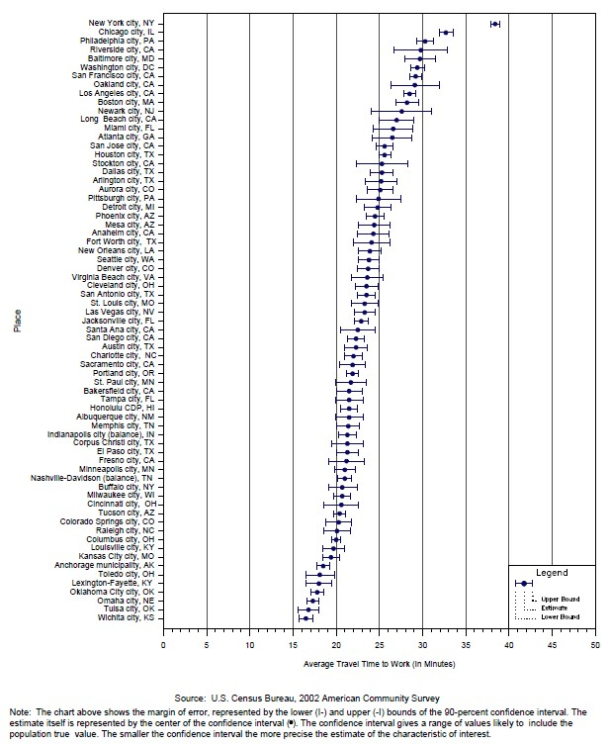

However, we note that even a conservative relationship reveals that the average distance people live from their place of work is well under 30 miles. If we consider terrorist activities and incidents as the “work” of terrorists, then our terrorists tend to operate farther away from their

residences (with a median distance of 60 miles) than the average US worker. Still, 40% seem to behave similarly to ordinary workers. This analysis is shown in further detail (Figure 27) by the rose diagram and histogram for the terrorists’ residences to incidents analysis below. A similar pattern exists in this diagram to the terrorists’ residences to antecedent activities diagram above.

Figure 27. All Categories Terrorists’ Residences to Incidents Rose Diagram

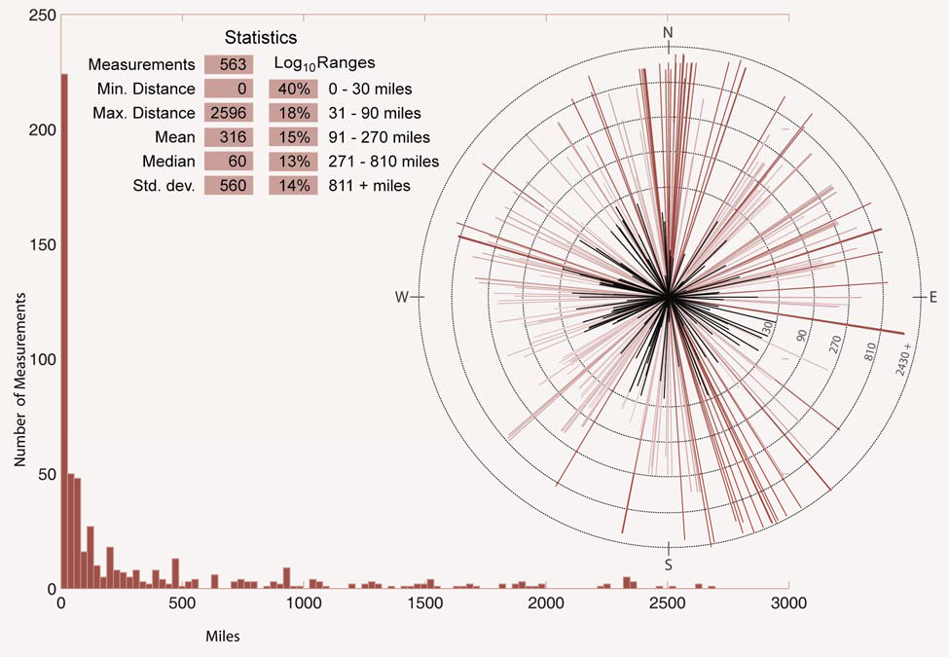

The histogram is heavily skewed to the left and is dominated by short distances. This tends to obscure the smaller peaks in the right tail of the histogram. These peaks appear at approximately 200 miles, 500 miles, 900 miles, 1500, and 2,300 miles. Subsequent work can look at this relationship with the more fine-grained approach of disaggregating drive times to the

county, tract and census block level and correlating the local values with the operating areas of the terrorist groups in this study.

ATS Only Terrorist Residences to Events Analysis

Measurements taken from the ATS database showed no marked difference from the full data set, with one exception. While the residence to antecedent events distribution was very similar to the full dataset, the residence to incident distribution changed significantly. Whereas
approximately 40% (225 of the 563) measurements in the full data set were under 30 miles, only

31% (133 of 463) of the ATS measurements where within 30 miles. (Table 15) This difference is due to removal of environmental cases that were non-ATS incidents. Further analysis is needed as to why they were not included in the ATS dataset in order to draw further conclusions.

Table 15. ATS Only Terrorists’ Residences to Events Linear Distance Analysis

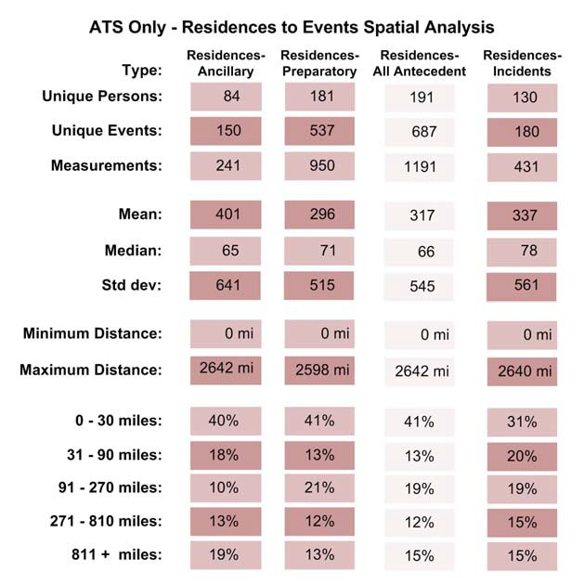

Right-Wing Terrorist Residences to Events Analysis

Subsets of spatial measurements in the right-wing category tend to be dominated by a relatively small number of case studies. For example, 263 of 614 residences to antecedent measurements are taken from cases involving Montana Freeman, Order and KSM (out of 33 case studies). Of the 71 residence to incident measurements, 21 come from Montana Freeman and Up the IRS case studies. Each of these case studies has twice as many measurements as the other 31 case studies in the category.(Appendix A) We think, therefore, it is important to avoid the tendency to over generalize these results. Nevertheless, we note that in this category, group members ventured farther from their residences. (Table 16) The median of these measurements was significantly higher that the full data set and the measurements were much more evenly distributed across our range bins (0-30 miles, 31-90 miles, etc.).

Table 16. Right-Wing Terrorists’ Residences to Events Linear Distance Analysis

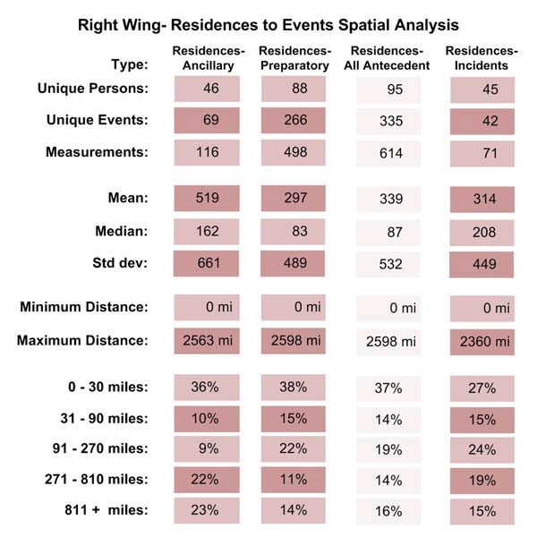

This is especially true of residence to incident measurements. (Figure 28) Only 42% of the incidents were within 90 miles. The peaks are caused by the domination of the case studies mentioned above. The overall picture of the spatial relationship between right-wing terrorists’ residences and incidents shows a more dispersed pattern in terms of the locations of residences.

Figure 28. Right-Wing Terrorists’ Residences to Incidents Rose Diagram

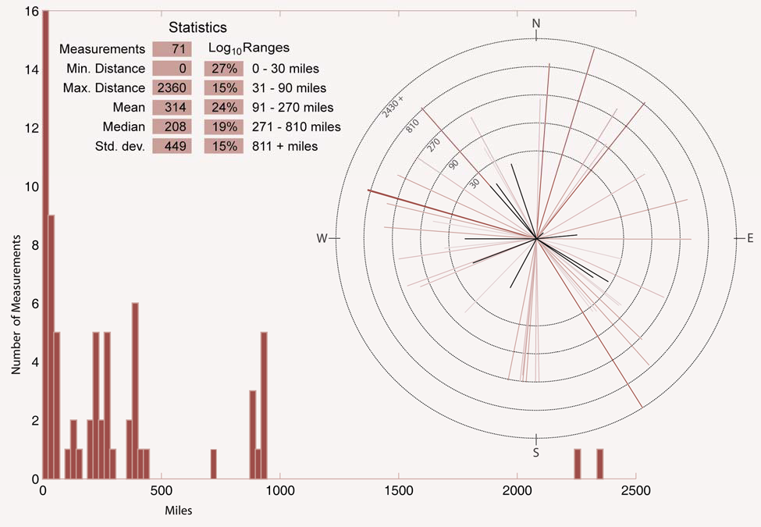

In contrast, residences to ancillary measurements show a distinctive bi-model distribution with a large number of measurements less than 30 miles (36%) and an even larger number of measurements beyond 271miles (45%). This modality would be more apparent in logarithmically scaled histogram but can also be seen in the linear histogram below. The larger number of residences to preparatory acts shows less bimodality but it is apparent that more

preparatory activities in this category occur near a residence than the incident itself. Fully 53%

of preparatory events were within 90 miles of the related residence.

Figure 29. Right-Wing Terrorists’ Residences to Antecedent Activities Rose Diagram

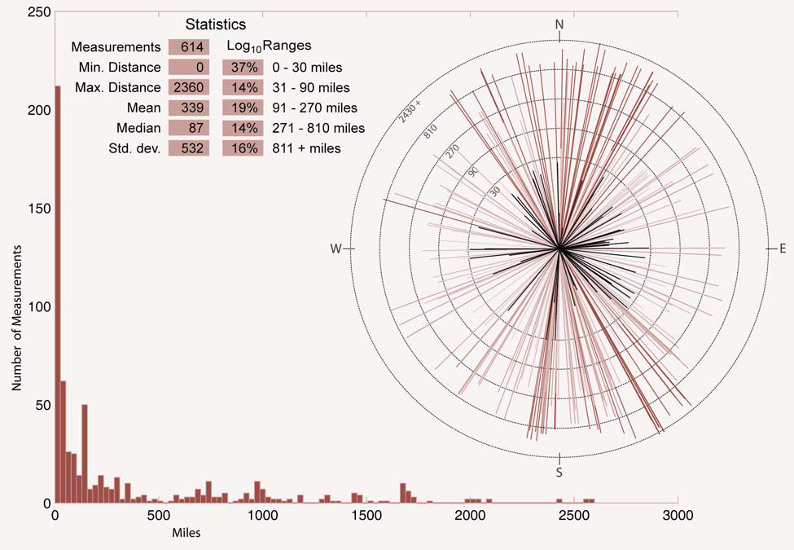

Left-Wing Terrorist Residences to Events Analysis

Left Wing terrorist groups in this study showed a tendency to establish residences near to both antecedent acts and incidents themselves. Over one-half of the residences to antecedent measurements were less than 30 miles and over two-thirds of terrorists’ residences were within
90 miles of the incident target. Table 17 shows the major differences that exist between the residences to antecedent activities measurements and that of the incident locations.

Table 17. Left-Wing Terrorists’ Residences to Events Linear Distance Analysis

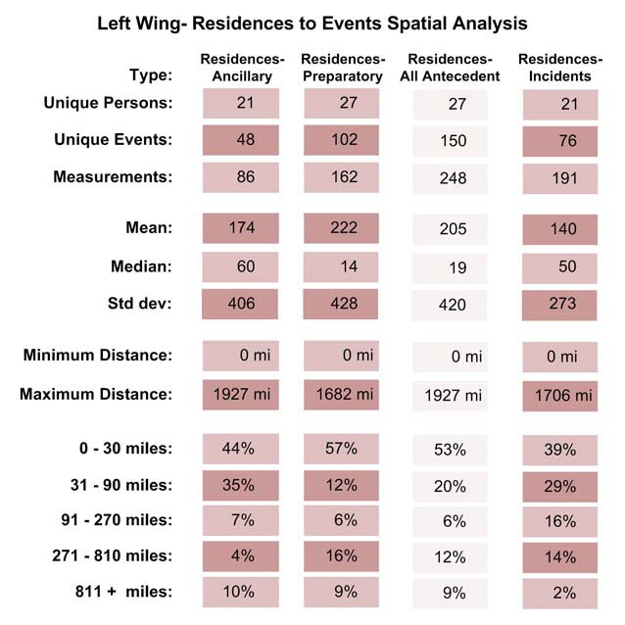

While only 39% of the residences to incident acts were within 30 miles (much closer to the full data set value), 68% were less than 90 miles. Figure 30 shows the very long tail of the histogram revealing that the means in this category are almost meaningless because of the few very distant events.

Figure 30. Left-Wing Terrorists’ Residences to Incidents Rose Diagram

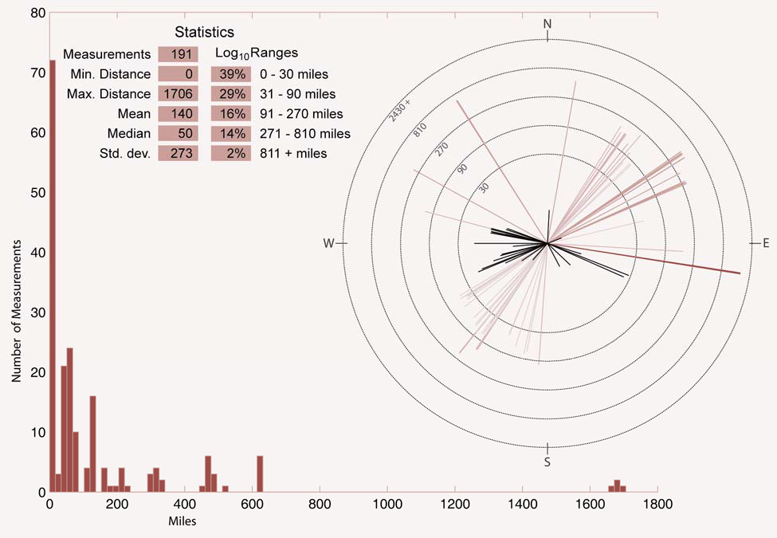

However, measurements in this category were better distributed across the 9 case studies. It is important to point out that 156 of 191 residences to incident measurements were taken from UFF, M19CO and FALN. Likewise, 170 of 248 of residences to antecedent acts were taken from three case studies – EPB, UFF and WUO-FALN. Figure 31 shows the left-wing residences to antecedent activities measurements histogram and rose diagram. Over half (53%) of all antecedent acts were conducted within a 30 mile radius of the target and almost three-quarters (73%) were within 90 miles. Again, generalizing these results is possible, but should be made with caution.

Figure 31. Left-Wing Terrorists’ Residences to Antecedent Activities Rose Diagram

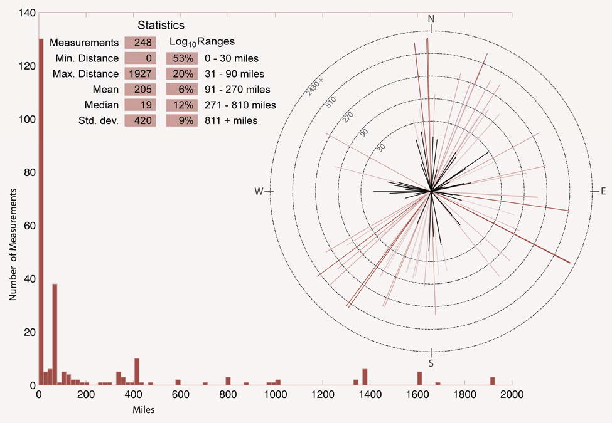

International Terrorist Residences to Events Analysis

Measurements taken from the 13 case studies in this category are dominated by four case studies – the three Al Qaeda case studies and CNM. The antecedent acts of international terrorist groups also exhibit strong bi-modality and long, but significant, right tails. Means and standard deviations are less meaningful than our “outlier” resistant measurements. Concerning residences to preparatory measurements, there is a gap from 31-90 miles with 47% of the measurements less than 30 miles but 48% beyond 90 miles. These patterns are exhibited in Table 18 and Figure 32.

Table 18. International Terrorists’ Residences to Events Linear Distance Analysis

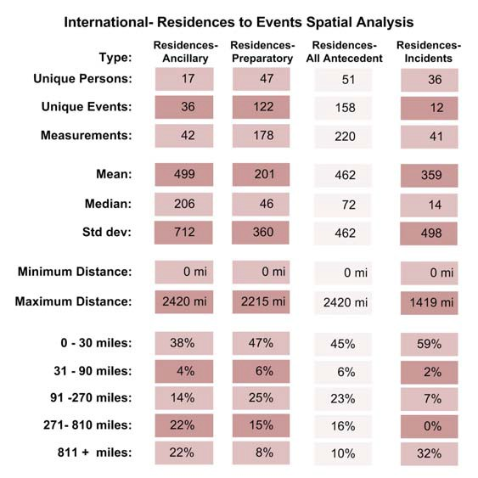

Figure 32. International Terrorists’ Residences to Antecedent Activities Rose Diagram

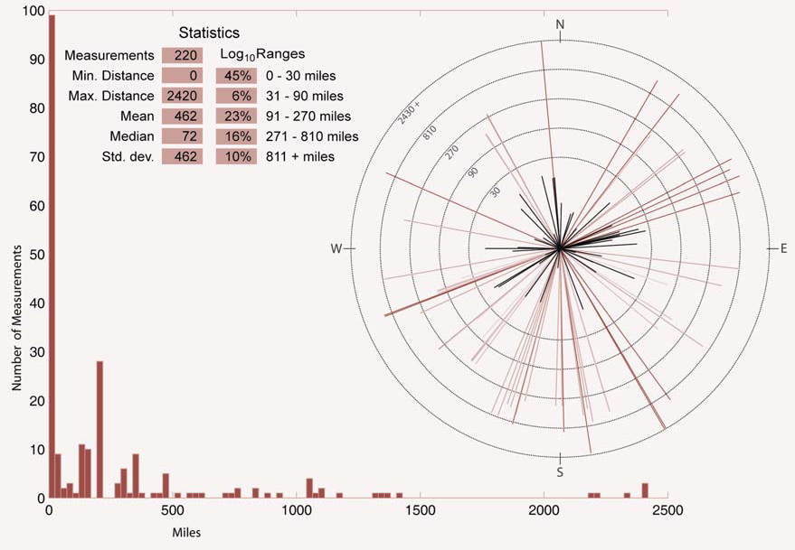

An even larger gap is found in the residences to incident measurements – only 9% of the measurements falling between 31 and 810 miles. In Figure 33 below, the international terrorists’ residences to incident results are shown. The histogram of residences to incidents shows a cluster below 30 miles and a second significant cluster from 900 – 1100 miles. This second cluster is made up almost entirely of the Al Qaeda New York, Al Qaeda Millennium and Jokhan bombings. Due to the low number of measurements and the small number of groups which dominate the results, the extension of patterns to other groups should be done with caution.

Figure 33. International Terrorists’ Residences to Incidents Rose Diagram

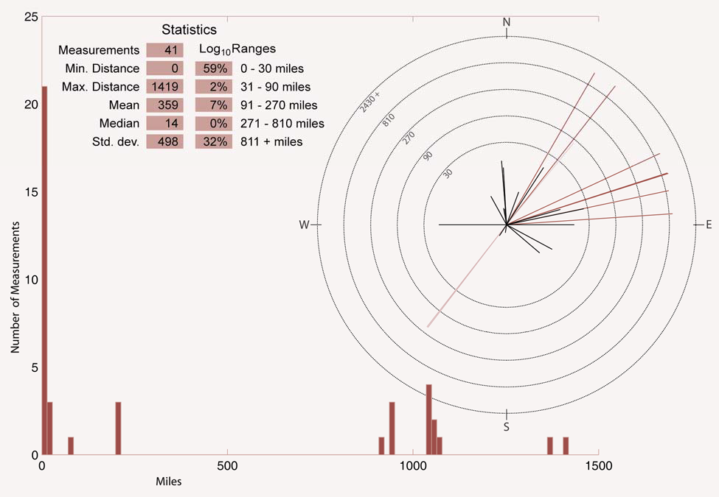

Environmental Terrorist Residences to Events Analysis

Of the 23 case studies in this category, only 7 are taken from the original ATS, and one – ELF Family – consists of measurements that account for 111 of the 198 residences to antecedent measurements. It is for this reason that this case study was given more attention in the prior GATA study. The case does not dominate the residence to incident measurement as much (only
61 of the 236) but still represents 25% of the available measurements. We were able to collect open source data on fewer (in some cases far fewer) residences antecedent measurements than residences to incident measurements. The two notable exceptions are ELF Family and ALF Wisconsin).

Table 19. Environmental Terrorists’ Residences to Events Linear Distance Analysis

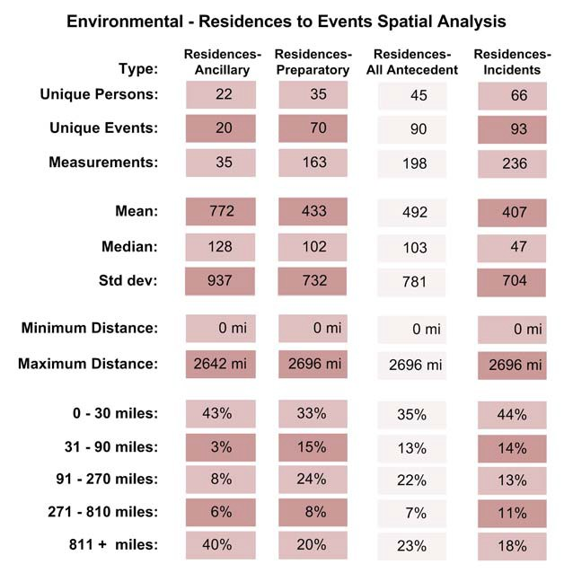

Figure 34 shows the spatial distribution of the environmental terrorists’ residences to incidents rose diagram and histogram. Almost 50% of the residences were located within 30 miles of the incident target. The distribution in the other distance ranges is split pretty evenly with a slight increase at the farthest distance.

Figure 34. Environmental Terrorists’ Residences to Incidents Rose Diagram

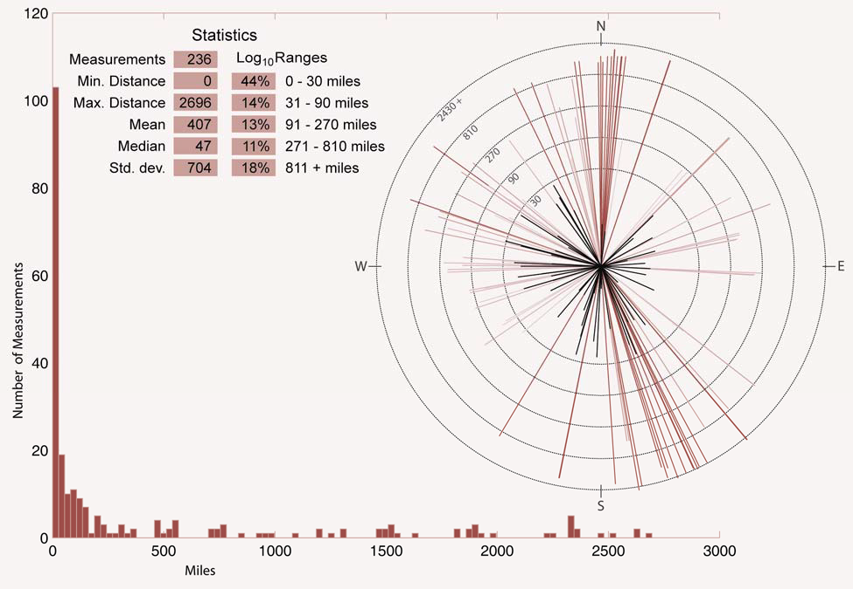

Residences to antecedent measurements in this category showed four loose clusters – one from 0 to 200 miles, another around 500 miles, a third between 800 and 1000 miles and a large one around 2250 miles. (Figure 35) Still, 35% of the measurements to antecedent activities were less than 30 miles while 30% were beyond 270 miles. Residences to preparatory acts were more evenly distributed: note that one-third were less than 30 miles, roughly one-quarter were

between 91 and 270 miles, while another one-quarter were beyond 810 miles. The distribution of distances from residences to incidents was more bi-modal (at least on a logarithmic scale).

Figure 35. Environmental Terrorists’ Residences to Antecedent Activities Rose Diagram

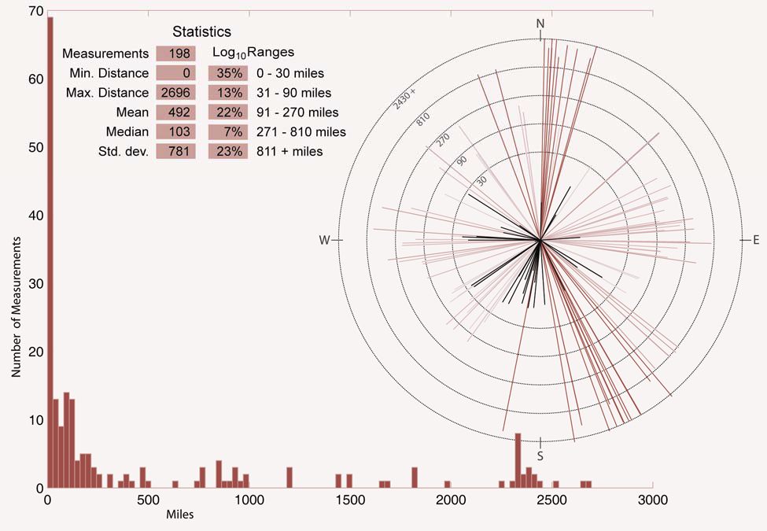

Single Issue – Other Terrorist Residences to Events Analysis

Of the 24 measurements in this catch-all category, 16 were from the activities taken from the Unabomber case. As this case was somewhat unique, these results cannot be easily generalized. Fully two-thirds of the measurements from residences to incidents were beyond 270 miles because of the nature of the Unabomber attacks. The few residences to preparatory measurements indicate more bi-modality. Activities in the subset are shared by JDL and the

Unabomber (each contributes 8 measurements). Table 20 shows the results of the limited analysis of this category. Further data collection is needed to increase validity of results.

Table 20. Single Issue – Other Terrorists’ Residences to Events Linear Distance Analysis

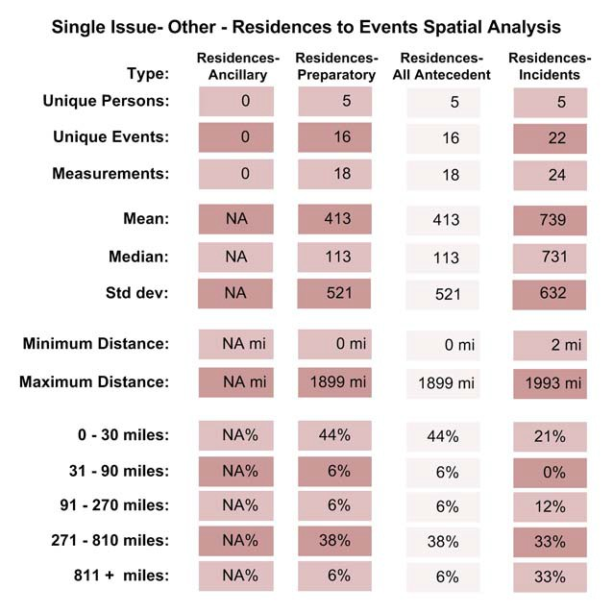

All Categories Antecedent Activities to Incidents Analysis

The histogram of distance measurements from antecedent (preparatory and ancillary) acts to related incidents shows four distinct peaks or clusters. (Figure 36) The first, and largest, occurs at or near zero miles. This reflects the large number of ancillary and preparatory activities that took place at the target itself. Fatwah’s issued for assassinations of former group members, surveillance activities at the target and other preparatory activities related directly to the target contribute to this strong peak.

Figure 36. All Categories Antecedent Activities to Incidents Rose Diagram

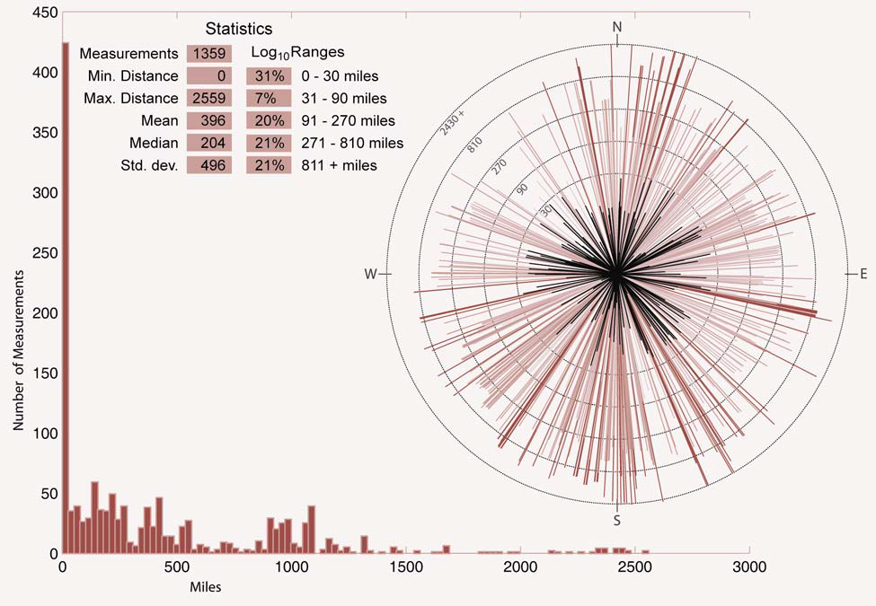

Further breakdown of the results into ancillary and preparatory activities is shown in Table

21. Note that 34% of the preparatory acts occurred within 30 miles of the target. Ancillary acts tend to be more scattered and even quite distant from the target. The second cluster peaks at about 200 miles. A third, weaker, cluster appears at about 600 miles with a final significant cluster appearing between 800 and 1100 miles. Dominant activities in these clusters are clearer in the category analysis in the sections that follow. Medians of these measurements tend to be large, especially for ancillary events (which, as we noted earlier, tend to be scattered). A curious result of the full dataset is the dearth of measurements between 31and 90 miles. We also point out that 62% of the measurements from antecedents to incidents (69% ancillary, 60%

preparatory) are larger than 90 miles. This implies a very large operating area for many of the groups in this study.

Table 21. All Categories Antecedent Activities to Incidents Linear Distance Analysis

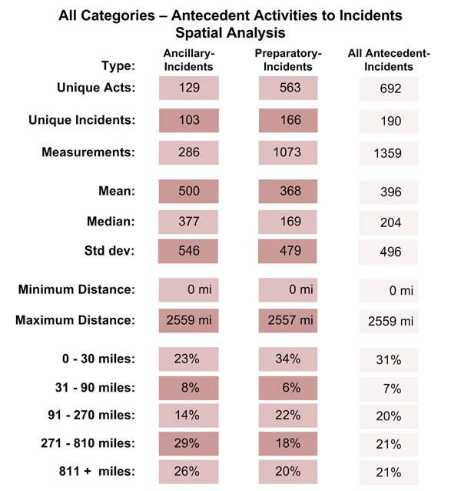

ATS Only Antecedent Activities to Incidents Analysis

A significant number of measurements from antecedent to incident acts in the full dataset came from the ATS data base. As a result, the distribution of distances does not differ significantly from those described for the entire data set. (Table 22)

Table 22. ATS Only Antecedent Activities to Incidents Linear Distance Analysis

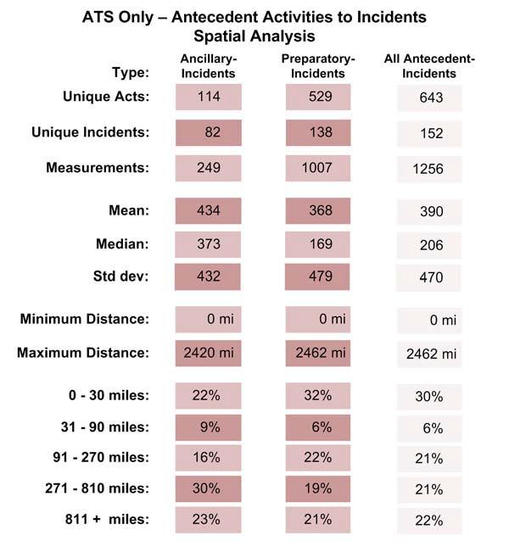

Right-Wing Antecedent Activities to Incidents Analysis

Measurements are well distributed across the groups that make up this category. A few – MP Ricin and OKC Bombing in particular – stand out for the number of measurements they contribute to the total. In general, 8 case studies contribute 288 of the 353 preparatory to
incident measurements. Furthermore, note that the number of preparatory measurements far exceeds the number of ancillary measurements. The results are shown in Table 23 below.

Table 23. Right-wing Antecedent Activities to Incidents Linear Distance Analysis

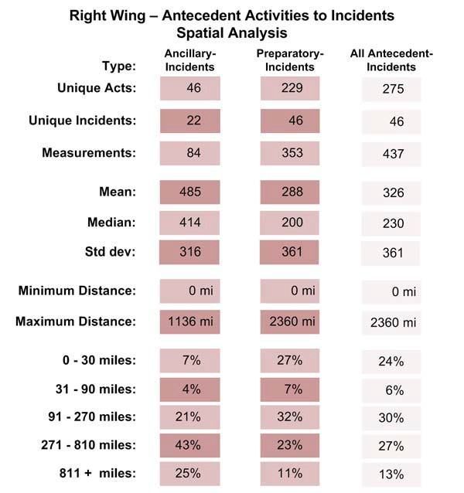

The distance histogram (Figure 37) shows multiple strong peaks in the less than 500 mile range and a strong peak at about 900 miles. Only six case studies (out of the 22 in this category) contribute to this peak - AN Furrow, American Front, CSA, Montana Freeman, OKC Bombing, OKC Militia, Order – and of these, OKC Bombing and AN Furrow contribute most heavily. Ancillary events occurring within 30 miles of the incident are extremely rare (only 7%) but recall that the number of ancillary events is relatively small. Preparatory distributions in our range bins show strikingly large areas of operations in these groups – 69% of antecedent acts were performed beyond 90 miles from the target and fully 40% were performed beyond 270 miles. Only 24% were performed less than 30 miles from the target.

Figure 37. Right-Wing Antecedent Activities to Incidents Rose Diagram

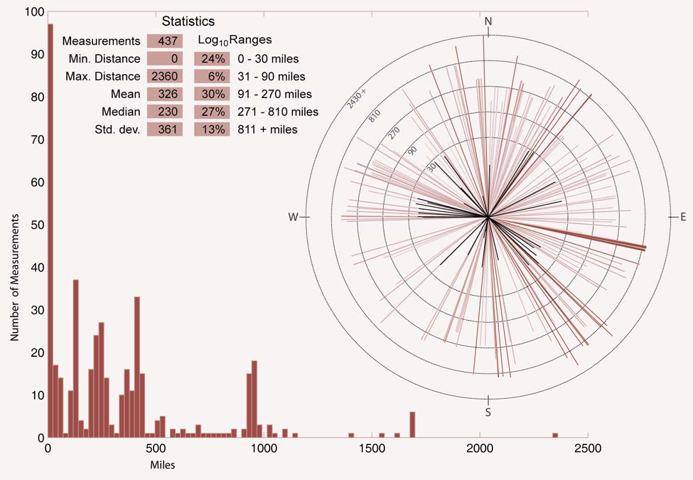

Left-Wing Antecedent Activities to Incidents Analysis

Eight case studies involved groups classified as left-wing. Of these eight cases, UFF contributed almost one-half of the ancillary and preparatory measurements. However, the remaining the measurements were more or less evenly spread across the six of the other seven groups (WUO-FALN contributed no measurements). The breakdown of antecedent preparatory and ancillary acts (Table 24) shows that the preparatory acts (40%) occurred significantly closer to the incident location than the ancillary acts (23%).

Table 24. Left-Wing Antecedent Activities to Incidents Linear Distance Analysis

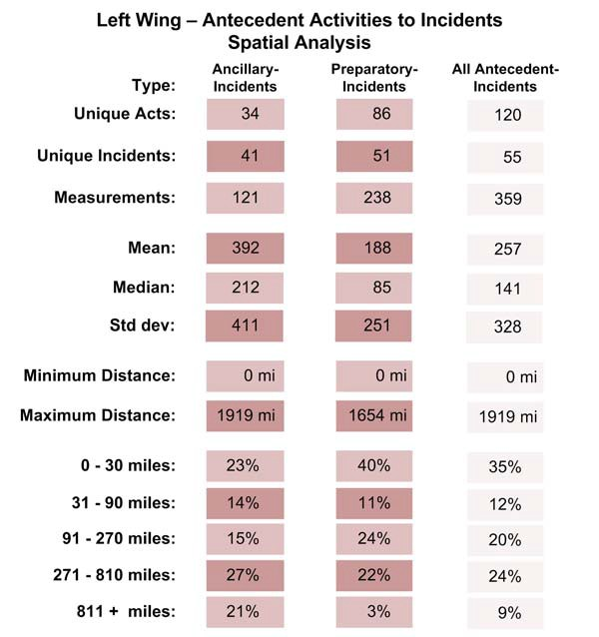

In Figure 38 below, again, we see several strong peaks at less than 600 mile with a few measurements clustered around 1000 and 1200 miles. The measurement histogram strongly hints at clusters within the data. In fact, these clusters (or the peaks we see in the histogram) do tend to correspond to activities related to a specific group. We observe that in aggregate, groups in this category operate relatively close to the target (40% of preparatory activities were within
30 miles of the target) and relatively far from the target (44% between 91and 810 miles). Again, we see the gap between 31 and 90 miles and very little activity beyond 810 miles.

Figure 38. Left-Wing Antecedent Activities to Incidents Rose Diagram

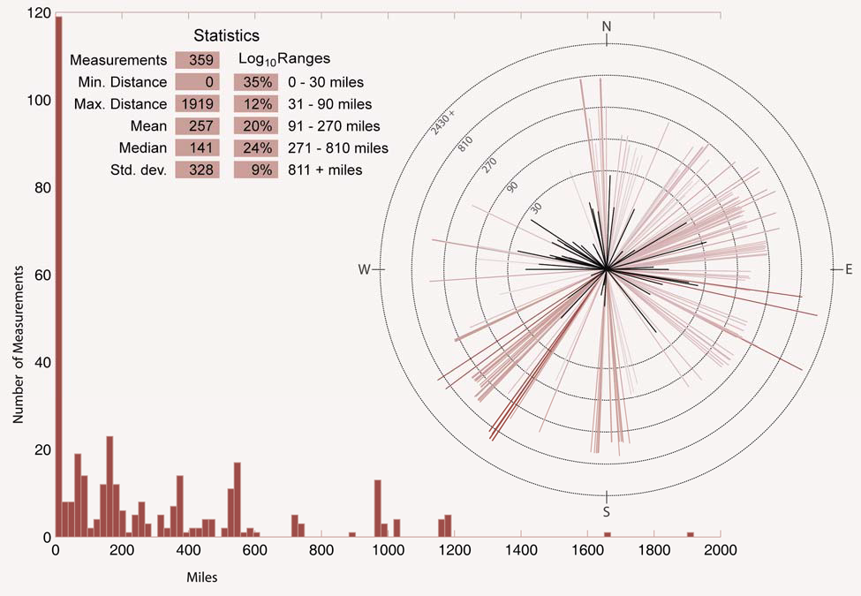

International Antecedent Activities Incidents Analysis

International groups exhibit strong bi-modal behavior in these measurements. Two strong peaks are visible in the histogram; the ever-present peak at zero miles (reflecting activities related to surveillance or other target preparation) and at about 1100 miles. In fact, 46% of preparatory activities were performed beyond 810 miles from the target, 25% within 30 miles of the target. Very little activity occurred between 31 and 90 miles of the target. It seems that international terrorists operating in the US tend to operate very close or very far from their eventual target. Table 25 shows the similar relationships between the distances from types of antecedent activities to incident locations.

Table 25. International Antecedent Activities to Incidents Linear Distance Analysis

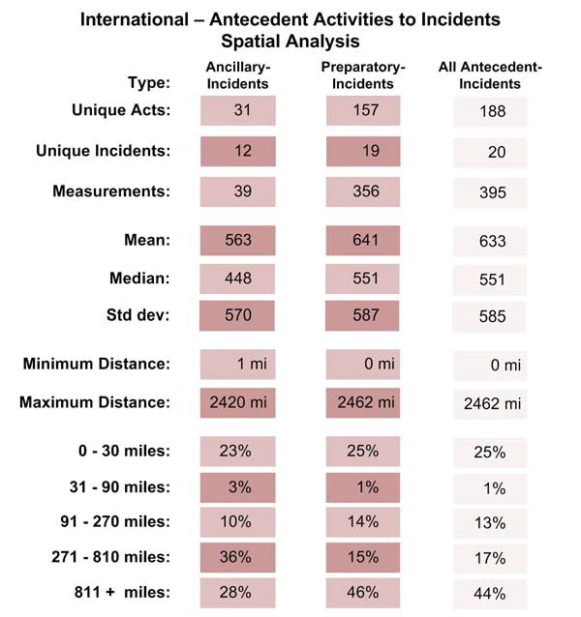

However, we again need point out the possible bias in these results. Of the 395 measurements, 208 were a result of preparatory activities of the Al Qaeda 9-11 case. We treated each of the four 9-11 hijacking as a separate incident and many of the preparatory acts were related to all four hijackings. This increases the effect of these preparatory acts on the histogram. A closer look at this case shows that more than 50 preparatory activities (flight training, for example) by Al Qaeda were more than 270 miles from the eventual targets. With four targets,
we find that these 50 preparatory events contribute 200 measurements to the total.

Figure 39. International Terrorists’ Antecedent Activities to Incidents Rose Diagram

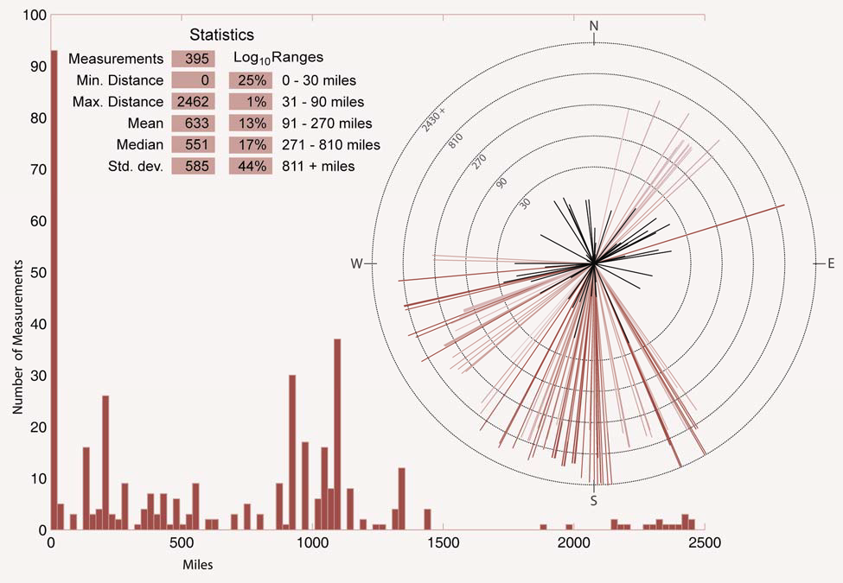

Environmental Antecedent Activities to Incidents Analysis

Environmental groups showed the strongest tendencies not only for short planning time-lines but for small operational areas as well. Fully 59% of antecedent activities occurred within 30 miles of the target. Many of these were even closer. ELF 3 and ELF Family case studies (as we noted in the residences to events section) contributed more to these measurements. A total of 93 of the 145 measurements came from these groups.

Figure 40. Environmental Terrorists’ Antecedent Activities to Incidents Rose Diagram

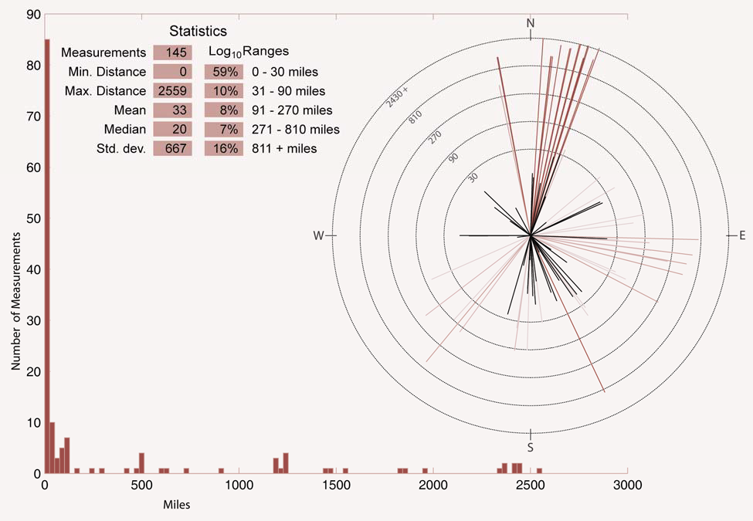

In this category, almost three times as many ancillary measurements were available. Only a few preparatory acts, just over 50 occurred beyond 270 miles from the target. Ancillary
activities proved to be more far reaching, however, with 40% of the 977 measurements occurring beyond 810 miles. Table 26 shows the results of the environmental antecedent to incident spatial analysis.

Table 26. Environmental Antecedent Activities to Incidents Linear Distance Analysis

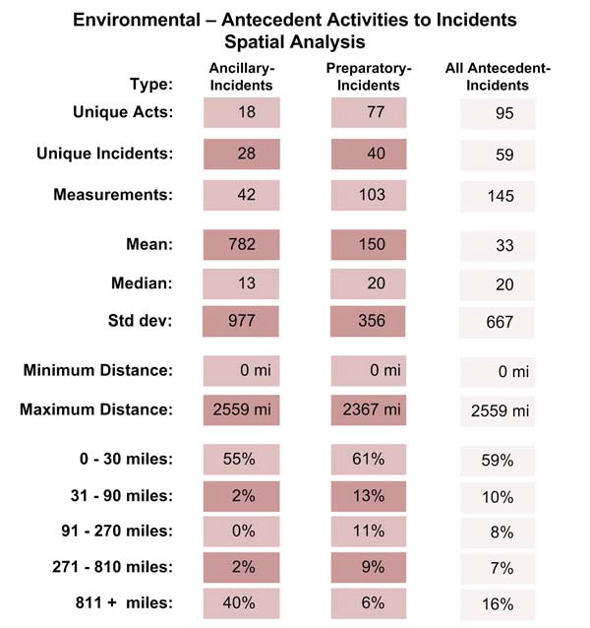

Single Issue – Other Antecedent Activities to Incidents Analysis

The JDL case study made up over one-half of the measurements in this category. Of the 23 total measurements, over 15 of them were in acts occurring within 30 miles of the target. Once again, the low number of case studies and spatial measurements limits the analysis that can be presented. (Table 27) Future data collection could improve the results.

Table 27. Single Issue – Other Antecedent Activities to Incidents Linear Distance Analysis

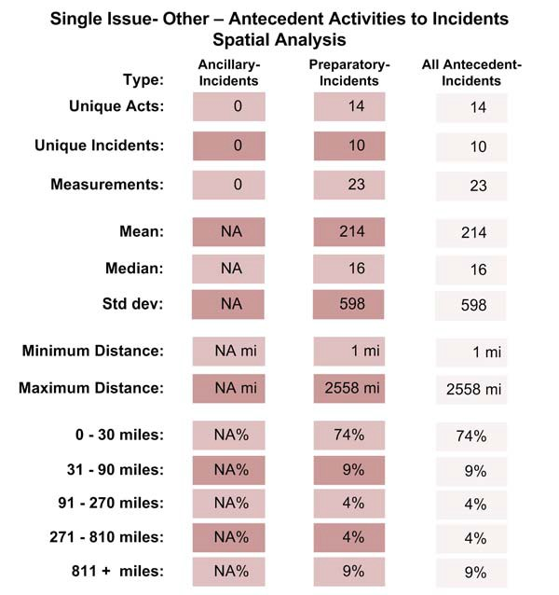

The Interaction of Time and Space

Having looked at temporal and spatial patterns separately, we turn our attention to patterns involving interactions between space and time. As we noted in the GATA report, anecdotal examination of the available cases had suggested the basic premise that “the nearer in time to the selected date for the incident, the closer the antecedent behaviors will occur in proximity to the target.” The suggested pattern can perhaps be conceptualized as a predator circling a prey.
While the activities of terrorists in preparing for an incident might not replicate this three- dimensional vortex, a two-dimensional perspective should render a positive relationship between time and space: that is, as time to the incident declines, distance to the target will decline

(although in our depiction this will be visualized as an inverse relationship due to our reversal of the X axis).

To explore this hypothesis requires that a substantial number of cases have coded temporal and spatial data. This was not the case for the data collected during the GATA project but we nevertheless demonstrated the potential for this methodology by visualizing two particular examples from the available cases, one environmental and one international. The first example depicts the activities of the “family” during the commission of over 20 arsons and “ecotage” activities (Figure 23). Unfortunately, the preparatory activities occurred so close in time to the incident that a pattern could not be identified. Essentially, this is a methodological problem. We used “daily” measures, rather than “hourly” measurements. A more sensitive measure of time (if the data are available) might have produced the hypothesized results.

Since the planning and preparation sequence of international terrorists tends to be longer than environmental terrorists, a second test on international cases was conducted. An example using the activities of Yu Kikumura, a member of the Japanese Red Army arrested in the United States in the late 1980s, is also depicted. Unlike what we hypothesized, the relationship reflects an “inverted U” rather than a linear relationship. In retrospect, this makes logical sense. The terrorist, in this case Kikumura, first conducted close up surveillance on the target, then in the months that followed, he retreated from the site, planning and preparing for the final attack (which in this case was prevented). As the date for the selected attack neared, his preparatory activities became increasingly closer to the target location. In both of these examples, the identification of surveillance activities may represent the best opportunity for early interdiction.

Both of these exploratory examinations suggest that, with adequate data, a number of behavioral patterns may be identifiable.

Figure 41. Time and Space Interaction

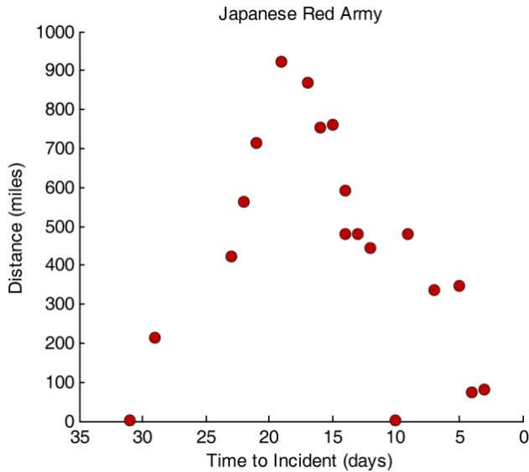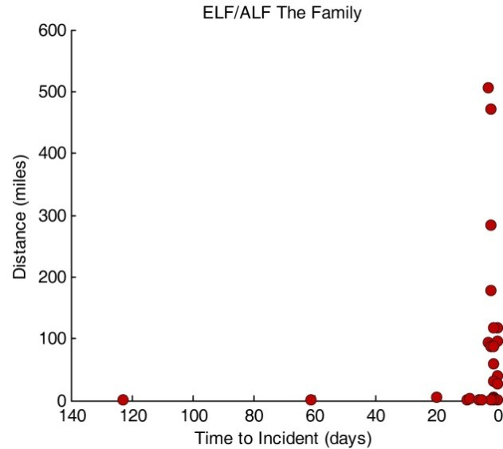

For this project, we made a concerted effort to collect and code more residences and events with both temporal and spatial data. We were partially successful. For reasons we discussed earlier in this report (see Section XXX), antecedent and incident event data yielded many more firm dates than did more ambiguous residences (although the opposite tended to be true for distances). In fact, we were able to identify 1,351antecedent to incident pairings covering all categories. A break-down by category and event type are provided in Table 28. Very few residence records with both spatial and well-known temporal data were available for this analysis. For this reason, we have chosen to limit our analysis of time and space interaction to
preparatory acts. Antecedent acts codes as ancillary are also excluded from this analysis because of highly variable nature of these events and there sometimes murky relationship to a given
event.

We have chosen to visualize time and space interactions using “linear-logarithmic scatter plots”. These plots show elapsed time between the preparatory act and its associated incident (in days) on the x-axis and the distance between these two events on the log10 scaled y-axis. Each marker, or data point, on the graph then represents a single preparatory act. The horizontal grey bars delineate the same distance bins we used to report statistics and produce rose-diagrams in
the previous section. Note that the time scale on the x-axis is inverted, with zero elapsed time on the far right of the graph and the largest elapsed time on the far left. This was done to convey the impression that as early preparatory acts (those performed long before the event) would start on the left of the graph and move to the right they drew closer to the actual event. This seemed to
us a more intuitive way to visualize the temporal path of events and mimics the timeline analysis presented earlier in this report.

Table 28. Breakdown of antecedent acts to incident with spatio-temporal values available for analysis.

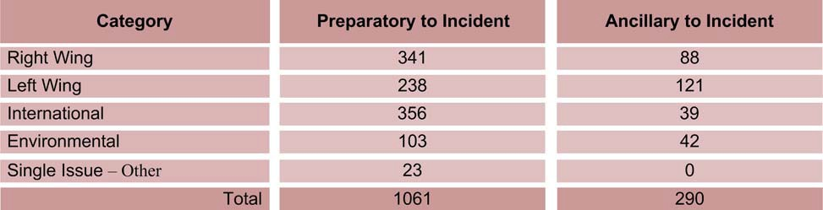

Categorical Comparisons

In order to get a broad image of time-space interactions, we first look at a scatter plot of all

1,065 preparatory acts to incident pairings. While no distinct pattern emerges, it is clear that there are a few outliers (outliers in the sense that they there are not many other pairings like

them, not that they are unimportant or not worth considering) to be explained. It is equally clear that different groups operate on different time scales (as we pointed out earlier). The relative short preparations of international (again, in purple) and Singe Issue- environmental (in green) groups is in marked contrast to the long, drawn out preparations of left wing groups (in blue).

Patterns occurring over different time scales are more apparent if we plot each category individually and allow the scale of the time axis to fit the available data. No strong pattern emerges from these views. In all of the following interaction plots, event markers are colored based on the category in which they fall. International groups are always shown in purple, Right Wing groups in blue, Left Wing groups in red, single issue – environmental group in green and single issue – other groups in yellow.

Figure 42. Scatter plot of elapsed time vs. log10 distances of preparatory acts to incidents by category

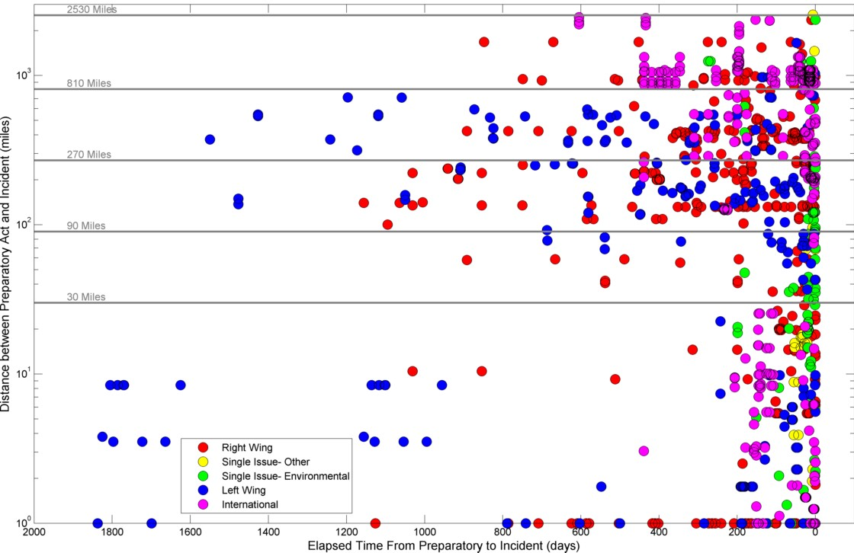

Analysis of Individual Incidents

As we have pointed out, groups tend to operate on different scales in both time and space. As a result, aggregate time and space scatter plots do not reveal any strong patterns of behavior.

In this section, we briefly show and discuss, in aggregate, scatter plots showing preparatory acts by incident. The title of the plot indicates the group’s name, the color of the markers shows the category of the group, the type (based on the Type 4 code in the database) of the incident is given. The number or measured preparatory acts leading up to the incident .is also provided. Only incidents for which 10 or more preparatory acts were measured are shown here. Note that for these individual incidents, the time scale on the x-axis changes dramatically.

One feature of these interaction plots that stands out is how preparatory events have a tendency to cluster, not just in time as we have seen, but also in both time and space. This seems to occur across categories and groups but at different time and distance scales. This is no doubt due in part to the types of preparatory events coded and may well be an artifact of the measurement process. We have yet to investigate the degree to which this cluster (in time, space and in time/space) is due to actual behavior patterns of these terrorist groups. The most
prominent outlier is a transfer of money related to the Al Qaeda 9/11 hijackings. Figure 43 below shows how individual incidents can be displayed and analyzed using the scatter plot diagrams. Overall, the analysis is somewhat in conclusive so these are shown as examples. Further data collection and refinement of the coding schema concerning preparatory and ancillary antecedent activities is needed to further investigate the time and space relationships.

Figure 43. Scatter plots of elapsed time vs. log10 distances of selected incidents

·""""
OKC Bomtling • 50282 (9ombine, 2t Pwep.araik)(y Acts )
,_ - El Rukns • 891$I(9ornbin0, II Pweparatcwy Actt )

) •• •• ... ·'
t ..
I! l
I · i

w .I. ..
i i
I l
I I
r
r
- .. "' .

·,;., "" ,.,. ,, ...
Eli&!Mdn.tFrom •lndlllllniiOIIpi £.-T-I"roon,.._*J•r.oct.n t
AIOMCII9oi1 • 803Q (Prtparllo!yAc:b:) -- ElF3· 8'720 (Bombi'lg, 1•)

• '""'""
. . • .

... ..-·. .. •.
I • l
I I J... ... I J
I I
J• -·

,- -
...., - - j
># - ,. uo tOo • I

BaiNf TNrNIIIAIIIW*'Y.,...,.,.(!Itrrt.

V. SUMMARY AND DISCUSSION

The body of empirical data that now exists as a result of data collection from this and past geospatial and temporal projects is now sufficient to draw some comparisons between terrorism categories. The four main categories of terrorism– right-wing, left-wing, international, and environmental all have sufficient data for analysis and comparisons. Although data for the fifth category, “single issue – other” remains sparse, the collection of additional case data eventually will allow analysis to be conducted. A total of over 4,000 spatial measurements have been made between associated terrorist residences, antecedent acts. This section will address the similarities and differences between the four main terrorism categories.

It is important to note once again the methodology for measuring distances between locations of terrorist residences, antecedent acts, and incidents. There were cases where multiple residence locations were recorded for terrorists and co-conspirators. In these cases, measurements were taken from the residence that was most closely tied to the incident or act. If data collection did not reveal specific mention of a time period for use of the residences, then the closest residence
to the act or target was used. Additionally, one act such as a meeting may have been tied to more than one incident. In these cases the distance was measured between that act and each of the incident locations. It would be the same case for measuring residences to acts or incidents. The same residence was used in multiple incidents and multiple terrorists were staying at the same residence. A measurement was recorded for each person to act or incident.

Residences to Incidents Spatial Analysis: A total of 563 spatial measurements were made from terrorist incident locations to incidents or planned incident locations. These distances were measured between 173 individual’s residences and 245 incident locations for all categories.

Almost half of the distances measured fell within 30 miles of the terrorist residences (40%, 226 of 563) which is consistent with our past findings. Terrorists are choosing to stay within a relatively close proximity to the selected targets throughout the planning process. When one looks at the specific categories of terrorism you see that more of the international terrorists (59%) lived closer to their intended targets than all of the other categories. The environmental
(44%) and left-wing (39%) groups were less likely to reside as near to the targets as international terrorists, but a larger percentage are closer than among the right-wing groups (27%). In fact if you look at all residences that were closer than 15 miles to the incident, over a third (34%, 192 of
563) of all residences falls within the range (Table not shown). Over half (51%) of international terrorists, over a third of the environmental terrorists (36%) and left-wing terrorists (38%) resided within this 15 mile radius of the target.

Table 29. Breakdown by Category Terrorism for Residences to Incidents Spatial Analysis

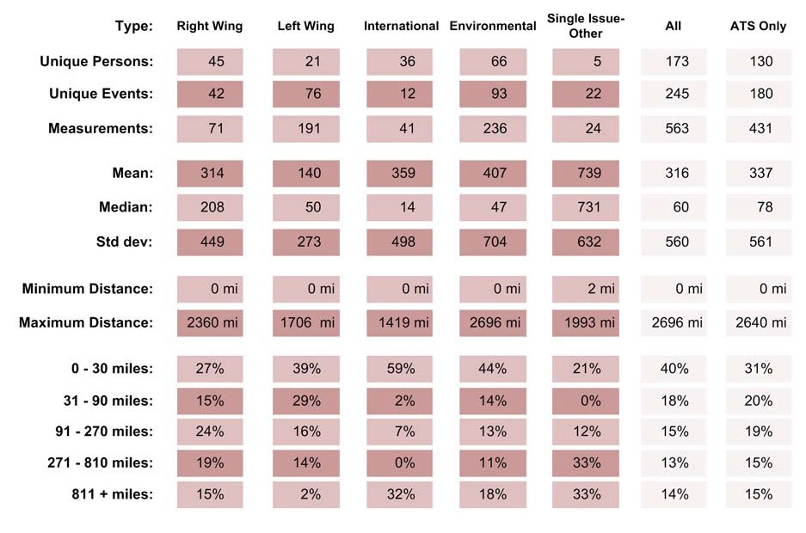

Overall the international groups tend to have the most distinguishable pattern in terms of the proximity to the target locations that they choose to stay. They tended to either live close to the target (59%) or far away (32%). The environmental groups have similar characteristics as the international, but are not as clearly pronounced and they have more residences distributed into the mid level distance ranges. Although the percentages of right-wing residences were spread out across all categories the highest percentage was still in the 0 – 30 mile range. This lack of routinized spatial patterning among right-wing terrorists probably reflects their ideological beliefs. Living in rural areas to escape the “pollutants” of urban life, they nevertheless chose targets in urban areas some distance away.

The spatial measurements results in Table 29 are also broken out into “ATS only” court cases for the purpose of examining whether removal of incidents not found on the ATS court case list have a significant impact on the analysis. The largest drop in the residences to incidents measurements is seen in the first distance range of 0 - 30 miles which drops from an average of
40% for all measurements to 31% for ATS only. Although a significant difference is seen, the specific measurements that were removed were almost all from the environmental category (86 of 89). These cases did not make the ATS list for multiple reasons. Four of the case studies and
20 measurements occurred after the end date from the latest list from the FBI. It is anticipated that these will be on the next update of official terrorism court cases.

Residences to Antecedent Activities Spatial Analysis: Upon selection of a target the terrorist planning cycle continues with preparation for the upcoming incident. The question is whether these terrorists then commit these antecedent activities close to their residences or far away to avoid detection. Additionally, what is the spatial relationship between the antecedent activities

and the incident location? A total of 1,298 spatial measurements were made between antecedent activities locations, which includes both preparatory and ancillary acts. The right-wing group made up almost half of the spatial measurements (614 of 1,298) and recorded the second highest ratio of acts per person measured. These results are shown in Table 30 below.

Table 30. Breakdown by Category Terrorism for Residences to Antecedent Activities
Spatial Analysis

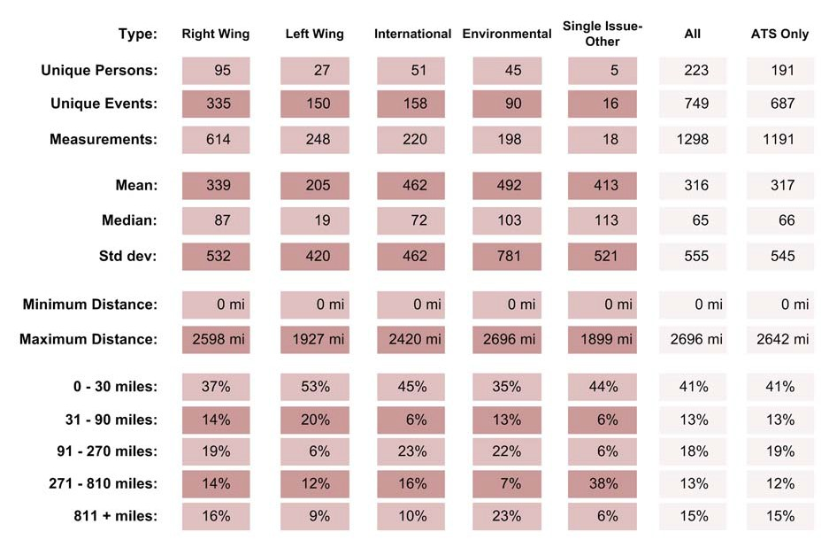

As the table above demonstrates, the spatial analysis of all categories revealed that the antecedent activities were occurring in the same proximity to the residence as the incidents target locations. The average for “residence to incident” was 40% and the average for “residence to antecedent” was 41%. Unlike the “residences to incidents” measurements when non-ATS court cases were removed from the analysis, the spatial results did not change. This shows that inclusion of non-ATS incidents has no effect on this measure of spatial analysis. Differences do

exist, however, when looking at individual categories. Two categories increased in the proximity to the residence that the antecedent activities were taking place compared to the selected incident target locations. Both the right-wing and left-wing groups saw an increase in proximity to residences. The right-wing groups increased from 27% to 37% and the left-wing from 39% to
53%. These results show that overall the antecedent acts were taking place farther away from the residence than the locations of the targets within these two categories. In contrast, the international and environmental groups both saw over a 10% decrease in the 0 -30 mile range and had increases in the 91 -270 mile range.

Antecedent Activities to Incidents Spatial Analysis: Analyzing the proximity of the antecedent activities to the target incident locations can help determine the environs in which the terrorists act. Are they preparing for the incidents at locations other than their residences? Are they purchasing materials close to the scene of the incident? Alternatively, are they committing crimes farther away to help avoid detection as they prepare for an incident? These and other questions can be answered by examining the spatial analysis of terrorist antecedent activities locations to the target incident locations. Over 1,300 spatial measurements were made across all categories, making this measure the largest available spatial analysis. Table 31 below shows the results.

Table 31. Breakdown by Category Terrorism for Antecedent Activities to
Incidents Spatial Analysis

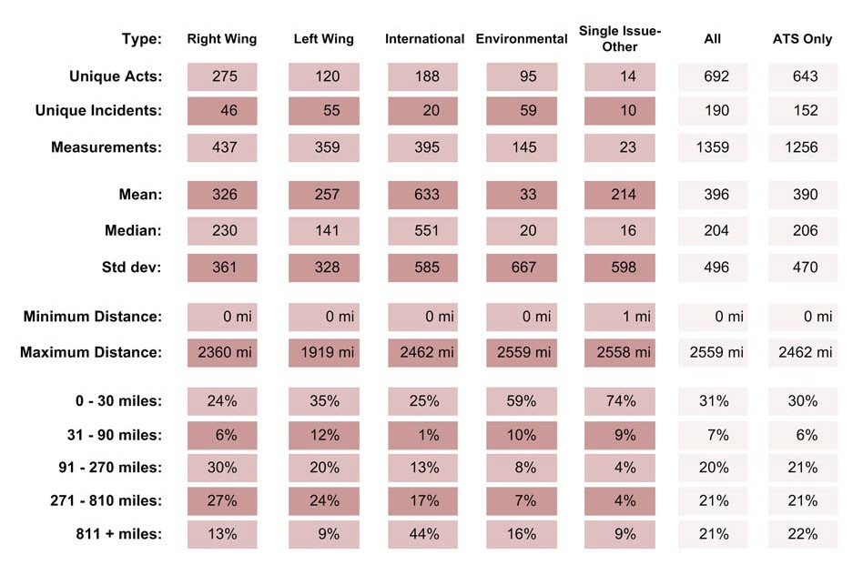

The results above show that the antecedent activities are taking place closer to the incident target locations for the environmental group but farther away for the three other major categories. The single issue – other group also saw a large increase in proximity to the incident target location, but due to the low sample size these results are not discussed.

VI. REFERENCES

Abadinsky, Howard. 2000. Organized Crime, Sixth Edition, Belmont, CA: Wadsworth
Publishing.

Albanese, Jay. 1996. Organized Crime in America, Third Edition. Cincinnati: Anderson
Publishing.

Anselin, Luc, Jacqueline Cohen, David Cook, Wilpen Gorr, and George Tita. 2000. Spatial Analyses of Crime. In From Measurement and Analysis of Crime and Justice: Criminal Justice 2000 4:213-262.

Berrebi, Claude and Darius Lakdawalla, 2007. “How Does Terrorism Risk Vary Across Space And Time? An Analysis Based On The Israeli Experience," Defence and Peace Economics, Taylor and Francis Journals, vol. 18(2), pages 113-131.

Blumstein, Alfred. 1996. Comments during the “Planning Meeting on Terrorism, Hate Crime, and Anti-Government Violence.” Committee on Law and Justice, NAS/NRC, Washington, DC, March 20.

Clarke, Ronald V. 1992. Situational Crime Prevention: Successful Case Studies. Albany, NY: Harrow and Heston.

Clarke, Ronald V. and Graeme R. Newman. 2006. Outsmarting the Terrorists. Westport, CN: Prager Security International.
CNN.com Law Center. 2004. “Difficulty of Fighting Terror in the Courts.” September 6, 2004. Cohen, Lawrence and Marcus Felson. 1979. “Social Change in Crime Rate Trends: A Routine
Activity Approach.” American Sociological Review. 44:588-608.

Corley, Sarah, Brent L. Smith, and Kelly R. Damphousse. 2005. “The Changing Face of American Terrorism” Pp. 49-62 in Lynne Snowden and Brad whitsel (Eds.) Terrorism: Research, Readings and Realities. Upper Saddle River, NJ: Prentice Hall.

Crenshaw, Martha. 1988. “Theories of Terrorism: Instrumental and Organizational Approaches.” Pp. 13-31 in David C. Rapoport (ed.) Inside Terrorist Organizations. New York: Columbia University Press.

Crenshaw, Martha. 1992. “Current Research on Terrorism: The Academic Perspective.”
Studies in Conflict and Terrorism, 15(1):1-11.

Damphousse, Kelly R. and Brent L. Smith. 2004. “Terrorism and Empirical Testing: Using Indictment Data to Assess Changes in Terrorist Conduct.” Pp. 75-90 in Mathieu DeFlem (ed.) Terrorism and Counter-Terrorism: Criminological Perspectives. Boston, MA: Elsevier.

Davis, Lois M., K. Jack Riley, Greg Ridgeway, Jennifer Pace, Sarah K. Cotton, Paul S.
Steinberg, Kelly Damphousse, and Brent L. Smith. 2004. When Terrorism Hits Home: How Prepared are State and Local Law Enforcement. Santa Monica, CA: RAND Corporation.

Drake, C.J.M. 1998. Terrorists’ Target Selection. New York: St. Martin’s Press. Dyson, William. 2001. Terrorism: an Investigator’s Handbook. Cincinnati, OH: Fernandez, Ronald. 1987. Los Macheteros. New York: Prentice-Hall.
Gattrell, A., Bailey, T., Diggle, P., Rowlingson B. 1996. Spatial point pattern analysis and its application in geographical epidemiology. Trans Institute of British Geographers. London: Royal Geographical Society.

Hamm, Mark S. 2007 Terrorism as Crime: From Oklahoma City to Al-Qaeda and Beyond. NYU Press.

Hoffman, Bruce. 1992. “Current Research on Terrorism and Low-Intensity Conflict.” (1):25-
37.

Hoffman, Bruce. 1998. Inside Terrorism. New York: Columbia University Press.

Inciardi, James, Ruth Horowitz, and Anne Pottieger. 1993. Street Kids, Street Drugs, Street Crime: An Examination of Drug Use and Serious Delinquency in Miami. Belmont, CA: Wadsworth Publishing.

Jarboe, James. 2002. Testimony before the U.S. House of Representatives House Resources
Committee, February 12, 2002. Washington, DC.

Jeffrey, C. Ray. 1971. Crime Prevention Through Environmental Design. Beverly Hills, CA: Sage.

Kaplan, Howard B. 1995. Drugs, Crime, and Other Deviant Adaptations. New York: Plenum
Publishing.

LaFree, Gary. 2004. Personal conversation relative to ongoing efforts to quantify the
“Pinkerton” database of international terrorism. Nashville, TN.

Leipnik, Mark R., and Donald P. Albert. 2003. GIS in Law Enforcement: Implementation Issues and Case Studies. London; New York: Taylor & Francis.

Mickolus, Edward F. 1980. Transnational Terrorism: A Chronology of Events, 1968-1979.
Westport, CT: Greenwood Press.

Mickolus, Edward F. 1989a. International Terrorism in the 1980s: A Chronology of Events, Volume I: 1980-1983. Ames, IO: Iowa State University Press.

Mickolus, Edward F. 1989b. International Terrorism in the 1980s: A Chronology of Events, Volume II: 1984-1987. Ames, IO: Iowa State University Press.

Mickolus, Edward F., Todd Sandler, and Jean M. Murdock. 1993. Terrorism, 1988-1991: A Chronology of Events and a Selectively Annotated Bibliography. Westport, CT: Greenwood Press.

Murray, John and Richard H. Ward. 1996. Extremist Groups: An International Compilation of Terrorist Organizations, Violent Political Groups, and Issue-Oriented Militant Movements. Chicago, IL: Office of International Criminal Justice.

Newman, Oscar. 1972. Defensible Space: Crime Prevention Through Urban Design. New
York: MacMillan.

Office of the Attorney General. 1983, revised in 2002. Attorney General’s Guidelines on
Domestic Security/Terrorism Investigations. Washington: U.S. Department of Justice. Park, Robert E. and E. W. Burgess. 1925. The City. Chicago: University of Chicago Press.
Paulsen, Derek J. and Matthew B. Robinson. 2004. Spatial Aspects of Crime: Theory and
Practice. Boston, MA: Pearson.

Rapoport, David C. 1992. “Terrorism.” In Mary Hawkesworth and Maurice Kogan (eds.)
Routledge Encyclopedia of Government and Politics, Volume II. London: Routledge.

Reppetto, Thomas A. 1974. Residential Crime. Cambridge, Massachusetts: Ballinger
Publishing.

Roach, Jason, Paul Ekblom, and Richard Flynn. 2005. “The Conjunction of Terrorist Opportunity: A Framework for Diagnosing and Preventing Acts of Terrorism.” Security Journal. 18(3):7-25.

Rossmo, Kim, 1999. Geographic Profiling. Boca Raton, FL: CRC Press.

Schafer, Stephen. 1974. The Political Criminal: The Problem of Morality and Crime. New
York: Free Press.

Shaw, Clifford R. and Henry D. McKay. 1942. Juvenile Delinquency in Urban Areas. Chicago: University of Chicago Press.

Smith, Brent L. 1994. Terrorism in America: Pipe Bombs and Pipe Dreams. Albany, New
York: State University of New York Press.

Smith, Brent L. and Kathryn D. Morgan. 1994 “Terrorists right and left: empirical issues in profiling American terrorists”” Stud. Conf. Terror. 17:1

Smith, Brent L. and Gregory Orvis. 1993. "America's Response to Terrorism: An Empirical
Analysis of Federal Intervention Strategies During the 1980's." Justice Quarterly.
10(4):663-683.

Smith, Brent L. and Kelly Damphousse. 1996. "Punishing Political Offenders: The Effect of
Political Motive on Federal Sentencing Decisions." Criminology. 34(3):289-321.

Smith, Brent L. and Kelly R. Damphousse. 1998. “Terrorism, Politics, and Punishment: A Test of Structural Contextual Theory and the Liberation Hypothesis.” Criminology. 36(1):67-
92.

Smith, Brent L., Kelly R. Damphousse, and Amy Karlson. 2001. “Terrorism and the American System of Criminal Justice.” Pp. 447-460 in Handbook of Criminal Justice Administration, Toni DuPont-Morales, Michael Hooper, and Judy Schmidt (eds). New York: Marcel Dekker.

Smith, Brent L., Kelly R. Damphousse, Freedom Jackson, and Amy Sellers. 2002. “The Prosecution and Punishment of International Terrorists in Federal Courts: 1980-1998. Criminology and Public Policy. 1(3):311-338.

Smith, Brent L. and Kelly Damphousse. 2003a. “The Impact of the Federal Sentencing Guidelines on the Prosecution and Punishment of American Terrorists.” Presentation to the NIJ Research and Evaluation Conference, Washington, DC, July 28, 2003.

Smith, Brent L. and Kelly Damphousse. 2003b. “Terrorism and Empirical Assessment: Using Indictment Data to Assess Changes in Terrorist Conduct.” Presentation to the annual meeting of the Justice Statistics Research Association, San Francisco, CA, October 2.

Smith, Brent L., Kelly R. Damphousse, and Paxton Roberts. 2006. “Final Report: Pre-Incident
Indicators of Terrorist Activities.” Final report for NIJ Award #2003-DT-CX-0003.

Transactional Records Access Clearinghouse. 2003. “Criminal Terrorism Enforcement Since the
9/11/01 Attacks.” Syracuse, New York: Syracuse University.

Turk, Austin. 1979. “Analyzing Official Deviance: For Nonpartisan Conflict Analyses in
Criminology. Criminology. 16(4):459-476.

Wardlaw, Grant. 1989. Political Terrorism. 2nd Edition. New York: Cambridge University
Press.

Ward, Richard. 2005. Conversations and observations relative to relational database development through the Institute for the Study of Violent Groups. Huntsville, TX.

Wolfgang, Marvin. 1958. Patterns in Criminal Homicide. New York: John Wiley.

Wright, Richard and Scott H. Decker. 1997. Armed Robbers in Action: stickups and Street
Culture. UPNE

APPENDIX A.

Table 1. Right-wing Terrorists' Residences to Events Case Study Breakdown

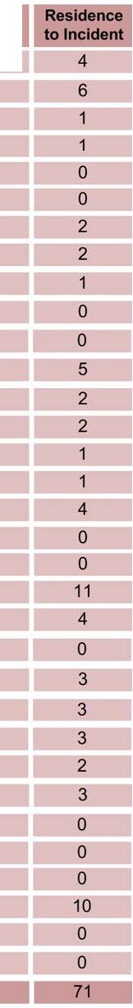Case Study Name Number of Residence to Residence to Residence to
I nci dents Ancillary Preparatory Antecedent
AN Furrow ATS 4 3 3 6

AN Winslow ATS 2 0 14 14
AOG Jordi ATS 1 0 4 4
AOG Kopp 1 0 2 2
AOG Waagner 2 6 1 7
ARA ATS 1 11 31 42
American Front ATS 2 0 2 2
Arizona Patriots ATS 2 19 17 36
Brailey Assassination ATS 1 1 1 2

C1LF ATS 0 7 20 27

Chewning ATS 0 0 5 5
CSA ATS 3 5 6 11

FRSH ATS 5 0 7 7
Felton Chase ATS 1 7 8
HDFB ATS 1 0 0 0
KKK Texas ATS 0 0 0 0
KSM ATS 0 9 46 55
Logan ATS 1 0 1 1
MP Ricin ATS 1 0 4 4
Montana Freeman ATS 3 4 137 141
Moody 4 2 3 5

NA Doles ATS 0 0 2 2

OKC Bombing ATS 1 15 39 54

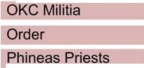ATS 1 0 14 14
ATS 2 32 35 67
ATS 3 0 6 6

ROT ATS 1 0 0 0

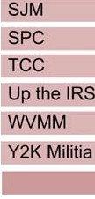ATS 0 1 2 3
ATS 0 24 24
ATS 1 0 2 2
ATS 10 0 12 12
ATS 1 0 16 16 1 0 35 35
Totals 58 1 16 498 614

Table 2. Left-Wing Terrorists’ Residences to Events
Case Study Measurement Breakdown

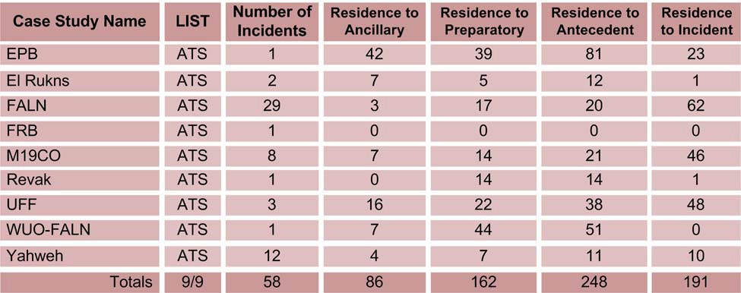

Table 3. International Terrorists’ Residences to Events
Case Study Measurement Breakdown

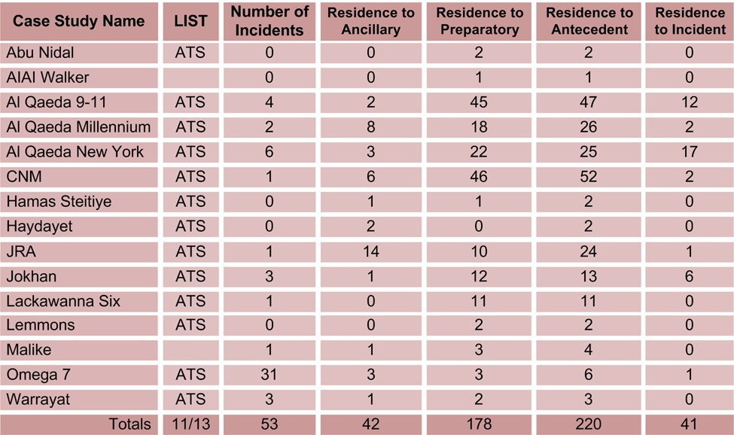

Table 4. Environmental Terrorists’ Residences to Events
Case Study Measurement Breakdown

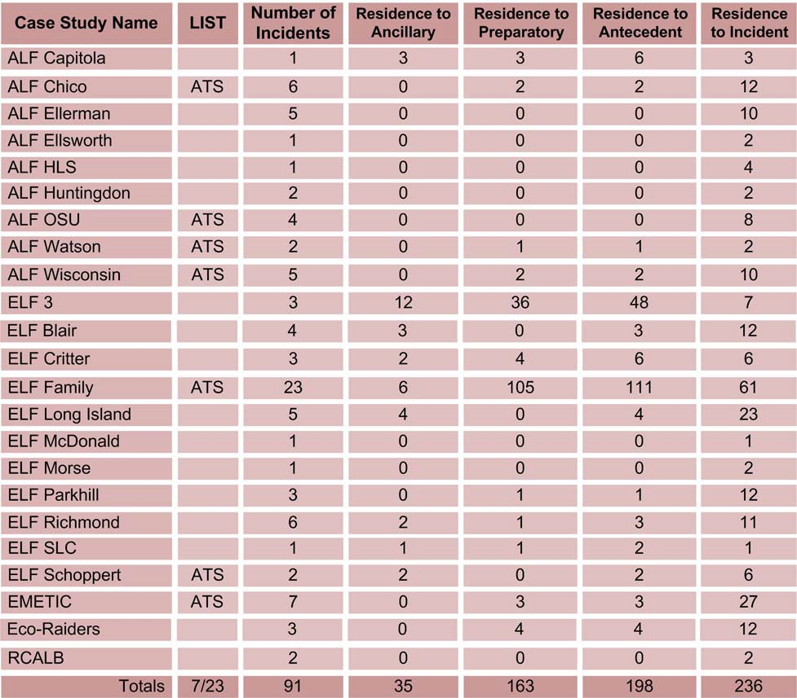

Table 5. Single Issue – Other Terrorists’ Residences to Events
Case Study Measurement Breakdown

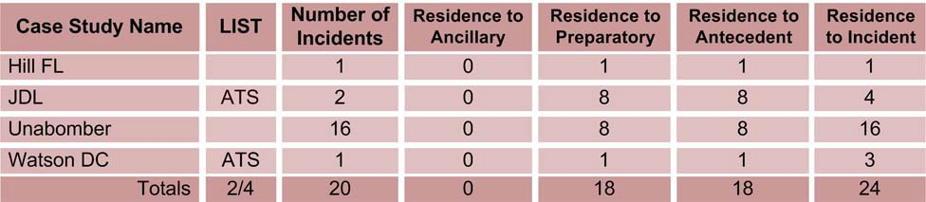

Table 6. Right-wing Terrorists’ Antecedent Activities to Incidents
Case Study Measurement Breakdown

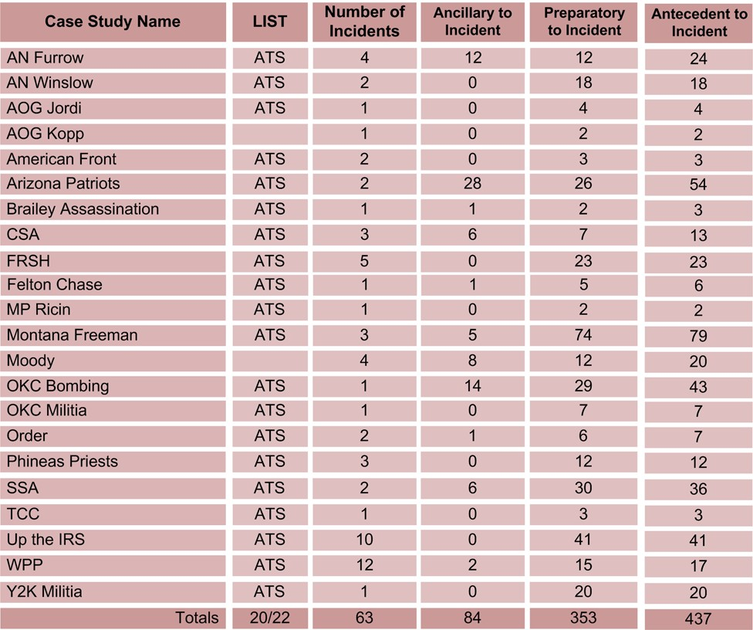

Table 7. Left-Wing Terrorists’ Antecedent Activities to Incidents
Case Study Measurement Breakdown

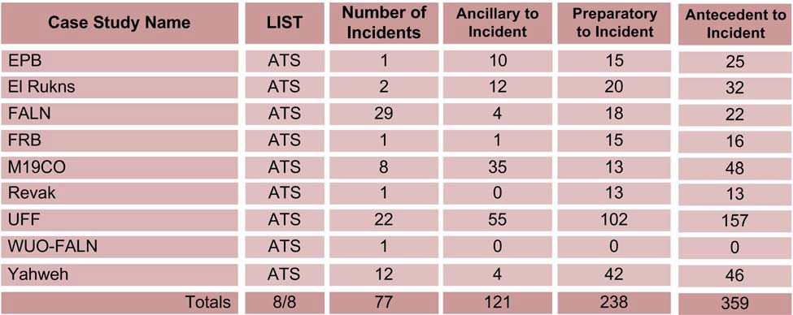

Table 8. International Terrorists’ Antecedent Activities to Incidents
Case Study Measurement Breakdown

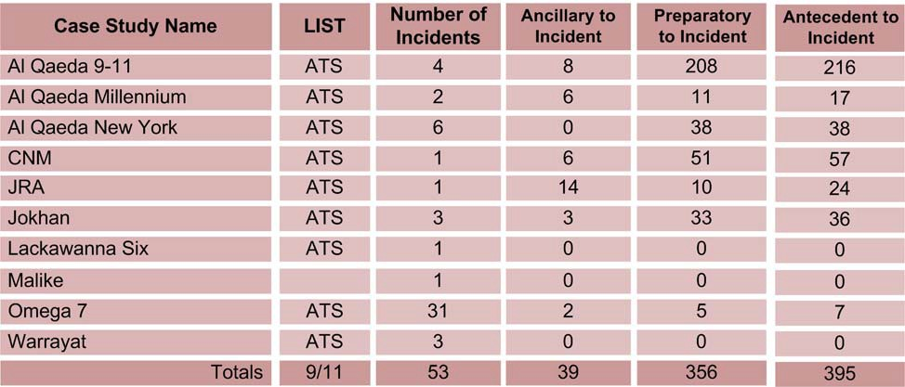

Table 9. Environmental Terrorists’ Antecedent Activities to Incidents
Case Study Measurement Breakdown

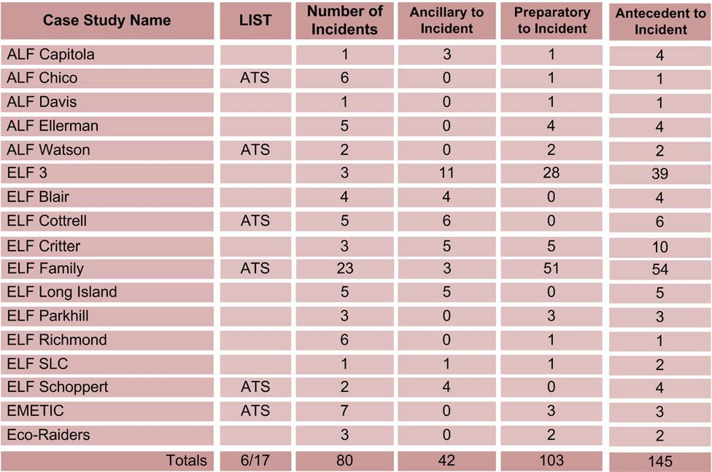

Table 10. Single Issue – Other Terrorists’ Antecedent Activities to Incidents
Case Study Measurement Breakdown

